**Bangladesh:  
Data on economic transformation**

Economic structures 1

Table 1. GDP, employment and relative productivity levels, Bangladesh   
(WDI/ILO GET data) 1

Table 2. GDP, employment and relative productivity levels, Bangladesh   
(UNSD/ILO WESO data) NEW 2

Table 3. Labour productivity levels and changes, Bangladesh   
(WDI/ILO GET data) 3

Table 4. Labour productivity levels and changes, Bangladesh, 1991–2013   
(UNSD/ILO WESO data) NEW 3

Figure 1. Relative productivity and changes in employment shares by sector, Bangladesh (WDI/ILO GET data) 4

Figure 2. Relative productivity and changes in employment shares by sector, Bangladesh (UNSD/ILO WESO data) NEW 5

Figure 3. Decomposition of labour productivity change, Bangladesh, 1990–2005   
(WDI/ILO GET data) 7

Figure 4. Decomposition of labour productivity change, Bangladesh, 1990–2005   
(UNSD/ILO WESO data) NEW 7

Figure 5. Productivity gaps in Bangladesh, 2005 (WDI/ILO GET data) 8

Figure 6. Productivity gaps in Bangladesh, 2013 (UNSD/ILO WESO data) NEW 8

Figure 7. Total employment by sex and broad sector, Bangladesh (ILO GET data) 9

Figure 8. Broad sectoral employment by sex, Bangladesh (ILO GET data) 9

Figure 9. Sectoral employment by sex, Bangladesh (ILO WESO data) NEW 10

Trade 11

Basic data 11

Figure 10. Total value of trade, Bangladesh, 2005–11 11

Figure 11. Exports by broad HS Section, Bangladesh, 2005–8 and 2009–11 12

Figure 12. Change in export share by HS Section, Bangladesh, 2005–8 and 2009–11 13

Figure 13. Export visualisation, Bangladesh, 2005 and 2012 14

Figure 14. Top export products, Bangladesh (average 2009–11) 15

Figure 15. Top export markets, Bangladesh (average 2009–11) 15

Figure 16. Imports by broad HS Section, Bangladesh, 2005–8 and 2009–11 16

Figure 17. Change in import share by HS Section, Bangladesh, 2005–8 and 2009–11 17

Figure 18. Import visualisation, Bangladesh, 2005 and 2012 18

Figure 19. Top import products, Bangladesh (average 2009–11) 19

Figure 20. Top import sources, Bangladesh (average 2009–11) 19

Diversification 20

Figure 21. Export diversification index, Bangladesh, 1975–2010 20

Figure 22. Export quality index, Bangladesh, 1975–2010 20

Figure 23. Number of export items and markets, Bangladesh, 2005–11 21

Figure 24. Number of import items and suppliers, Bangladesh, 2005–11 21

Revealed comparative advantage 22

Table 5. Revealed comparative advantage by HS Section, Bangladesh 22

Trade in value added 23

Figure 25. Compound annual growth rate of domestic value added, foreign value added and exports, 1996-2011 and 2006-11, Bangladesh 23

Figure 26. Domestic and foreign value added content of gross exports as share of gross exports, 1996, 2000, 2006 and 2011, Bangladesh 23

Figure 27. Overall value of domestic and foreign value added, 1996, 2000, 2006 and 2011 (in USD 1,000), Bangladesh 23

Figure 28. Compound annual growth rate of DVA embodied in gross exports by sector, 1996-2011 and 2006-2011, Bangladesh 24

Figure 29. Sectoral DVA embodied in exports as a share of sectoral gross exports, 2000 and 2011, Bangladesh 24

Figure 30. Sectoral DVA as a share of total DVA, 2000 and 2011, Bangladesh 25

Figure 31. Compound annual growth rate of FVA embodied in gross exports by sector, 1996-2011 and 2006-2011, Bangladesh 26

Figure 32. Sectoral FVA embodied in exports as a share of sectoral gross exports, 2000 and 2011, Bangladesh 26

Figure 33. Sectoral FVA as a share of total FVA, 2000 and 2011, Bangladesh 27

Trade in services 28

Figure 34. Exports of goods and services, Bangladesh 28

Figure 35. Sectoral shares of services exports, Bangladesh 28

Estimates of total factor productivity at firm level 29

Figure 36. Dispersion in productivity across firms by sector – Bangladesh 29

Figure 37. Distribution in productivity in Bangladesh – comparing kernel and normal distributions 30

# Economic structures

1. GDP, employment and relative productivity levels, Bangladesh (WDI/ILO GET data)

|  |  |  |  |  |  |  |  |  |  |  |  |  |  |
| --- | --- | --- | --- | --- | --- | --- | --- | --- | --- | --- | --- | --- | --- |
|  | Value added (% of GDP) | | | | | % of total employment | | | | Relative productivity levels d | | | |
|  | *1991* | *2000* | *2003* | *2005* | *2013* | *1991* | *2000* | *2003* | *2005* | *1991* | *2000* | *2003* | *2005* |
| Agriculture a | 30.4 | 25.5 | 21.8 | 20.1 | 17.2 | 66.4 | 62.1 | 51.7 | 48.1 | 0.4 | 0.4 | 0.4 | 0.4 |
| Industry b | 21.7 | 25.3 | 26.3 | 27.2 | 28.9 | 13.0 | 10.3 | 13.7 | 14.5 | 1.6 | 2.4 | 1.9 | 1.9 |
| *Of which: Manufacturing* | *13.4* | *15.2* | *15.8* | *16.5* | *17.6* | *n/a* | *n/a* | *n/a* | *n/a* |  |  |  |  |
| Services c | 47.9 | 49.2 | 52.0 | 52.6 | 53.9 | 16.2 | 23.5 | 34.6 | 37.4 | 3.3 | 2.2 | 1.5 | 1.4 |
| **Total** | **100.0** | **100.0** | **100.0** | **100.0** | **100.0** | **95.6** | **95.9** | **100.0** | **100.0** | **1** | **1** | **1** | **1** |

Notes:  
(a) Agriculture corresponds to ISIC divisions 1-5 and includes forestry, hunting, and fishing, as well as cultivation of crops and livestock production.   
(b) Industry corresponds to ISIC divisions 10-45 and includes manufacturing (ISIC divisions 15-37). It comprises value added in mining, manufacturing (also reported as a separate subgroup), construction, electricity, water, and gas.  
(c) Services correspond to ISIC divisions 50-99 and they include value added in wholesale and retail trade (including hotels and restaurants), transport, and government, financial, professional, and personal services such as education, health care, and real estate services. Also included are imputed bank service charges, import duties, and any statistical discrepancies noted by national compilers as well as discrepancies arising from rescaling.  
(d) Derived by calculating labour productivity levels (value added at constant prices divided by number of persons employed) and expressing the result as a ratio of total economy labour productivity.  
Numbers may not sum due to rounding. It is unclear why the sectoral shares of total employment add up to well below 100% in some years.  
Source: Authors’ calculations using sectoral value added and employment share data from the World Bank’s World Development Indicators (<http://databank.worldbank.org/data/views/variableSelection/selectvariables.aspx?source=world-development-indicators>) and total employment data from the ILO’s Global Employment Trends 2014 (<http://www.ilo.org/global/research/global-reports/global-employment-trends/2014/WCMS_234879/lang--en/index.htm>).

1. GDP, employment and relative productivity levels, Bangladesh (UNSD/ILO WESO data) NEW

|  |  |  |  |  |  |  |  |  |  |  |  |  |  |  |  |  |  |  |
| --- | --- | --- | --- | --- | --- | --- | --- | --- | --- | --- | --- | --- | --- | --- | --- | --- | --- | --- |
| **Economic activity** | **Gross value added (current US$, %)** | | | | | | **Employment by sector (%)** | | | | | | **Relative productivity levels a** | | | | | |
|  | *1975* | *1991* | *2000* | *2005* | *2010* | *2013* | *1975* | *1991* | *2000* | *2005* | *2010* | *2013* | *1975* | *1991* | *2000* | *2005* | *2010* | *2013* |
| Agriculture | 51.2 | 29.5 | 24.4 | 19.3 | 17.8 | 16.3 | n/a | 61.1 | 59.5 | 48.1 | 47.3 | 44.1 | n/a | 0.4 | 0.4 | 0.4 | 0.4 | 0.4 |
| Mining & utilities | 0.3 | 2.5 | 2.8 | 3.0 | 2.8 | 3.1 | n/a | 0.7 | 0.9 | 0.3 | 0.4 | 0.4 | n/a | 3.3 | 3.1 | 9.9 | 7.0 | 7.2 |
| Manufacturing | 10.9 | 12.6 | 14.3 | 15.6 | 16.9 | 17.3 | n/a | 10.9 | 7.0 | 11.0 | 12.4 | 12.2 | n/a | 1.1 | 2.1 | 1.4 | 1.4 | 1.6 |
| Construction | 2.7 | 4.6 | 6.0 | 6.4 | 6.5 | 7.2 | n/a | 0.9 | 2.0 | 3.2 | 4.8 | 5.5 | n/a | 4.6 | 2.8 | 2.0 | 1.4 | 1.3 |
| Wholesale, retail, hotels | 13.6 | 12.3 | 12.7 | 14.1 | 14.9 | 14.5 | n/a | 12.6 | 14.1 | 16.5 | 15.4 | 16.3 | n/a | 1.0 | 0.9 | 0.9 | 0.9 | 0.9 |
| Transport, storage, comms | 6.2 | 9.4 | 8.5 | 10.6 | 10.6 | 10.9 | n/a | 2.9 | 4.6 | 8.4 | 7.4 | 8.1 | n/a | 3.3 | 2.1 | 1.3 | 1.5 | 1.4 |
| Other | 15.2 | 29.1 | 31.3 | 31.1 | 30.6 | 30.7 | n/a | 11.0 | 12.0 | 12.6 | 12.3 | 13.3 | n/a | 3.1 | 2.7 | 2.5 | 2.4 | 2.1 |
| **Total** | **100** | **100** | **100** | **100** | **100** | **100** | **n/a** | **100** | **100** | **100** | **100** | **100** | **n/a** | **1.0** | **1.0** | **1.0** | **1.0** | **1.0** |

Notes:  
(a) Derived by calculating labour productivity levels (gross value added at constant prices divided by number of persons employed per sector) and expressing the result as a ratio of total economy labour productivity.  
Numbers may not sum due to rounding.  
Source: Authors’ calculations using UNSD National Accounts Main Aggregates data on ‘gross value added by kind of economic activity’ (<https://data.un.org/search.aspx?q=gross+value+added+datamart%5bsnaama%5d>) and ILO World Employment and Social Outlook (WESO) – Trends 2015 supporting dataset ‘employment by sector and sex’ (<http://www.ilo.org/global/research/global-reports/weso/2015/lang--en/index.htm>).

1. Labour productivity levels and changes, Bangladesh (WDI/ILO GET data)

|  |  |  |  |  |  |  |  |  |
| --- | --- | --- | --- | --- | --- | --- | --- | --- |
|  | Labour productivity levels (index, 1991=100) | | | | Annualised growth | | | |
|  | *1991* | *2000* | *2003* | *2005* | *1991-2005* | *1991–2000* | *2000–03* | *2003-05* |
| Agriculture | 100.0 | 117.6 | 140.7 | 154.0 | 3.1% | 1.8% | 6.2% | 4.6% |
| Industry | 100.0 | 193.8 | 167.6 | 176.5 | 4.1% | 7.6% | -4.7% | 2.6% |
| Services | 100.0 | 84.9 | 63.4 | 63.0 | -3.2% | -1.8% | -9.3% | -0.3% |
| **Total** | **100.0** | **125.8** | **136.9** | **146.9** | **2.8%** | **2.6%** | **2.8%** | **3.6%** |

Source: Authors’ calculations using sectoral value added and employment share data from the World Bank’s World Development Indicators (<http://databank.worldbank.org/data/views/variableSelection/selectvariables.aspx?source=world-development-indicators>) and total employment data from the ILO’s Global Employment Trends 2014 (<http://www.ilo.org/global/research/global-reports/global-employment-trends/2014/WCMS_234879/lang--en/index.htm>).

1. Labour productivity levels and changes, Bangladesh, 1991–2013 (UNSD/ILO WESO data) NEW

|  |  |  |  |  |  |  |  |  |  |  |
| --- | --- | --- | --- | --- | --- | --- | --- | --- | --- | --- |
| **Economic activity** | **Labour productivity (index, 1991=100)** | | | | | **Annualised growth in labour productivity** | | | | |
|  | *1991* | *2000* | *2005* | *2010* | *2013* | *1991-2013* | *1991-2000* | *2000-05* | *2005-10* | *2010-13* |
| Agriculture | 100 | 112.5 | 141.3 | 171.6 | 190.8 | 3.0% | 1.3% | 4.6% | 4.0% | 3.6% |
| Mining & utilities | 100 | 117.7 | 441.3 | 386.8 | 455.4 | 7.1% | 1.8% | 30.3% | -2.6% | 5.6% |
| Manufacturing | 100 | 232.6 | 184.7 | 223.9 | 285.4 | 4.9% | 9.8% | -4.5% | 3.9% | 8.4% |
| Construction | 100 | 75.8 | 63.9 | 55.5 | 57.4 | -2.5% | -3.0% | -3.3% | -2.8% | 1.1% |
| Wholesale, retail, hotels | 100 | 119.2 | 125.9 | 174.0 | 186.5 | 2.9% | 2.0% | 1.1% | 6.7% | 2.3% |
| Transport, storage, comms | 100 | 81.0 | 56.0 | 82.7 | 89.0 | -0.5% | -2.3% | -7.1% | 8.1% | 2.5% |
| Other | 100 | 107.8 | 115.2 | 136.4 | 137.4 | 1.5% | 0.8% | 1.3% | 3.4% | 0.3% |
| **Total** | **100** | **125.1** | **145.5** | **180.9** | **205.4** | **3.3%** | **2.5%** | **3.1%** | **4.5%** | **4.3%** |

*Note: Derived by calculating labour productivity levels (gross value added at constant 2005 prices divided by number of persons engaged) and expressing the results as an index related to 1991 levels.  
Source: Authors’ calculations using UNSD National Accounts Main Aggregates data on ‘gross value added by kind of economic activity’ (*[*https://data.un.org/search.aspx?q=gross+value+added+datamart%5bsnaama%5d*](https://data.un.org/search.aspx?q=gross+value+added+datamart%5bsnaama%5d)*) and ILO World Employment and Social Outlook (WESO) – Trends 2015 supporting dataset ‘employment by sector and sex’ (*[*http://www.ilo.org/global/research/global-reports/weso/2015/lang--en/index.htm*](http://www.ilo.org/global/research/global-reports/weso/2015/lang--en/index.htm)*).*

1. Relative productivity and changes in employment shares by sector, Bangladesh (WDI/ILO GET data)

Note: Size of bubbles represents number of persons employed in each sector in the later year of each of the three periods.  
Source: Authors’ calculations using sectoral value added and employment share data from the World Bank’s World Development Indicators (<http://databank.worldbank.org/data/views/variableSelection/selectvariables.aspx?source=world-development-indicators>) and total employment data from the ILO’s Global Employment Trends 2014 (<http://www.ilo.org/global/research/global-reports/global-employment-trends/2014/WCMS_234879/lang--en/index.htm>).

1. Relative productivity and changes in employment shares by sector, Bangladesh (UNSD/ILO WESO data) NEW

Note: Size of bubbles represents number of persons employed in each sector in the later year of each period.  
Source: Authors’ calculations using UNSD National Accounts Main Aggregates data on ‘gross value added by kind of economic activity’ (<https://data.un.org/search.aspx?q=gross+value+added+datamart%5bsnaama%5d>) and ILO World Employment and Social Outlook (WESO) – Trends 2015 supporting dataset ‘employment by sector and sex’ (<http://www.ilo.org/global/research/global-reports/weso/2015/lang--en/index.htm>).

1. Decomposition of labour productivity change, Bangladesh, 1990–2005 (WDI/ILO GET data)

Note: Given that, as shown in Table 1, the sectoral employment shares obtained from WDI do not add up to 100% in 1991 and 2000, the results on within-sector effects in periods shown above including these years must be treated with caution.  
Source: Authors’ calculations using sectoral value added and employment share data from the World Bank’s World Development Indicators (<http://databank.worldbank.org/data/views/variableSelection/selectvariables.aspx?source=world-development-indicators>) and total employment data from the ILO’s Global Employment Trends 2014 (<http://www.ilo.org/global/research/global-reports/global-employment-trends/2014/WCMS_234879/lang--en/index.htm>).

1. Decomposition of labour productivity change, Bangladesh, 1990–2005 (UNSD/ILO WESO data) NEW

*Source: Authors’ calculations using UNSD National Accounts Main Aggregates data on ‘gross value added by kind of economic activity’ (*[*https://data.un.org/search.aspx?q=gross+value+added+datamart%5bsnaama%5d*](https://data.un.org/search.aspx?q=gross+value+added+datamart%5bsnaama%5d)*) and ILO World Employment and Social Outlook (WESO) – Trends 2015 supporting dataset ‘employment by sector and sex’ (*[*http://www.ilo.org/global/research/global-reports/weso/2015/lang--en/index.htm*](http://www.ilo.org/global/research/global-reports/weso/2015/lang--en/index.htm)*).*

1. Productivity gaps in Bangladesh, 2005 (WDI/ILO GET data)

Source: Authors’ calculations using sectoral value added and employment share data from the World Bank’s World Development Indicators (<http://databank.worldbank.org/data/views/variableSelection/selectvariables.aspx?source=world-development-indicators>) and total employment data from the ILO’s Global Employment Trends 2014 (<http://www.ilo.org/global/research/global-reports/global-employment-trends/2014/WCMS_234879/lang--en/index.htm>).

1. Productivity gaps in Bangladesh, 2013 (UNSD/ILO WESO data) NEW

*Source: Authors’ calculations using UNSD National Accounts Main Aggregates data on ‘gross value added by kind of economic activity’ (*[*https://data.un.org/search.aspx?q=gross+value+added+datamart%5bsnaama%5d*](https://data.un.org/search.aspx?q=gross+value+added+datamart%5bsnaama%5d)*) and ILO World Employment and Social Outlook (WESO) – Trends 2015 supporting dataset ‘employment by sector and sex’ (*[*http://www.ilo.org/global/research/global-reports/weso/2015/lang--en/index.htm*](http://www.ilo.org/global/research/global-reports/weso/2015/lang--en/index.htm)*).*

1. Total employment by sex and broad sector, Bangladesh (ILO GET data)

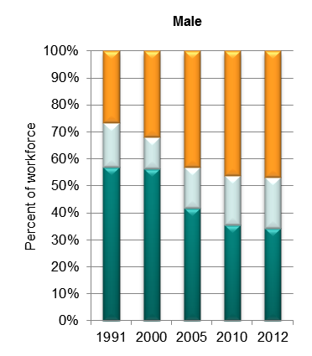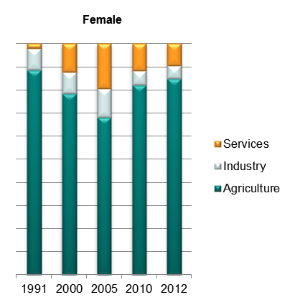

Source: ILO Global Employment Trends 2014 (<http://www.ilo.org/global/research/global-reports/global-employment-trends/2014/WCMS_234879/lang--en/index.htm>).

1. Broad sectoral employment by sex, Bangladesh (ILO GET data)

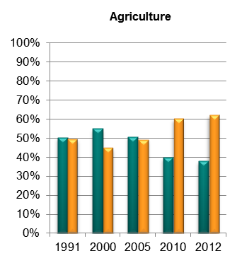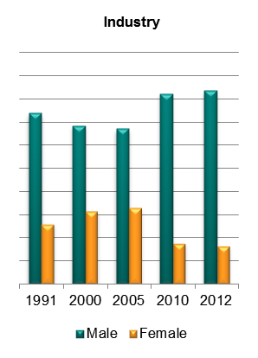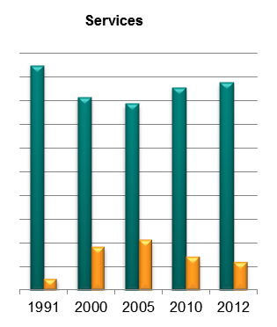

Source: Authors’ calculations using data from the ILO’s Global Employment Trends 2014 (<http://www.ilo.org/global/research/global-reports/global-employment-trends/2014/WCMS_234879/lang--en/index.htm>).

1. Sectoral employment by sex, Bangladesh (ILO WESO data) NEW

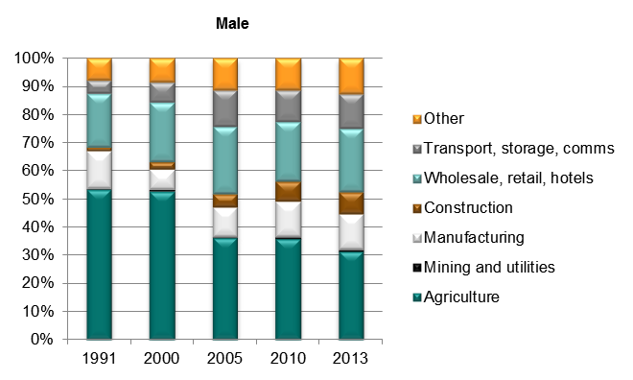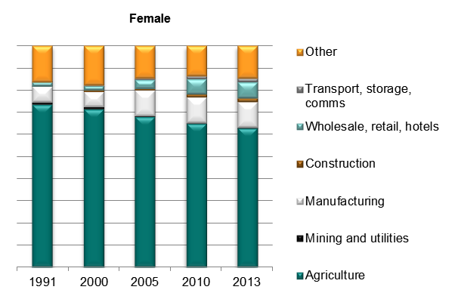

*Source: ILO World Employment and Social Outlook (WESO) – Trends 2015 supporting dataset ‘employment by sector and sex’ (*[*http://www.ilo.org/global/research/global-reports/weso/2015/lang--en/index.htm*](http://www.ilo.org/global/research/global-reports/weso/2015/lang--en/index.htm)*).*

# Trade

## Basic data

1. Total value of trade, Bangladesh, 2005–11

Source: UN COMTRADE database.

1. Exports by broad HS Section, Bangladesh, 2005–8 and 2009–11

|  |  |
| --- | --- |
| Key: |  |
| HS Sect. | Description |
| 1 | Live animals; animal products |
| 2 | Vegetable products |
| 3 | Animal or vegetable fats and oils and their cleavage products; prepared edible fats; animal or vegetable waxes |
| 4 | Prepared foodstuffs; beverages, spirits and vinegar; tobacco and manufactured tobacco substitutes |
| 5 | Mineral products |
| 6 | Products of the chemical or allied industries |
| 7 | Plastics and articles thereof; rubber and articles thereof |
| 8 | Raw hides and skins, leather, furskins and articles thereof; saddlery and harness; travel goods, handbags and similar containers; articles of animal gut (other than silk-worm gut) |
| 9 | Wood and articles of wood; wood charcoal; cork and articles of cork; manufactures of straw, of esparto or of other plaiting materials; basketware and wickerwork |
| 10 | Pulp of wood or of other fibrous cellulosic material; recovered (waste and scrap) paper or paperboard; paper and paperboard and articles thereof |
| 11 | Textiles and textile articles |
| 12 | Footwear, headgear, umbrellas, sun umbrellas, walking-sticks, seat-sticks, whips, riding-crops and parts thereof; prepared feathers and articles made therewith; artificial flowers; articles of human hair |
| 13 | Articles of stone, plaster, cement, asbestos, mica or similar materials; ceramic products; glass and glassware |
| 14 | Natural or cultured pearls, precious or semi-precious stones, precious metals, metals clad with precious metal and articles thereof; imitation jewellery; coin thereof; imitation jewellery; coin |
| 15 | Base metals and articles of base metal |
| 16 | Machinery and mechanical appliances; electrical equipment; parts thereof; sound recorders and reproducers, television image and sound recorders and reproducers, and parts and accessories of such articles |
| 17 | Vehicles, aircraft, vessels and associated transport equipment |
| 18 | Optical, photographic, cinematographic, measuring, checking, precision, medical or surgical instruments and apparatus; clocks and watches; musical instruments; parts and accessories thereof |
| 19 | Arms and ammunition; parts and accessories thereof |
| 20 | Miscellaneous manufactured articles |
| 21 | Works of art, collectors’ pieces and antiques |

Note: Bubble sizes and labels relate to the number of HS 6-digit subheads within the Section which were exported  
Source: Authors’ calculation using data from the UN’s COMTRADE database.

1. Change in export share by HS Section, Bangladesh, 2005–8 and 2009–11

|  |  |
| --- | --- |
| Key: |  |
| HS Sect. | Description |
| 1 | Live animals; animal products |
| 2 | Vegetable products |
| 3 | Animal or vegetable fats and oils and their cleavage products; prepared edible fats; animal or vegetable waxes |
| 4 | Prepared foodstuffs; beverages, spirits and vinegar; tobacco and manufactured tobacco substitutes |
| 5 | Mineral products |
| 6 | Products of the chemical or allied industries |
| 7 | Plastics and articles thereof; rubber and articles thereof |
| 8 | Raw hides and skins, leather, furskins and articles thereof; saddlery and harness; travel goods, handbags and similar containers; articles of animal gut (other than silk-worm gut) |
| 9 | Wood and articles of wood; wood charcoal; cork and articles of cork; manufactures of straw, of esparto or of other plaiting materials; basketware and wickerwork |
| 10 | Pulp of wood or of other fibrous cellulosic material; recovered (waste and scrap) paper or paperboard; paper and paperboard and articles thereof |
| 11 | Textiles and textile articles |
| 12 | Footwear, headgear, umbrellas, sun umbrellas, walking-sticks, seat-sticks, whips, riding-crops and parts thereof; prepared feathers and articles made therewith; artificial flowers; articles of human hair |
| 13 | Articles of stone, plaster, cement, asbestos, mica or similar materials; ceramic products; glass and glassware |
| 14 | Natural or cultured pearls, precious or semi-precious stones, precious metals, metals clad with precious metal and articles thereof; imitation jewellery; coin thereof; imitation jewellery; coin |
| 15 | Base metals and articles of base metal |
| 16 | Machinery and mechanical appliances; electrical equipment; parts thereof; sound recorders and reproducers, television image and sound recorders and reproducers, and parts and accessories of such articles |
| 17 | Vehicles, aircraft, vessels and associated transport equipment |
| 18 | Optical, photographic, cinematographic, measuring, checking, precision, medical or surgical instruments and apparatus; clocks and watches; musical instruments; parts and accessories thereof |
| 19 | Arms and ammunition; parts and accessories thereof |
| 20 | Miscellaneous manufactured articles |
| 21 | Works of art, collectors’ pieces and antiques |

Source: Authors’ calculation using data from the UN’s COMTRADE database.

1. Export visualisation, Bangladesh, 2005 and 2012

|  |
| --- |
| **2005** |
|  |
| **2012** |
|  |

Source: ‘The Atlas of Economic Complexity’, Center for International Development at Harvard University (<http://www.atlas.cid.harvard.edu>).

1. Top export products, Bangladesh (average 2009–11)

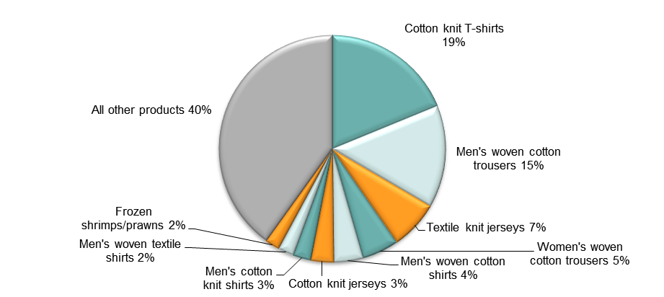

Note: At Harmonised System 6-digit level.  
Source: Authors’ calculations using data from UN COMTRADE database.

1. Top export markets, Bangladesh (average 2009–11)

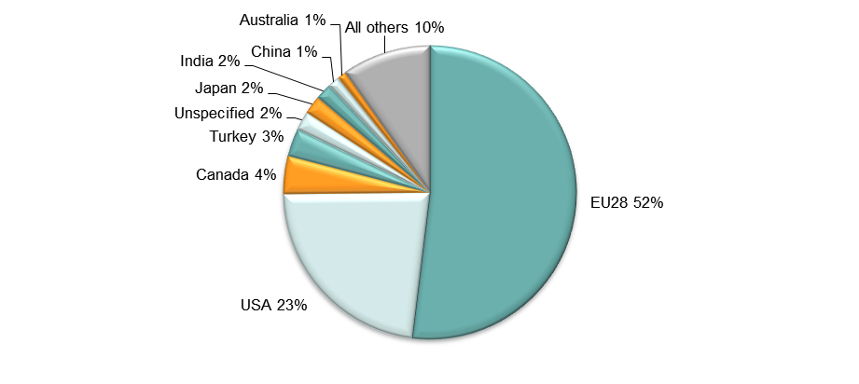

Source: Authors’ calculations using data from UN COMTRADE database.

1. Imports by broad HS Section, Bangladesh, 2005–8 and 2009–11

|  |  |
| --- | --- |
| Key: |  |
| HS Sect. | Description |
| 1 | Live animals; animal products |
| 2 | Vegetable products |
| 3 | Animal or vegetable fats and oils and their cleavage products; prepared edible fats; animal or vegetable waxes |
| 4 | Prepared foodstuffs; beverages, spirits and vinegar; tobacco and manufactured tobacco substitutes |
| 5 | Mineral products |
| 6 | Products of the chemical or allied industries |
| 7 | Plastics and articles thereof; rubber and articles thereof |
| 8 | Raw hides and skins, leather, furskins and articles thereof; saddlery and harness; travel goods, handbags and similar containers; articles of animal gut (other than silk-worm gut) |
| 9 | Wood and articles of wood; wood charcoal; cork and articles of cork; manufactures of straw, of esparto or of other plaiting materials; basketware and wickerwork |
| 10 | Pulp of wood or of other fibrous cellulosic material; recovered (waste and scrap) paper or paperboard; paper and paperboard and articles thereof |
| 11 | Textiles and textile articles |
| 12 | Footwear, headgear, umbrellas, sun umbrellas, walking-sticks, seat-sticks, whips, riding-crops and parts thereof; prepared feathers and articles made therewith; artificial flowers; articles of human hair |
| 13 | Articles of stone, plaster, cement, asbestos, mica or similar materials; ceramic products; glass and glassware |
| 14 | Natural or cultured pearls, precious or semi-precious stones, precious metals, metals clad with precious metal and articles thereof; imitation jewellery; coin thereof; imitation jewellery; coin |
| 15 | Base metals and articles of base metal |
| 16 | Machinery and mechanical appliances; electrical equipment; parts thereof; sound recorders and reproducers, television image and sound recorders and reproducers, and parts and accessories of such articles |
| 17 | Vehicles, aircraft, vessels and associated transport equipment |
| 18 | Optical, photographic, cinematographic, measuring, checking, precision, medical or surgical instruments and apparatus; clocks and watches; musical instruments; parts and accessories thereof |
| 19 | Arms and ammunition; parts and accessories thereof |
| 20 | Miscellaneous manufactured articles |
| 21 | Works of art, collectors’ pieces and antiques |

Note: Bubble sizes and labels relate to the number of HS 6-digit subheads within the Section which were imported  
Source: Authors’ calculation using data from the UN’s COMTRADE database.

1. Change in import share by HS Section, Bangladesh, 2005–8 and 2009–11

|  |  |
| --- | --- |
| Key: |  |
| HS Sect. | Description |
| 1 | Live animals; animal products |
| 2 | Vegetable products |
| 3 | Animal or vegetable fats and oils and their cleavage products; prepared edible fats; animal or vegetable waxes |
| 4 | Prepared foodstuffs; beverages, spirits and vinegar; tobacco and manufactured tobacco substitutes |
| 5 | Mineral products |
| 6 | Products of the chemical or allied industries |
| 7 | Plastics and articles thereof; rubber and articles thereof |
| 8 | Raw hides and skins, leather, furskins and articles thereof; saddlery and harness; travel goods, handbags and similar containers; articles of animal gut (other than silk-worm gut) |
| 9 | Wood and articles of wood; wood charcoal; cork and articles of cork; manufactures of straw, of esparto or of other plaiting materials; basketware and wickerwork |
| 10 | Pulp of wood or of other fibrous cellulosic material; recovered (waste and scrap) paper or paperboard; paper and paperboard and articles thereof |
| 11 | Textiles and textile articles |
| 12 | Footwear, headgear, umbrellas, sun umbrellas, walking-sticks, seat-sticks, whips, riding-crops and parts thereof; prepared feathers and articles made therewith; artificial flowers; articles of human hair |
| 13 | Articles of stone, plaster, cement, asbestos, mica or similar materials; ceramic products; glass and glassware |
| 14 | Natural or cultured pearls, precious or semi-precious stones, precious metals, metals clad with precious metal and articles thereof; imitation jewellery; coin thereof; imitation jewellery; coin |
| 15 | Base metals and articles of base metal |
| 16 | Machinery and mechanical appliances; electrical equipment; parts thereof; sound recorders and reproducers, television image and sound recorders and reproducers, and parts and accessories of such articles |
| 17 | Vehicles, aircraft, vessels and associated transport equipment |
| 18 | Optical, photographic, cinematographic, measuring, checking, precision, medical or surgical instruments and apparatus; clocks and watches; musical instruments; parts and accessories thereof |
| 19 | Arms and ammunition; parts and accessories thereof |
| 20 | Miscellaneous manufactured articles |
| 21 | Works of art, collectors’ pieces and antiques |

Source: Authors’ calculation using data from the UN’s COMTRADE database.

1. Import visualisation, Bangladesh, 2005 and 2012

|  |
| --- |
| **2005** |
|  |
| **2012** |
|  |

Source: ‘The Atlas of Economic Complexity’, Center for International Development at Harvard University (<http://www.atlas.cid.harvard.edu>).

1. Top import products, Bangladesh (average 2009–11)

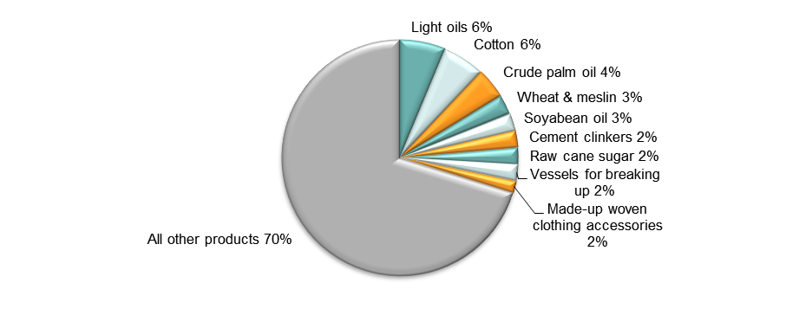

Note: At Harmonised System 6-digit level.  
Source: Authors’ calculations using data from UN COMTRADE database.

1. Top import sources, Bangladesh (average 2009–11)

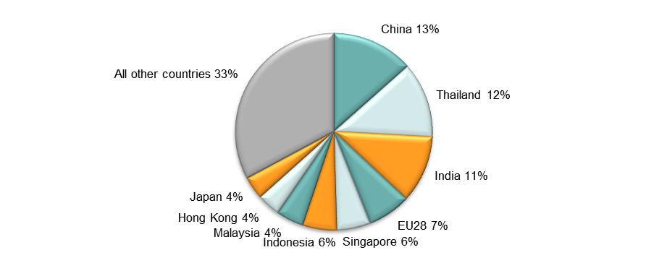

Source: Authors’ calculations using data from UN COMTRADE database.

## Diversification

1. Export diversification index, Bangladesh, 1975–2010

Notes:  
Higher values reflect lower diversification.  
**Extensive export diversification** reflects an increase in the number of export products or trading partners.  
**Intensive export diversification** considers the shares of export volumes across active products or trading partners. Thus, a country is less diversified when export revenues are driven by only a few sectors or trading partners, even though the country might be exporting many different goods or to many different trading partners. Countries with a more evenly balanced mix of exports or trading partners have a higher level of intensive diversification.  
Source: DFID–IMF Diversification Toolkit (<http://www.imf.org/external/np/res/dfidimf/diversification.htm>): Export Diversification Database.

1. Export quality index, Bangladesh, 1975–2010

Source: DFID–IMF Diversification Toolkit (<http://www.imf.org/external/np/res/dfidimf/diversification.htm>): Export Quality Database.

1. Number of export items and markets, Bangladesh, 2005–11

Note: EU countries counted individually.  
Source: Authors’ calculation using data from the UN’s COMTRADE database.

1. Number of import items and suppliers, Bangladesh, 2005–11

Note: EU countries counted individually.  
Source: Authors’ calculation using data from the UN’s COMTRADE database.

## Revealed comparative advantage

1. Revealed comparative advantage by HS Section, Bangladesh

|  |  |  |  |  |  |  |  |  |
| --- | --- | --- | --- | --- | --- | --- | --- | --- |
| **HS Section** | **Product label** | **2005** | **2006** | **2007** | **2008** | **2009** | **2010** | **2011** |
|  | **Total in HS 1-97** | **1.00** | **1.00** | **1.00** | **1.00** | **1.00** | **1.00** | **1.00** |
| 1 | Live animals; animal products | 2.29 | 2.64 | 2.96 | 2.02 | 1.22 | 1.44 | 1.35 |
| 2 | Vegetable products | 0.82 | 0.65 | 0.52 | 0.41 | 0.27 | 0.31 | 0.31 |
| 3 | Animal or vegetable fats and oils and their cleavage products; prepared edible fats; animal or vegetable waxes | 0.03 | 0.03 | 0.01 | 0.04 | 0.08 | 0.06 | 0.04 |
| 4 | Prepared foodstuffs; beverages, spirits and vinegar; tobacco and manufactured tobacco substitutes | 0.14 | 0.11 | 0.15 | 0.16 | 0.17 | 0.20 | 0.19 |
| 5 | Mineral products | 0.04 | 0.05 | 0.11 | 0.08 | 0.11 | 0.12 | 0.07 |
| 6 | Products of the chemical or allied industries | 0.20 | 0.13 | 0.14 | 0.14 | 0.08 | 0.05 | 0.05 |
| 7 | Plastics and articles thereof; rubber and articles thereof | 0.12 | 0.08 | 0.09 | 0.10 | 0.08 | 0.08 | 0.09 |
| 8 | Raw hides and skins, leather, furskins and articles thereof; saddlery and harness; travel goods, handbags and similar containers; articles of animal gut (other than silk-worm gut) | 4.18 | 3.77 | 4.06 | 3.14 | 2.29 | 2.71 | 2.72 |
| 9 | Wood and articles of wood; wood charcoal; cork and articles of cork; manufactures of straw, of esparto or of other plaiting materials; basketware and wickerwork | 0.04 | 0.04 | 0.05 | 0.05 | 0.04 | 0.04 | 0.03 |
| 10 | Pulp of wood or of other fibrous cellulosic material; recovered (waste and scrap) paper or paperboard; paper and paperboard and articles thereof | 0.15 | 0.13 | 0.27 | 0.18 | 0.09 | 0.07 | 0.07 |
| 11 | Textiles and textile articles | 16.64 | 18.19 | 17.81 | 20.75 | 18.94 | 20.03 | 20.36 |
| 12 | Footwear, headgear, umbrellas, sun umbrellas, walking-sticks, seat-sticks, whips, riding-crops and parts thereof; prepared feathers and articles made therewith; artificial flowers; articles of human hair | 2.39 | 2.12 | 2.31 | 2.62 | 1.95 | 2.09 | 2.17 |
| 13 | Articles of stone, plaster, cement, asbestos, mica or similar materials; ceramic products; glass and glassware | 0.29 | 0.22 | 0.29 | 0.27 | 0.19 | 0.17 | 0.15 |
| 14 | Natural or cultured pearls, precious or semi-precious stones, precious metals, metals clad with precious metal and articles thereof; imitation jewellery; coin thereof; imitation jewellery; coin | 0.00 | 0.00 | 0.00 | 0.00 | 0.00 | 0.00 | 0.00 |
| 15 | Base metals and articles of base metal | 0.10 | 0.08 | 0.10 | 0.06 | 0.08 | 0.09 | 0.07 |
| 16 | Machinery and mechanical appliances; electrical equipment; parts thereof; sound recorders and reproducers, television image and sound recorders and reproducers, and parts and accessories of such articles | 0.02 | 0.02 | 0.07 | 0.03 | 0.01 | 0.02 | 0.02 |
| 17 | Vehicles, aircraft, vessels and associated transport equipment | 0.11 | 0.09 | 0.06 | 0.07 | 0.12 | 0.09 | 0.07 |
| 18 | Optical, photographic, cinematographic, measuring, checking, precision, medical or surgical instruments and apparatus; clocks and watches; musical instruments; parts and accessories thereof | 0.06 | 0.05 | 0.06 | 0.04 | 0.02 | 0.04 | 0.04 |
| 19 | Arms and ammunition; parts and accessories thereof | 0.01 | 0.00 | 0.00 | 0.06 | 0.01 | 0.01 | 0.14 |
| 20 | Miscellaneous manufactured articles | 0.11 | 0.10 | 0.12 | 0.10 | 0.10 | 0.11 | 0.10 |
| 21 | Works of art, collectors’ pieces and antiques | 0.01 | 0.01 | 0.32 | 0.01 | 0.01 | 0.01 | 0.01 |

Note: Share of country’s exports in each HS Section in country’s total exports as a ratio of share of world exports in each HS Section in world total exports. ‘World’ = UN COMTRADE’s ‘all countries’ aggregate, i.e. total of however many countries have reported their data in any given year.   
Source: Authors’ calculations using data from the UN’s COMTRADE database.

## Trade in value added

1. Compound annual growth rate of domestic value added, foreign value added and exports, 1996-2011 and 2006-11, Bangladesh

Source: Own computations using Eora26 database

1. Domestic and foreign value added content of gross exports as share of gross exports, 1996, 2000, 2006 and 2011, Bangladesh

Source: Own computations using Eora26 database

1. Overall value of domestic and foreign value added, 1996, 2000, 2006 and 2011 (in USD 1,000), Bangladesh

Source: Own computations using Eora26 database

1. Compound annual growth rate of DVA embodied in gross exports by sector, 1996-2011 and 2006-2011, Bangladesh

Source: Own computations using Eora26 database

1. Sectoral DVA embodied in exports as a share of sectoral gross exports, 2000 and 2011, Bangladesh

Source: Own computations using Eora26 database

1. Sectoral DVA as a share of total DVA, 2000 and 2011, Bangladesh

Source: Own computations using Eora26 database

1. Compound annual growth rate of FVA embodied in gross exports by sector, 1996-2011 and 2006-2011, Bangladesh

Source: Own computations using Eora26 database

1. Sectoral FVA embodied in exports as a share of sectoral gross exports, 2000 and 2011, Bangladesh

Source: Own computations using Eora26 database

1. Sectoral FVA as a share of total FVA, 2000 and 2011, Bangladesh

Source: Own computations using Eora26 database

## Trade in services

1. Exports of goods and services, Bangladesh

Source: Authors’ calculation using data from the World Bank’s World Development Indicators.

1. Sectoral shares of services exports, Bangladesh

Source: Authors’ calculation using data from the World Bank’s World Development Indicators.

# Estimates of total factor productivity at firm level

1. Dispersion in productivity across firms by sector – Bangladesh



Source: Authors’ calculations using data from World Bank Enterprise Surveys (<http://www.enterprisesurveys.org/>).

1. Distribution in productivity in Bangladesh – comparing kernel and normal distributions



Source: Authors’ calculations using data from World Bank Enterprise Surveys (<http://www.enterprisesurveys.org/>).