**DR Congo:  
Data on economic transformation**

Economic structures 3

Table 1. Value added (% of GDP), DR Congo 3

Table 2. GDP, employment and relative productivity levels, DR Congo, 1975–2013 NEW 4

Table 3. Labour productivity levels and changes, DR Congo, 1991–2013 NEW 4

Figure 1. Relative productivity and changes in employment shares by sector,   
DR Congo NEW 6

Figure 2. Decomposition of labour productivity change, DR Congo, 1991–2013 NEW 7

Figure 3. Productivity gaps in DR Congo, 2013 NEW 8

Figure 4. Total employment by sex and broad sector, DR Congo (ILO GET data) 9

Figure 5. Broad sectoral employment by sex, DR Congo (ILO GET data) 9

Figure 6. Sectoral employment by sex, DR Congo (ILO WESO data) NEW 10

Trade 11

Basic data 11

Figure 7. Total value of trade, DR Congo, 2005–13 (mirror data) 11

Figure 8. Exports by broad HS Section, DR Congo, 2005–8 and 2009–13 (mirror data) 12

Figure 9. Change in export share by HS Section, DR Congo, 2005–8 and 2009–13 (mirror data) 13

Figure 10. Export visualisation, DR Congo, 2005 and 2012 14

Figure 11. Top export products, DR Congo (average 2011–13, mirror data) 15

Figure 12. Top export markets, DR Congo (average 2011–13, mirror data) 15

Figure 13. Imports by broad HS Section, DR Congo, 2005–8 and 2009–13 (mirror data) 16

Figure 14. Change in import share by HS Section, DR Congo, 2005–8 and 2009–13 (mirror data) 17

Figure 15. Import visualisation, DR Congo, 2005 and 2012 18

Figure 16. Top import products, DR Congo (average 2011–13, mirror data) 19

Figure 17. Top import sources, DR Congo (average 2011–13, mirror data) 19

Diversification 20

Figure 18. Export diversification index, DR Congo, 1965–2010 20

Figure 19. Export quality index, DR Congo, 1965–2010 20

Figure 20. Number of export items and markets, DR Congo, 2005–13 (mirror data) 21

Figure 21. Number of import items and suppliers, DR Congo, 2005–13 (mirror data) 21

Revealed comparative advantage 22

Table 4. Revealed comparative advantage by HS Section, DR Congo (mirror data) 22

Trade in value added 23

Figure 22. Compound annual growth rate of domestic value added, foreign value added and exports, 1996-2011 and 2006-11, DR Congo 23

Figure 23. Domestic and foreign value added content of gross exports as share of gross exports, 1996, 2000, 2006 and 2011, DR Congo 23

Figure 24. Overall value of domestic and foreign value added, 1996, 2000, 2006 and 2011 (in USD 1,000), DR Congo 23

Figure 25. Compound annual growth rate of DVA embodied in gross exports by sector, 1996-2011 and 2006-2011, DR Congo 24

Figure 26. Sectoral DVA embodied in exports as a share of sectoral gross exports, 2000 and 2011, DR Congo 24

Figure 27. Sectoral DVA as a share of total DVA, 2000 and 2011, DR Congo 25

Figure 28. Compound annual growth rate of FVA embodied in gross exports by sector, 1996-2011 and 2006-2011, DR Congo 26

Figure 29. Sectoral FVA embodied in exports as a share of sectoral gross exports, 2000 and 2011, DR Congo 26

Figure 30. Sectoral FVA as a share of total FVA, 2000 and 2011, DR Congo 27

Trade in services 28

Figure 31. Exports of goods and services, DR Congo 28

Figure 32. Sectoral shares of services exports, DR Congo 28

Estimates of total factor productivity at firm level 29

Figure 33. Dispersion in productivity across firms by sector – DR Congo 29

Figure 34. Distribution in productivity in DR Congo – comparing kernel and normal distributions 30

# Economic structures

1. Value added (% of GDP), DR Congo

|  |  |  |  |  |  |  |  |
| --- | --- | --- | --- | --- | --- | --- | --- |
|  | **1991** | **2000** | | **2005** | | **2009** | |
| Agriculture a | 41.7 | | 32.3 | | 22.4 | | 25.2 | |
| Industry b | 17.6 | | 22.7 | | 33.0 | | 35.1 | |
| *Of which: Manufacturing* | *7.4* | | *10.0* | | *20.0* | | *25.1* | |
| Services c | 40.8 | | 45.0 | | 44.6 | | 39.7 | |
| **Total** | **100.0** | | **100.0** | | **100.0** | | **100.0** | |

Notes:  
(a) Agriculture corresponds to ISIC divisions 1-5 and includes forestry, hunting, and fishing, as well as cultivation of crops and livestock production.   
(b) Industry corresponds to ISIC divisions 10-45 and includes manufacturing (ISIC divisions 15-37). It comprises value added in mining, manufacturing (also reported as a separate subgroup), construction, electricity, water, and gas.  
(c) Services correspond to ISIC divisions 50-99 and they include value added in wholesale and retail trade (including hotels and restaurants), transport, and government, financial, professional, and personal services such as education, health care, and real estate services. Also included are imputed bank service charges, import duties, and any statistical discrepancies noted by national compilers as well as discrepancies arising from rescaling.  
Source: World Bank, World Development Indicators (<http://databank.worldbank.org/data/views/variableSelection/selectvariables.aspx?source=world-development-indicators>).

1. GDP, employment and relative productivity levels, DR Congo, 1975–2013 NEW

|  |  |  |  |  |  |  |  |  |  |  |  |  |  |  |  |  |  |  |
| --- | --- | --- | --- | --- | --- | --- | --- | --- | --- | --- | --- | --- | --- | --- | --- | --- | --- | --- |
| **Economic activity** | **Gross value added (current US$, %)** | | | | | | **Employment by sector (%)** | | | | | | **Relative productivity levels a** | | | | | |
|  | *1975* | *1991* | *2000* | *2005* | *2010* | *2013* | *1975* | *1991* | *2000* | *2005* | *2010* | *2013* | *1975* | *1991* | *2000* | *2005* | *2010* | *2013* |
| Agriculture | 18.8 | 41.7 | 32.3 | 22.3 | 22.4 | 20.8 | n/a | 76.2 | 77.3 | 74.9 | 72.9 | 71.9 | n/a | 0.2 | 0.4 | 0.3 | 0.3 | 0.3 |
| Mining & utilities | 12.5 | 7.5 | 9.7 | 9.0 | 19.3 | 22.7 | n/a | 0.7 | 0.8 | 0.8 | 0.8 | 0.8 | n/a | 9.3 | 10.7 | 11.6 | 27.2 | 30.8 |
| Manufacturing | 12.5 | 7.4 | 10.0 | 19.9 | 17.0 | 16.6 | n/a | 2.7 | 3.8 | 5.6 | 7.0 | 7.2 | n/a | 11.8 | 5.9 | 3.6 | 1.7 | 1.5 |
| Construction | 6.3 | 2.6 | 2.9 | 3.9 | 4.2 | 5.2 | n/a | 1.9 | 1.5 | 1.8 | 2.1 | 2.3 | n/a | 0.9 | 1.4 | 2.1 | 1.6 | 1.9 |
| Wholesale and retail | 18.8 | 16.1 | 17.6 | 14.1 | 11.1 | 11.1 | n/a | 2.0 | 1.9 | 1.9 | 2.0 | 2.0 | n/a | 7.4 | 7.1 | 7.3 | 7.7 | 7.5 |
| Transport, storage, comms | 6.3 | 15.6 | 18.4 | 14.3 | 11.2 | 10.7 | n/a | 0.5 | 0.4 | 0.4 | 0.5 | 0.5 | n/a | 22.3 | 22.3 | 33.5 | 30.1 | 27.1 |
| Other (inc. restaurants/hotels) | 25.0 | 9.0 | 9.1 | 16.5 | 14.7 | 13.0 | n/a | 16.0 | 14.3 | 14.5 | 14.8 | 15.2 | n/a | 1.1 | 1.2 | 1.1 | 1.0 | 0.9 |
| **Total** | **100** | **100** | **100** | **100** | **100** | **100** | **n/a** | **100** | **100** | **100** | **100** | **100** | **n/a** | **1.0** | **1.0** | **1.0** | **1.0** | **1.0** |

Notes:  
(a) Derived by calculating labour productivity levels (gross value added at constant prices divided by number of persons employed per sector) and expressing the result as a ratio of total economy labour productivity.  
Numbers may not sum due to rounding.  
Source: Authors’ calculations using UNSD National Accounts Main Aggregates data on ‘gross value added by kind of economic activity’ (<https://data.un.org/search.aspx?q=gross+value+added+datamart%5bsnaama%5d>) and ILO World Employment and Social Outlook (WESO) – Trends 2015 supporting dataset ‘employment by sector and sex’ (<http://www.ilo.org/global/research/global-reports/weso/2015/lang--en/index.htm>). NB: in the gross value added data for DR Congo, ‘restaurants and hotels’ are included under ‘other’ activities rather than with ‘wholesale and retail’; this was taken into account when aggregating the employment data.

1. Labour productivity levels and changes, DR Congo, 1991–2013 NEW

|  |  |  |  |  |  |  |  |  |  |  |
| --- | --- | --- | --- | --- | --- | --- | --- | --- | --- | --- |
| **Economic activity** | **Labour productivity (index, 1991=100)** | | | | | **Annualised growth in labour productivity** | | | | |
|  | *1991* | *2000* | *2005* | *2010* | *2013* | *1991-2013* | *1991-2000* | *2000-05* | *2005-10* | *2010-13* |
| Agriculture | 100 | 78.5 | 68.6 | 71.9 | 74.2 | -1.3% | -2.7% | -2.6% | 0.9% | 1.1% |
| Mining & utilities | 100 | 55.5 | 61.8 | 165.2 | 211.0 | 3.5% | -6.3% | 2.2% | 21.7% | 8.5% |
| Manufacturing | 100 | 24.1 | 15.0 | 7.9 | 8.2 | -10.7% | -14.6% | -9.0% | -12.0% | 1.3% |
| Construction | 100 | 75.8 | 120.2 | 104.8 | 135.1 | 1.4% | -3.0% | 9.7% | -2.7% | 8.9% |
| Wholesale and retail | 100 | 46.5 | 48.9 | 59.2 | 64.4 | -2.0% | -8.2% | 1.0% | 3.9% | 2.9% |
| Transport, storage, comms | 100 | 48.6 | 74.9 | 76.5 | 77.7 | -1.1% | -7.7% | 9.0% | 0.4% | 0.5% |
| Other (inc. restaurants/hotels) | 100 | 52.8 | 50.0 | 50.3 | 49.2 | -3.2% | -6.9% | -1.1% | 0.1% | -0.7% |
| **Total** | **100** | **48.5** | **49.9** | **56.7** | **63.9** | **-2.0%** | **-7.7%** | **0.6%** | **2.6%** | **4.1%** |

Note: Derived by calculating labour productivity levels (gross value added at constant 2005 prices divided by number of persons engaged) and expressing the results as an index related to 1991 levels.  
Source: Authors’ calculations using UNSD National Accounts Main Aggregates data on ‘gross value added by kind of economic activity’ (<https://data.un.org/search.aspx?q=gross+value+added+datamart%5bsnaama%5d>) and ILO World Employment and Social Outlook (WESO) – Trends 2015 supporting dataset ‘employment by sector and sex’ (<http://www.ilo.org/global/research/global-reports/weso/2015/lang--en/index.htm>). NB: in the gross value added data for DR Congo, ‘restaurants and hotels’ are included under ‘other’ activities rather than with ‘wholesale and retail’; this was taken into account when aggregating the employment data.

1. Relative productivity and changes in employment shares by sector, DR Congo NEW

Note: Size of bubbles represents number of persons employed in each sector in the later year of each period.  
Source: Authors’ calculations using UNSD National Accounts Main Aggregates data on ‘gross value added by kind of economic activity’ (<https://data.un.org/search.aspx?q=gross+value+added+datamart%5bsnaama%5d>) and ILO World Employment and Social Outlook (WESO) – Trends 2015 supporting dataset ‘employment by sector and sex’ (<http://www.ilo.org/global/research/global-reports/weso/2015/lang--en/index.htm>). NB: in the gross value added data for DR Congo, ‘restaurants and hotels’ are included under ‘other’ activities rather than with ‘wholesale and retail’; this was taken into account when aggregating the employment data.

1. Decomposition of labour productivity change, DR Congo, 1991–2013 NEW

Source: Authors’ calculations using UNSD National Accounts Main Aggregates data on ‘gross value added by kind of economic activity’ (<https://data.un.org/search.aspx?q=gross+value+added+datamart%5bsnaama%5d>) and ILO World Employment and Social Outlook (WESO) – Trends 2015 supporting dataset ‘employment by sector and sex’ (<http://www.ilo.org/global/research/global-reports/weso/2015/lang--en/index.htm>). NB: in the gross value added data for DR Congo, ‘restaurants and hotels’ are included under ‘other’ activities rather than with ‘wholesale and retail’; this was taken into account when aggregating the employment data.

1. Productivity gaps in DR Congo, 2013 NEW

Source: Authors’ calculations using UNSD National Accounts Main Aggregates data on ‘gross value added by kind of economic activity’ (<https://data.un.org/search.aspx?q=gross+value+added+datamart%5bsnaama%5d>) and ILO World Employment and Social Outlook (WESO) – Trends 2015 supporting dataset ‘employment by sector and sex’ (<http://www.ilo.org/global/research/global-reports/weso/2015/lang--en/index.htm>). NB: in the gross value added data for DR Congo, ‘restaurants and hotels’ are included under ‘other’ activities rather than with ‘wholesale and retail’; this was taken into account when aggregating the employment data.

1. Total employment by sex and broad sector, DR Congo (ILO GET data)

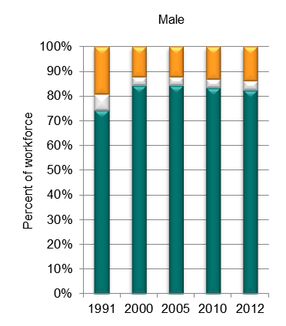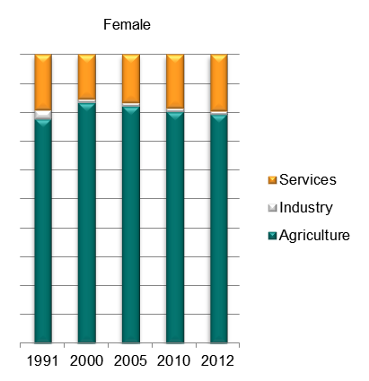

Source: ILO Global Employment Trends 2014 (<http://www.ilo.org/global/research/global-reports/global-employment-trends/2014/WCMS_234879/lang--en/index.htm>).

1. Broad sectoral employment by sex, DR Congo (ILO GET data)

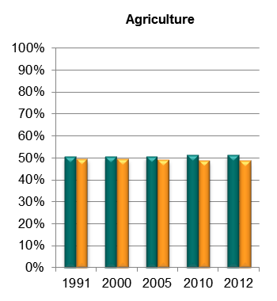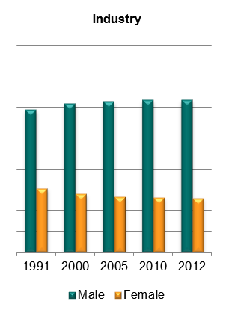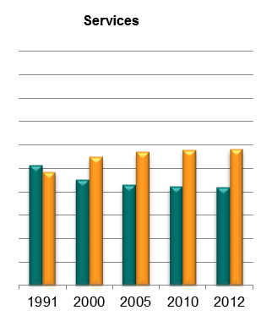

Source: Authors’ calculations using data from the ILO’s Global Employment Trends 2014 (<http://www.ilo.org/global/research/global-reports/global-employment-trends/2014/WCMS_234879/lang--en/index.htm>).

1. Sectoral employment by sex, DR Congo (ILO WESO data) NEW

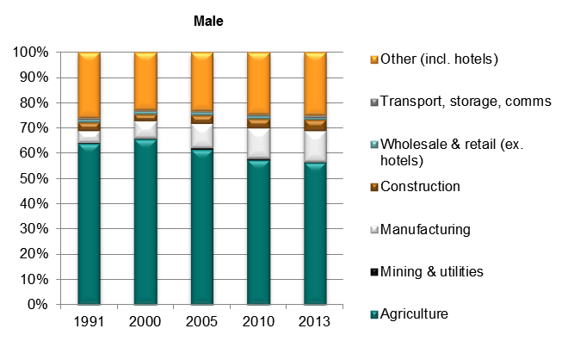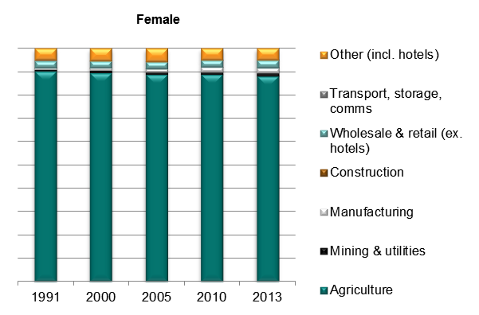

*Source: ILO World Employment and Social Outlook (WESO) – Trends 2015 supporting dataset ‘employment by sector and sex’ (*[*http://www.ilo.org/global/research/global-reports/weso/2015/lang--en/index.htm*](http://www.ilo.org/global/research/global-reports/weso/2015/lang--en/index.htm)*).*

# Trade

## Basic data

1. Total value of trade, DR Congo, 2005–13 (mirror data)

Source: ITC Trade Map. Note the use of mirror data, which is indicative only and should be treated with caution. In particular, the total number of reporters may vary from year to year.

1. Exports by broad HS Section, DR Congo, 2005–8 and 2009–13 (mirror data)

|  |  |
| --- | --- |
| Key: |  |
| HS Sect. | Description |
| 1 | Live animals; animal products |
| 2 | Vegetable products |
| 3 | Animal or vegetable fats and oils and their cleavage products; prepared edible fats; animal or vegetable waxes |
| 4 | Prepared foodstuffs; beverages, spirits and vinegar; tobacco and manufactured tobacco substitutes |
| 5 | Mineral products |
| 6 | Products of the chemical or allied industries |
| 7 | Plastics and articles thereof; rubber and articles thereof |
| 8 | Raw hides and skins, leather, furskins and articles thereof; saddlery and harness; travel goods, handbags and similar containers; articles of animal gut (other than silk-worm gut) |
| 9 | Wood and articles of wood; wood charcoal; cork and articles of cork; manufactures of straw, of esparto or of other plaiting materials; basketware and wickerwork |
| 10 | Pulp of wood or of other fibrous cellulosic material; recovered (waste and scrap) paper or paperboard; paper and paperboard and articles thereof |
| 11 | Textiles and textile articles |
| 12 | Footwear, headgear, umbrellas, sun umbrellas, walking-sticks, seat-sticks, whips, riding-crops and parts thereof; prepared feathers and articles made therewith; artificial flowers; articles of human hair |
| 13 | Articles of stone, plaster, cement, asbestos, mica or similar materials; ceramic products; glass and glassware |
| 14 | Natural or cultured pearls, precious or semi-precious stones, precious metals, metals clad with precious metal and articles thereof; imitation jewellery; coin thereof; imitation jewellery; coin |
| 15 | Base metals and articles of base metal |
| 16 | Machinery and mechanical appliances; electrical equipment; parts thereof; sound recorders and reproducers, television image and sound recorders and reproducers, and parts and accessories of such articles |
| 17 | Vehicles, aircraft, vessels and associated transport equipment |
| 18 | Optical, photographic, cinematographic, measuring, checking, precision, medical or surgical instruments and apparatus; clocks and watches; musical instruments; parts and accessories thereof |
| 19 | Arms and ammunition; parts and accessories thereof |
| 20 | Miscellaneous manufactured articles |
| 21 | Works of art, collectors’ pieces and antiques |

Note: Bubble sizes and labels relate to the number of HS 6-digit subheads within the Section which were exported  
Source: Authors’ calculation using data from ITC’s Trade Map. Note the use of mirror data, which is indicative only and should be treated with caution.

1. Change in export share by HS Section, DR Congo, 2005–8 and 2009–13 (mirror data)

|  |  |
| --- | --- |
| Key: |  |
| HS Sect. | Description |
| 1 | Live animals; animal products |
| 2 | Vegetable products |
| 3 | Animal or vegetable fats and oils and their cleavage products; prepared edible fats; animal or vegetable waxes |
| 4 | Prepared foodstuffs; beverages, spirits and vinegar; tobacco and manufactured tobacco substitutes |
| 5 | Mineral products |
| 6 | Products of the chemical or allied industries |
| 7 | Plastics and articles thereof; rubber and articles thereof |
| 8 | Raw hides and skins, leather, furskins and articles thereof; saddlery and harness; travel goods, handbags and similar containers; articles of animal gut (other than silk-worm gut) |
| 9 | Wood and articles of wood; wood charcoal; cork and articles of cork; manufactures of straw, of esparto or of other plaiting materials; basketware and wickerwork |
| 10 | Pulp of wood or of other fibrous cellulosic material; recovered (waste and scrap) paper or paperboard; paper and paperboard and articles thereof |
| 11 | Textiles and textile articles |
| 12 | Footwear, headgear, umbrellas, sun umbrellas, walking-sticks, seat-sticks, whips, riding-crops and parts thereof; prepared feathers and articles made therewith; artificial flowers; articles of human hair |
| 13 | Articles of stone, plaster, cement, asbestos, mica or similar materials; ceramic products; glass and glassware |
| 14 | Natural or cultured pearls, precious or semi-precious stones, precious metals, metals clad with precious metal and articles thereof; imitation jewellery; coin thereof; imitation jewellery; coin |
| 15 | Base metals and articles of base metal |
| 16 | Machinery and mechanical appliances; electrical equipment; parts thereof; sound recorders and reproducers, television image and sound recorders and reproducers, and parts and accessories of such articles |
| 17 | Vehicles, aircraft, vessels and associated transport equipment |
| 18 | Optical, photographic, cinematographic, measuring, checking, precision, medical or surgical instruments and apparatus; clocks and watches; musical instruments; parts and accessories thereof |
| 19 | Arms and ammunition; parts and accessories thereof |
| 20 | Miscellaneous manufactured articles |
| 21 | Works of art, collectors’ pieces and antiques |

Source: Authors’ calculation using data from ITC’s Trade Map. Note the use of mirror data, which is indicative only and should be treated with caution.

1. Export visualisation, DR Congo, 2005 and 2012

|  |
| --- |
| **2005** |
|  |
| **2012** |
|  |

Source: MIT Observatory of Economic Complexity (<http://atlas.media.mit.edu/explore/tree_map/hs/export/rwa/all/show/2012/>).

1. Top export products, DR Congo (average 2011–13, mirror data)

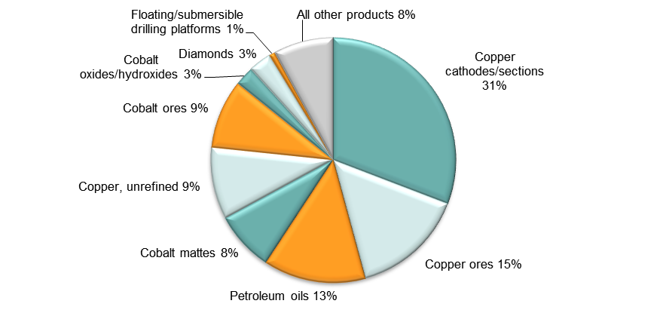

Note: At Harmonised System 6-digit level.  
Source: Authors’ calculations using data from ITC’s Trade Map. Note the use of mirror data, which is indicative only and should be treated with caution.

1. Top export markets, DR Congo (average 2011–13, mirror data)

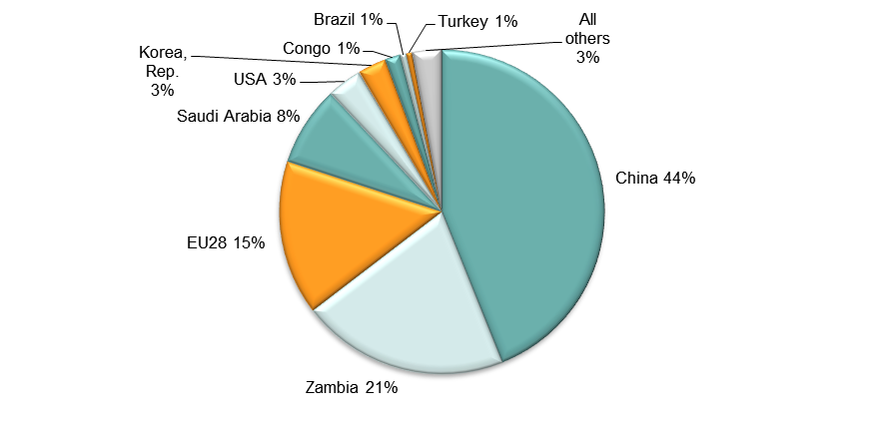

Source: Authors’ calculations using data from ITC’s Trade Map. Note the use of mirror data, which is indicative only and should be treated with caution.

1. Imports by broad HS Section, DR Congo, 2005–8 and 2009–13 (mirror data)

|  |  |
| --- | --- |
| Key: |  |
| HS Sect. | Description |
| 1 | Live animals; animal products |
| 2 | Vegetable products |
| 3 | Animal or vegetable fats and oils and their cleavage products; prepared edible fats; animal or vegetable waxes |
| 4 | Prepared foodstuffs; beverages, spirits and vinegar; tobacco and manufactured tobacco substitutes |
| 5 | Mineral products |
| 6 | Products of the chemical or allied industries |
| 7 | Plastics and articles thereof; rubber and articles thereof |
| 8 | Raw hides and skins, leather, furskins and articles thereof; saddlery and harness; travel goods, handbags and similar containers; articles of animal gut (other than silk-worm gut) |
| 9 | Wood and articles of wood; wood charcoal; cork and articles of cork; manufactures of straw, of esparto or of other plaiting materials; basketware and wickerwork |
| 10 | Pulp of wood or of other fibrous cellulosic material; recovered (waste and scrap) paper or paperboard; paper and paperboard and articles thereof |
| 11 | Textiles and textile articles |
| 12 | Footwear, headgear, umbrellas, sun umbrellas, walking-sticks, seat-sticks, whips, riding-crops and parts thereof; prepared feathers and articles made therewith; artificial flowers; articles of human hair |
| 13 | Articles of stone, plaster, cement, asbestos, mica or similar materials; ceramic products; glass and glassware |
| 14 | Natural or cultured pearls, precious or semi-precious stones, precious metals, metals clad with precious metal and articles thereof; imitation jewellery; coin thereof; imitation jewellery; coin |
| 15 | Base metals and articles of base metal |
| 16 | Machinery and mechanical appliances; electrical equipment; parts thereof; sound recorders and reproducers, television image and sound recorders and reproducers, and parts and accessories of such articles |
| 17 | Vehicles, aircraft, vessels and associated transport equipment |
| 18 | Optical, photographic, cinematographic, measuring, checking, precision, medical or surgical instruments and apparatus; clocks and watches; musical instruments; parts and accessories thereof |
| 19 | Arms and ammunition; parts and accessories thereof |
| 20 | Miscellaneous manufactured articles |
| 21 | Works of art, collectors’ pieces and antiques |

Note: Bubble sizes and labels relate to the number of HS 6-digit subheads within the Section which were imported  
Source: Authors’ calculation using data from ITC’s Trade Map. Note the use of mirror data, which is indicative only and should be treated with caution.

1. Change in import share by HS Section, DR Congo, 2005–8 and 2009–13 (mirror data)

|  |  |
| --- | --- |
| Key: |  |
| HS Sect. | Description |
| 1 | Live animals; animal products |
| 2 | Vegetable products |
| 3 | Animal or vegetable fats and oils and their cleavage products; prepared edible fats; animal or vegetable waxes |
| 4 | Prepared foodstuffs; beverages, spirits and vinegar; tobacco and manufactured tobacco substitutes |
| 5 | Mineral products |
| 6 | Products of the chemical or allied industries |
| 7 | Plastics and articles thereof; rubber and articles thereof |
| 8 | Raw hides and skins, leather, furskins and articles thereof; saddlery and harness; travel goods, handbags and similar containers; articles of animal gut (other than silk-worm gut) |
| 9 | Wood and articles of wood; wood charcoal; cork and articles of cork; manufactures of straw, of esparto or of other plaiting materials; basketware and wickerwork |
| 10 | Pulp of wood or of other fibrous cellulosic material; recovered (waste and scrap) paper or paperboard; paper and paperboard and articles thereof |
| 11 | Textiles and textile articles |
| 12 | Footwear, headgear, umbrellas, sun umbrellas, walking-sticks, seat-sticks, whips, riding-crops and parts thereof; prepared feathers and articles made therewith; artificial flowers; articles of human hair |
| 13 | Articles of stone, plaster, cement, asbestos, mica or similar materials; ceramic products; glass and glassware |
| 14 | Natural or cultured pearls, precious or semi-precious stones, precious metals, metals clad with precious metal and articles thereof; imitation jewellery; coin thereof; imitation jewellery; coin |
| 15 | Base metals and articles of base metal |
| 16 | Machinery and mechanical appliances; electrical equipment; parts thereof; sound recorders and reproducers, television image and sound recorders and reproducers, and parts and accessories of such articles |
| 17 | Vehicles, aircraft, vessels and associated transport equipment |
| 18 | Optical, photographic, cinematographic, measuring, checking, precision, medical or surgical instruments and apparatus; clocks and watches; musical instruments; parts and accessories thereof |
| 19 | Arms and ammunition; parts and accessories thereof |
| 20 | Miscellaneous manufactured articles |
| 21 | Works of art, collectors’ pieces and antiques |

Source: Authors’ calculation using data from ITC’s Trade Map. Note the use of mirror data, which is indicative only and should be treated with caution.

1. Import visualisation, DR Congo, 2005 and 2012

|  |
| --- |
| **2005** |
|  |
| **2012** |
|  |

Source: MIT Observatory of Economic Complexity (<http://atlas.media.mit.edu/explore/tree_map/hs/export/rwa/all/show/2012/>).

1. Top import products, DR Congo (average 2011–13, mirror data)

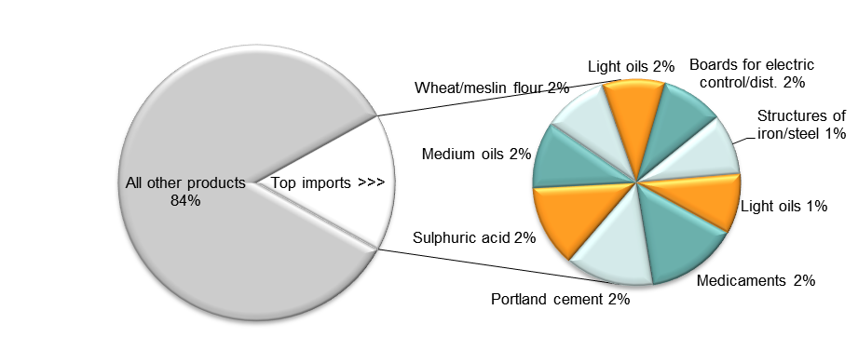

Note: At Harmonised System 6-digit level.  
Source: Authors’ calculations using data from ITC’s Trade Map. Note the use of mirror data, which is indicative only and should be treated with caution.

1. Top import sources, DR Congo (average 2011–13, mirror data)

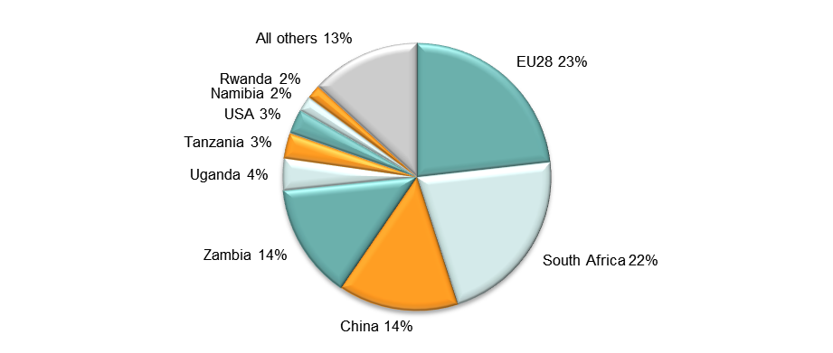

Source: Authors’ calculations using data from ITC’s Trade Map. Note the use of mirror data, which is indicative only and should be treated with caution.

## Diversification

1. Export diversification index, DR Congo, 1965–2010

Notes:  
Higher values reflect lower diversification.  
**Extensive export diversification** reflects an increase in the number of export products or trading partners.  
**Intensive export diversification** considers the shares of export volumes across active products or trading partners. Thus, a country is less diversified when export revenues are driven by only a few sectors or trading partners, even though the country might be exporting many different goods or to many different trading partners. Countries with a more evenly balanced mix of exports or trading partners have a higher level of intensive diversification.  
Source: DFID–IMF Diversification Toolkit (<http://www.imf.org/external/np/res/dfidimf/diversification.htm>): Export Diversification Database.

1. Export quality index, DR Congo, 1965–2010

Source: DFID–IMF Diversification Toolkit (<http://www.imf.org/external/np/res/dfidimf/diversification.htm>): Export Quality Database.

1. Number of export items and markets, DR Congo, 2005–13 (mirror data)

Note: EU countries counted individually.  
Source: Authors’ calculation using data from ITC’s Trade Map. Note the use of mirror data, which is indicative only and should be treated with caution. In particular, as countries report their data in different versions of the Harmonised System, virtually identical products may have had different codes during the period covered in the graph, and thus be duplicated in the subhead count plotted above.

1. Number of import items and suppliers, DR Congo, 2005–13 (mirror data)

Note: EU countries counted individually.  
Source: Authors’ calculation using data from ITC’s Trade Map. In particular, as countries report their data in different versions of the Harmonised System, virtually identical products may have had different codes during the period covered in the graph, and thus be duplicated in the subhead count plotted above.

## Revealed comparative advantage

1. Revealed comparative advantage by HS Section, DR Congo (mirror data)

|  |  |  |  |  |  |  |  |  |  |  |
| --- | --- | --- | --- | --- | --- | --- | --- | --- | --- | --- |
| **HS Sect.** | **Product label** | **2005** | **2006** | **2007** | **2008** | **2009** | **2010** | **2011** | **2012** | **2013** |
|  | **Total in HS 1-97** | **1.00** | **1.00** | **1.00** | **1.00** | **1.00** | **1.00** | **1.00** | **1.00** | **1.00** |
| 1 | Live animals; animal products | 0.09 | 0.03 | 0.02 | 0.02 | 0.04 | 0.02 | 0.01 | 0.01 | 0.00 |
| 2 | Vegetable products | 0.57 | 0.65 | 0.42 | 0.33 | 0.37 | 0.25 | 0.20 | 0.16 | 0.13 |
| 3 | Animal or vegetable fats and oils and their cleavage products; prepared edible fats; animal or vegetable waxes | - | 0.21 | 0.17 | 0.11 | 0.17 | 0.03 | 0.16 | 0.15 | 0.12 |
| 4 | Prepared foodstuffs; beverages, spirits and vinegar; tobacco and manufactured tobacco substitutes | 0.72 | 0.55 | 0.44 | 0.37 | 0.34 | 0.24 | 0.17 | 0.06 | 0.07 |
| 5 | Mineral products | 2.70 | 2.40 | 2.78 | 2.56 | 3.37 | 2.46 | 2.32 | 1.73 | 2.06 |
| 6 | Products of the chemical or allied industries | 0.03 | 0.09 | 0.05 | 0.02 | 0.10 | 0.38 | 0.34 | 0.23 | 0.36 |
| 7 | Plastics and articles thereof; rubber and articles thereof | 0.06 | 0.08 | 0.04 | 0.03 | 0.02 | 0.03 | 0.01 | 0.03 | 0.04 |
| 8 | Raw hides and skins, leather, furskins and articles thereof; saddlery and harness; travel goods, handbags and similar containers; articles of animal gut (other than silk-worm gut) | 0.00 | 0.04 | 0.04 | 0.02 | 0.01 | 0.01 | 0.00 | 0.00 | 0.00 |
| 9 | Wood and articles of wood; wood charcoal; cork and articles of cork; manufactures of straw, of esparto or of other plaiting materials; basketware and wickerwork | 6.11 | 9.74 | 9.46 | 6.85 | 4.99 | 3.06 | 3.27 | 2.95 | 2.35 |
| 10 | Pulp of wood or of other fibrous cellulosic material; recovered (waste and scrap) paper or paperboard; paper and paperboard and articles thereof | 0.00 | 0.01 | 0.01 | 0.00 | 0.00 | 0.08 | 0.00 | 0.00 | 0.00 |
| 11 | Textiles and textile articles | 0.02 | 0.01 | 0.01 | 0.02 | 0.02 | 0.01 | 0.01 | 0.01 | 0.01 |
| 12 | Footwear, headgear, umbrellas, sun umbrellas, walking-sticks, seat-sticks, whips, riding-crops and parts thereof; prepared feathers and articles made therewith; artificial flowers; articles of human hair | 0.00 | 0.08 | 0.02 | 0.00 | 0.00 | 0.00 | 0.00 | 0.00 | 0.00 |
| 13 | Articles of stone, plaster, cement, asbestos, mica or similar materials; ceramic products; glass and glassware | 0.00 | 0.03 | 0.04 | 0.03 | 0.01 | 0.01 | 0.05 | 0.06 | 0.05 |
| 14 | Natural or cultured pearls, precious or semi-precious stones, precious metals, metals clad with precious metal and articles thereof; imitation jewellery; coin thereof; imitation jewellery; coin | 24.12 | 18.35 | 13.24 | 6.62 | 2.44 | 1.20 | 1.09 | 1.15 | 1.04 |
| 15 | Base metals and articles of base metal | 0.85 | 1.43 | 2.04 | 3.33 | 4.50 | 5.85 | 5.51 | 7.65 | 6.84 |
| 16 | Machinery and mechanical appliances; electrical equipment; parts thereof; sound recorders and reproducers, television image and sound recorders and reproducers, and parts and accessories of such articles | 0.02 | 0.01 | 0.01 | 0.01 | 0.02 | 0.02 | 0.01 | 0.01 | 0.01 |
| 17 | Vehicles, aircraft, vessels and associated transport equipment | 0.02 | 0.01 | 0.05 | 0.04 | 0.02 | 0.02 | 0.13 | 0.04 | 0.26 |
| 18 | Optical, photographic, cinematographic, measuring, checking, precision, medical or surgical instruments and apparatus; clocks and watches; musical instruments; parts and accessories thereof | 0.04 | 0.01 | 0.02 | 0.01 | 0.00 | 0.00 | 0.03 | 0.01 | 0.01 |
| 19 | Arms and ammunition; parts and accessories thereof | - | 0.03 | - | - | - | - | 0.00 | - | - |
| 20 | Miscellaneous manufactured articles | 0.02 | 0.01 | 0.01 | 0.02 | 0.01 | 0.01 | 0.01 | 0.01 | 0.00 |
| 21 | Works of art, collectors’ pieces and antiques | 1.20 | 2.26 | 2.20 | 0.80 | 1.27 | 1.12 | 0.45 | 0.38 | 1.77 |

Note: Share of country’s exports in each HS Section in country’s total exports (based on mirror data) as a ratio of share of world exports in each HS Section in world total exports. ‘World’ = UN COMTRADE’s ‘all countries’ aggregate, i.e. total of however many countries have reported their data in any given year.   
Source: Authors’ calculations using data from the UN’s COMTRADE database.

## Trade in value added

1. Compound annual growth rate of domestic value added, foreign value added and exports, 1996-2011 and 2006-11, DR Congo

Source: Own computations using Eora26 database

1. Domestic and foreign value added content of gross exports as share of gross exports, 1996, 2000, 2006 and 2011, DR Congo

Source: Own computations using Eora26 database

1. Overall value of domestic and foreign value added, 1996, 2000, 2006 and 2011 (in USD 1,000), DR Congo

Source: Own computations using Eora26 database

1. Compound annual growth rate of DVA embodied in gross exports by sector, 1996-2011 and 2006-2011, DR Congo

Source: Own computations using Eora26 database

1. Sectoral DVA embodied in exports as a share of sectoral gross exports, 2000 and 2011, DR Congo

Source: Own computations using Eora26 database

1. Sectoral DVA as a share of total DVA, 2000 and 2011, DR Congo

Source: Own computations using Eora26 database

1. Compound annual growth rate of FVA embodied in gross exports by sector, 1996-2011 and 2006-2011, DR Congo

Source: Own computations using Eora26 database

1. Sectoral FVA embodied in exports as a share of sectoral gross exports, 2000 and 2011, DR Congo

Source: Own computations using Eora26 database

1. Sectoral FVA as a share of total FVA, 2000 and 2011, DR Congo

Source: Own computations using Eora26 database

## Trade in services

1. Exports of goods and services, DR Congo

Source: Authors’ calculation using data from the World Bank’s World Development Indicators.

1. Sectoral shares of services exports, DR Congo

Source: Authors’ calculation using data from the World Bank’s World Development Indicators.

# Estimates of total factor productivity at firm level

1. Dispersion in productivity across firms by sector – DR Congo



Source: Authors’ calculations using data from World Bank Enterprise Surveys (<http://www.enterprisesurveys.org/>).

1. Distribution in productivity in DR Congo – comparing kernel and normal distributions



Source: Authors’ calculations using data from World Bank Enterprise Surveys (<http://www.enterprisesurveys.org/>).