**South Africa:  
Data on economic transformation**

Economic structures 2

Table 1. GDP, employment and relative productivity levels, South Africa, 1960–2010   
(GGDC Africa sector database data) 2

Table 2. GDP, employment and relative productivity levels, South Africa, 1991–2013 (UNSD/ILO WESO data) NEW 2

Table 3. Labour productivity levels and changes South Africa, 1960–2010   
(GGDC Africa sector database data) 2

Table 4. Labour productivity levels and changes, South Africa, 1991–2013   
(UNSD/ILO WESO data) NEW 2

Figure 1. Relative productivity and changes in employment shares by sector, South Africa (GGDC Africa sector database data) 2

Figure 2. Relative productivity and changes in employment shares by sector, South Africa (UNSD/ILO WESO data) NEW 2

Figure 3. Decomposition of labour productivity change, South Africa, 1990–2010   
(GGDC Africa sector database data) 2

Figure 4. Decomposition of labour productivity change, South Africa, 1991–2013   
(UNSD/ILO WESO data) NEW 2

Figure 5. Productivity gaps in South Africa, 2010 (GGDC Africa sector database data) 2

Figure 6. Productivity gaps in South Africa, 2013 (UNSD/ILO WESO data) NEW 2

Figure 7. Total employment by sex and broad sector, South Africa (ILO GET data) 2

Figure 8. Sectoral employment by sex, South Africa (GGDC Africa sector database data) 2

Figure 9. Sectoral employment by sex, South Africa (ILO WESO data) NEW 2

Trade 2

Basic data 2

Figure 10. Total value of trade, South Africa, 2005–13 2

Figure 11. Exports by broad HS Section, South Africa, 2005–8 and 2009–13 2

Figure 12. Change in export share by HS Section, South Africa, 2005–8 and 2009–13 2

Figure 13. Export visualisation, South Africa, 2005 and 2012 2

Figure 14. Top export products, South Africa (average 2011–13) 2

Figure 15. Top export markets, South Africa (average 2011–13) 2

Figure 16. Imports by broad HS Section, South Africa, 2005–8 and 2009–13 2

Figure 17. Change in import share by HS Section, South Africa, 2005–8 and 2009–13 2

Figure 18. Import visualisation, South Africa, 2005 and 2012 2

Figure 19. Top import products, South Africa (average 2011–13) 2

Figure 20. Top import sources, South Africa (average 2011–13) 2

Diversification 2

Figure 21. Export diversification index, South Africa, 1965–2010 2

Figure 22. Export quality index, South Africa, 1966–2010 2

Figure 23. Number of export items and markets, South Africa, 2005–13 2

Figure 24. Number of import items and suppliers, South Africa, 2005–13 2

Revealed comparative advantage 2

Table 5. Revealed comparative advantage by HS Section, South Africa 2

Trade in value added 2

Figure 25. Compound annual growth rate of domestic value added, foreign value added and exports, 1996-2011 and 2006-11, South Africa 2

Figure 26. Domestic and foreign value added content of gross exports as share of gross exports, 1996, 2000, 2006 and 2011, South Africa 2

Figure 27. Overall value of domestic and foreign value added, 1996, 2000, 2006 and 2011 (in USD 1,000) , South Africa 2

Figure 28. Compound annual growth rate of DVA embodied in gross exports by sector, 1996-2011 and 2006-2011, South Africa 2

Figure 29. Sectoral DVA embodied in exports as a share of sectoral gross exports, 2000 and 2011, South Africa 2

Figure 30. Sectoral DVA as a share of total DVA, 2000 and 2011, South Africa 2

Figure 31. Compound annual growth rate of FVA embodied in gross exports by sector, 1996-2011 and 2006-2011, South Africa 2

Figure 32. Sectoral FVA embodied in exports as a share of sectoral gross exports, 2000 and 2011, South Africa 2

Figure 33. Sectoral FVA as a share of total FVA, 2000 and 2011, South Africa 2

Trade in services 2

Figure 34. Exports of goods and services, South Africa 2

Figure 35. Sectoral shares of services exports, South Africa 2

Estimates of total factor productivity at firm level 2

Figure 36. Dispersion in productivity across firms by sector – South Africa 2

Figure 37. Distribution in productivity in South Africa – comparing kernel and normal distributions 2

# Economic structures

1. GDP, employment and relative productivity levels, South Africa, 1960–2010 (GGDC Africa sector database data)

|  |  |  |  |  |  |  |  |  |  |  |  |  |  |  |  |  |  |  |
| --- | --- | --- | --- | --- | --- | --- | --- | --- | --- | --- | --- | --- | --- | --- | --- | --- | --- | --- |
|  | Gross value added (%) a | | | | | | Number of persons engaged (%) b | | | | | | Relative productivity levels c | | | | | |
|  | *1960* | *1975* | *1990* | *2000* | *2005* | *2010* | *1960* | *1975* | *1990* | *2000* | *2005* | *2010* | *1960* | *1975* | *1990* | *2000* | *2005* | *2010* |
| **Agriculture** | **11.8** | **8.1** | **4.9** | **3.5** | **2.9** | **2.6** | **48.8** | **31.5** | **21.5** | **18.7** | **14.3** | **15.0** | **0.1** | **0.1** | **0.2** | **0.2** | **0.2** | **0.2** |
| **Industry** | **40.0** | **43.4** | **42.0** | **34.0** | **33.5** | **32.5** | **22.6** | **29.5** | **30.1** | **22.7** | **23.0** | **21.8** | **2.0** | **1.5** | **1.3** | **1.5** | **1.5** | **1.4** |
| Mining | 13.1 | 11.7 | 9.6 | 8.1 | 8.1 | 10.1 | 8.9 | 7.3 | 8.8 | 3.5 | 2.4 | 2.1 | 3.0 | 2.0 | 1.3 | 2.6 | 3.3 | 3.1 |
| Manufacturing | 21.2 | 23.9 | 24.8 | 20.3 | 19.9 | 14.7 | 9.3 | 14.2 | 14.7 | 13.6 | 13.3 | 11.9 | 1.6 | 1.5 | 1.5 | 1.5 | 1.5 | 1.6 |
| Other industry d | 5.7 | 7.8 | 7.6 | 5.6 | 5.5 | 7.7 | 4.4 | 7.9 | 6.7 | 5.6 | 7.3 | 7.9 | 1.0 | 0.9 | 0.8 | 0.9 | 0.7 | 0.8 |
| **Services e** | **48.2** | **48.5** | **53.1** | **62.5** | **63.7** | **64.9** | **28.7** | **39.0** | **48.4** | **58.7** | **62.7** | **63.1** | **1.7** | **1.4** | **1.2** | **1.1** | **1.0** | **1.1** |
| Market services | 30.7 | 31.5 | 33.1 | 38.9 | 40.9 | 40.5 | 15.5 | 21.4 | 27.5 | 33.6 | 37.2 | 36.6 | 1.6 | 1.5 | 1.2 | 1.1 | 1.1 | 1.2 |
| *Distribution services* | 25.2 | 23.8 | 23.6 | 26.0 | 25.6 | 24.2 | 13.8 | 18.6 | 22.6 | 26.1 | 27.7 | 25.3 | 1.2 | 1.2 | 0.9 | 0.9 | 0.9 | 1.0 |
| *Finance and business services* | 5.5 | 7.7 | 9.5 | 12.9 | 15.2 | 16.3 | 1.7 | 2.7 | 4.9 | 7.6 | 9.5 | 11.3 | 4.5 | 3.5 | 2.4 | 1.7 | 1.6 | 1.6 |
| Non-market services | 17.5 | 17.0 | 20.0 | 23.6 | 22.8 | 24.4 | 13.1 | 17.6 | 20.9 | 25.0 | 25.5 | 26.5 | 1.9 | 1.2 | 1.2 | 1.0 | 0.9 | 0.9 |
| *Government services* | 9.4 | 11.0 | 15.0 | 17.0 | 16.0 | 17.1 | 4.7 | 7.4 | 10.7 | 14.6 | 14.9 | 15.5 | 4.0 | 2.3 | 1.9 | 1.2 | 1.1 | 1.1 |
| *Other services* | 8.0 | 6.0 | 5.0 | 6.6 | 6.8 | 7.4 | 8.5 | 10.2 | 10.2 | 10.4 | 10.6 | 11.0 | 0.7 | 0.4 | 0.5 | 0.7 | 0.6 | 0.6 |
| **Total economy** | **100** | **100** | **100** | **100** | **100** | **100** | **100** | **100** | **100** | **100** | **100** | **100** | **1** | **1** | **1** | **1** | **1** | **1** |

Notes:  
(a) Based on current prices in local currency.  
(b) Includes paid employees, the self-employed and family workers.  
(c) Derived by calculating labour productivity levels (gross value added at constant prices divided by number of persons engaged) and expressing the result as a ratio of total economy labour productivity.  
(d) ‘Other industry’ includes construction and public services.  
(e) ‘Distribution’ includes transport services and distributive trade as well as hotels and restaurants; ‘Finance and business services’ excludes real estate activities; ‘Other services’ include other community, personal and household services.  
Numbers may not sum due to rounding.  
Source: Authors’ calculations using the Africa Sector Database (<http://www.rug.nl/research/ggdc/data/africa-sector-database>); de Vries et al. (2013).

1. GDP, employment and relative productivity levels, South Africa, 1991–2013 (UNSD/ILO WESO data) NEW

|  |  |  |  |  |  |  |  |  |  |  |  |  |  |  |  |  |  |  |
| --- | --- | --- | --- | --- | --- | --- | --- | --- | --- | --- | --- | --- | --- | --- | --- | --- | --- | --- |
| **Economic activity** | **Gross value added (current US$, %)** | | | | | | **Employment by sector (%)** | | | | | | **Relative productivity levels a** | | | | | |
|  | *1975* | *1991* | *2000* | *2005* | *2010* | *2013* | *1975* | *1991* | *2000* | *2005* | *2010* | *2013* | *1975* | *1991* | *2000* | *2005* | *2010* | *2013* |
| Agriculture | 7.7 | 4.5 | 3.3 | 2.7 | 2.6 | 2.3 | n/a | 14.8 | 13.5 | 6.4 | 4.1 | 4.2 | n/a | 0.2 | 0.2 | 0.4 | 0.6 | 0.6 |
| Mining & utilities | 12.9 | 11.8 | 10.0 | 9.2 | 12.0 | 12.7 | n/a | 5.3 | 4.9 | 3.5 | 2.5 | 3.0 | n/a | 2.4 | 2.1 | 2.7 | 2.8 | 2.2 |
| Manufacturing | 22.8 | 23.0 | 19.2 | 18.1 | 14.4 | 13.2 | n/a | 12.6 | 11.2 | 11.8 | 11.1 | 10.1 | n/a | 1.5 | 1.7 | 1.5 | 1.5 | 1.6 |
| Construction | 5.6 | 3.5 | 2.8 | 2.9 | 3.8 | 4.0 | n/a | 4.2 | 4.8 | 6.5 | 6.8 | 6.4 | n/a | 0.7 | 0.5 | 0.4 | 0.6 | 0.6 |
| Wholesale, retail, hotels | 13.5 | 14.0 | 14.7 | 14.2 | 14.9 | 14.8 | n/a | 18.6 | 19.5 | 23.0 | 21.0 | 19.8 | n/a | 0.7 | 0.7 | 0.6 | 0.7 | 0.7 |
| Transport, storage, comms | 9.4 | 8.8 | 10.1 | 10.9 | 9.2 | 10.0 | n/a | 3.9 | 4.2 | 4.2 | 4.9 | 5.1 | n/a | 1.8 | 2.3 | 2.6 | 2.2 | 2.2 |
| Other | 28.1 | 34.4 | 40.0 | 42.0 | 43.2 | 42.9 | n/a | 40.5 | 41.9 | 44.6 | 49.7 | 51.5 | n/a | 1.0 | 1.0 | 0.9 | 0.9 | 0.9 |
| **Total** | **100** | **100** | **100** | **100** | **100** | **100** | **n/a** | **100** | **100** | **100** | **100** | **100** | **n/a** | **1.0** | **1.0** | **1.0** | **1.0** | **1.0** |

Notes:  
(a) Derived by calculating labour productivity levels (gross value added at constant prices divided by number of persons employed per sector) and expressing the result as a ratio of total economy labour productivity.  
Numbers may not sum due to rounding.  
Source: Authors’ calculations using UNSD National Accounts Main Aggregates data on ‘gross value added by kind of economic activity’ (<https://data.un.org/search.aspx?q=gross+value+added+datamart%5bsnaama%5d>) and ILO World Employment and Social Outlook (WESO) – Trends 2015 supporting dataset ‘employment by sector and sex’ (<http://www.ilo.org/global/research/global-reports/weso/2015/lang--en/index.htm>). NB: in the ‘gross value added’ data, ‘Agriculture’ excludes irrigation canals and landscaping care, ‘Mining, Manufacturing, Utilities’ (which are disaggregated here) excludes publishing activities and includes irrigation canals, ‘Manufacturing’ excludes recycling and publishing activities, ‘Wholesale, retail trade, restaurants and hotels’ excludes repair of personal and household goods, ‘Transport, storage and communication’ excludes travel agencies, includes publishing activities, computer and related activities and radio/TV activities, ‘Other’ excludes computer and related activities and radio/TV activities and includes travel agencies and landscaping care; it was not possible to make corresponding adjustments when aggregating the employment data.

1. Labour productivity levels and changes South Africa, 1960–2010 (GGDC Africa sector database data)

|  |  |  |  |  |  |  |  |  |  |  |
| --- | --- | --- | --- | --- | --- | --- | --- | --- | --- | --- |
|  | Labour productivity levels (index, 1960=100) | | | | | | Annualised growth | | | |
|  | *1960* | *1975* | *1990* | *2000* | *2005* | *2010* | *1960–2010* | *1990–2000* | *2000–05* | *2005–10* |
| **Agriculture** | **100** | **194.9** | **296.5** | **306.9** | **410.7** | **418.2** | **2.9%** | **0.3%** | **6.0%** | **0.4%** |
| **Industry** | **100** | **132.5** | **114.4** | **137.6** | **149.6** | **164.2** | **1.0%** | **1.9%** | **1.7%** | **1.9%** |
| Mining | 100 | 123.5 | 77.7 | 159.1 | 231.1 | 243.3 | 1.8% | 7.4% | 7.7% | 1.0% |
| Manufacturing | 100 | 173.6 | 168.1 | 172.9 | 197.1 | 229.6 | 1.7% | 0.3% | 2.6% | 3.1% |
| Other | 100 | 163.3 | 155.5 | 167.6 | 157.8 | 181.8 | 1.2% | 0.8% | -1.2% | 2.9% |
| **Services** | **100** | **144.4** | **124.7** | **110.0** | **121.7** | **141.6** | **0.7%** | **-1.2%** | **2.0%** | **3.1%** |
| Market services | 100 | 169.6 | 133.4 | 125.5 | 142.6 | 173.2 | 1.1% | -0.6% | 2.6% | 4.0% |
| *Distribution services* | *100* | 176.4 | 134.4 | 136.6 | 155.2 | 190.9 | 1.3% | 0.2% | 2.6% | 4.2% |
| *Finance and business services* | *100* | 140.8 | 96.0 | 68.9 | 73.9 | 81.9 | -0.4% | -3.3% | 1.4% | 2.1% |
| Non-market services | 100 | 118.8 | 116.1 | 93.5 | 98.2 | 106.5 | 0.1% | -2.1% | 1.0% | 1.6% |
| *Government services* | *100* | 106.2 | 84.4 | 54.6 | 55.7 | 61.4 | -1.0% | -4.3% | 0.4% | 1.9% |
| *Other services* | *100* | 107.5 | 131.8 | 162.6 | 183.6 | 191.6 | 1.3% | 2.1% | 2.5% | 0.9% |
| **Total economy** | **100** | **182.3** | **180.2** | **180.3** | **207.3** | **233.2** | **1.7%** | **0.0%** | **2.8%** | **2.4%** |

Note: Derived by calculating labour productivity levels (gross value added at constant 2005 prices divided by number of persons engaged) and expressing the results as an index related to 1960 levels.   
Source: Authors’ calculations using the Africa Sector Database (<http://www.rug.nl/research/ggdc/data/africa-sector-database>); de Vries et al. (2013).

1. Labour productivity levels and changes, South Africa, 1991–2013 (UNSD/ILO WESO data) NEW

|  |  |  |  |  |  |  |  |  |  |  |
| --- | --- | --- | --- | --- | --- | --- | --- | --- | --- | --- |
| **Economic activity** | **Labour productivity (index, 1991=100)** | | | | | **Annualised growth in labour productivity** | | | | |
|  | *1991* | *2000* | *2005* | *2010* | *2013* | *1991-2013* | *1991-2000* | *2000-05* | *2005-10* | *2010-13* |
| Agriculture | 100 | 84.4 | 175.1 | 306.6 | 293.9 | 5.0% | -1.9% | 15.7% | 11.9% | -1.4% |
| Mining & utilities | 100 | 80.2 | 109.3 | 133.4 | 105.0 | 0.2% | -2.4% | 6.4% | 4.1% | -7.7% |
| Manufacturing | 100 | 101.6 | 101.8 | 115.8 | 128.1 | 1.1% | 0.2% | 0.0% | 2.6% | 3.4% |
| Construction | 100 | 62.7 | 62.4 | 89.9 | 95.3 | -0.2% | -5.1% | -0.1% | 7.6% | 2.0% |
| Wholesale, retail, hotels | 100 | 94.0 | 87.4 | 110.9 | 122.9 | 0.9% | -0.7% | -1.4% | 4.9% | 3.5% |
| Transport, storage, comms | 100 | 117.2 | 141.5 | 142.2 | 142.5 | 1.6% | 1.8% | 3.8% | 0.1% | 0.1% |
| Other | 100 | 86.7 | 90.2 | 97.8 | 99.4 | 0.0% | -1.6% | 0.8% | 1.6% | 0.5% |
| **Total** | **100** | **90.3** | **98.9** | **113.4** | **116.7** | **0.7%** | **-1.1%** | **1.8%** | **2.8%** | **1.0%** |

Note: Derived by calculating labour productivity levels (gross value added at constant 2005 prices divided by number of persons engaged) and expressing the results as an index related to 1991 levels.  
Source: Authors’ calculations using UNSD National Accounts Main Aggregates data on ‘gross value added by kind of economic activity’ (<https://data.un.org/search.aspx?q=gross+value+added+datamart%5bsnaama%5d>) and ILO World Employment and Social Outlook (WESO) – Trends 2015 supporting dataset ‘employment by sector and sex’ (<http://www.ilo.org/global/research/global-reports/weso/2015/lang--en/index.htm>). NB: in the ‘gross value added’ data, ‘Agriculture’ excludes irrigation canals and landscaping care, ‘Mining, Manufacturing, Utilities’ (which are disaggregated here) excludes publishing activities and includes irrigation canals, ‘Manufacturing’ excludes recycling and publishing activities, ‘Wholesale, retail trade, restaurants and hotels’ excludes repair of personal and household goods, ‘Transport, storage and communication’ excludes travel agencies, includes publishing activities, computer and related activities and radio/TV activities, ‘Other’ excludes computer and related activities and radio/TV activities and includes travel agencies and landscaping care; it was not possible to make corresponding adjustments when aggregating the employment data.

1. Relative productivity and changes in employment shares by sector, South Africa (GGDC Africa sector database data)

Note: Size of bubbles represents number of persons engaged in each sector in the later year of each of the three periods.  
Source: Authors’ calculations using the Africa Sector Database (<http://www.rug.nl/research/ggdc/data/africa-sector-database>); de Vries et al. (2013).

1. Relative productivity and changes in employment shares by sector, South Africa (UNSD/ILO WESO data) NEW

Note: Size of bubbles represents number of persons employed in each sector in the later year of each period.  
Source: Authors’ calculations using UNSD National Accounts Main Aggregates data on ‘gross value added by kind of economic activity’ (<https://data.un.org/search.aspx?q=gross+value+added+datamart%5bsnaama%5d>) and ILO World Employment and Social Outlook (WESO) – Trends 2015 supporting dataset ‘employment by sector and sex’ (<http://www.ilo.org/global/research/global-reports/weso/2015/lang--en/index.htm>). NB: in the ‘gross value added’ data, ‘Agriculture’ excludes irrigation canals and landscaping care, ‘Mining, Manufacturing, Utilities’ (which are disaggregated here) excludes publishing activities and includes irrigation canals, ‘Manufacturing’ excludes recycling and publishing activities, ‘Wholesale, retail trade, restaurants and hotels’ excludes repair of personal and household goods, ‘Transport, storage and communication’ excludes travel agencies, includes publishing activities, computer and related activities and radio/TV activities, ‘Other’ excludes computer and related activities and radio/TV activities and includes travel agencies and landscaping care; it was not possible to make corresponding adjustments when aggregating the employment data.

1. Decomposition of labour productivity change, South Africa, 1990–2010 (GGDC Africa sector database data)

Source: Authors’ calculations using the Africa Sector Database (<http://www.rug.nl/research/ggdc/data/africa-sector-database>); de Vries et al. (2013).

1. Decomposition of labour productivity change, South Africa, 1991–2013 (UNSD/ILO WESO data) NEW

Source: Authors’ calculations using UNSD National Accounts Main Aggregates data on ‘gross value added by kind of economic activity’ (<https://data.un.org/search.aspx?q=gross+value+added+datamart%5bsnaama%5d>) and ILO World Employment and Social Outlook (WESO) – Trends 2015 supporting dataset ‘employment by sector and sex’ (<http://www.ilo.org/global/research/global-reports/weso/2015/lang--en/index.htm>). NB: in the ‘gross value added’ data, ‘Agriculture’ excludes irrigation canals and landscaping care, ‘Mining, Manufacturing, Utilities’ (which are disaggregated here) excludes publishing activities and includes irrigation canals, ‘Manufacturing’ excludes recycling and publishing activities, ‘Wholesale, retail trade, restaurants and hotels’ excludes repair of personal and household goods, ‘Transport, storage and communication’ excludes travel agencies, includes publishing activities, computer and related activities and radio/TV activities, ‘Other’ excludes computer and related activities and radio/TV activities and includes travel agencies and landscaping care; it was not possible to make corresponding adjustments when aggregating the employment data.

1. Productivity gaps in South Africa, 2010 (GGDC Africa sector database data)

Source: Authors’ calculations using the Africa Sector Database (<http://www.rug.nl/research/ggdc/data/africa-sector-database>); de Vries et al. (2013).

1. Productivity gaps in South Africa, 2013 (UNSD/ILO WESO data) NEW

Source: Authors’ calculations using UNSD National Accounts Main Aggregates data on ‘gross value added by kind of economic activity’ (<https://data.un.org/search.aspx?q=gross+value+added+datamart%5bsnaama%5d>) and ILO World Employment and Social Outlook (WESO) – Trends 2015 supporting dataset ‘employment by sector and sex’ (<http://www.ilo.org/global/research/global-reports/weso/2015/lang--en/index.htm>). NB: in the ‘gross value added’ data, ‘Agriculture’ excludes irrigation canals and landscaping care, ‘Mining, Manufacturing, Utilities’ (which are disaggregated here) excludes publishing activities and includes irrigation canals, ‘Manufacturing’ excludes recycling and publishing activities, ‘Wholesale, retail trade, restaurants and hotels’ excludes repair of personal and household goods, ‘Transport, storage and communication’ excludes travel agencies, includes publishing activities, computer and related activities and radio/TV activities, ‘Other’ excludes computer and related activities and radio/TV activities and includes travel agencies and landscaping care; it was not possible to make corresponding adjustments when aggregating the employment data.

1. Total employment by sex and broad sector, South Africa (ILO GET data)

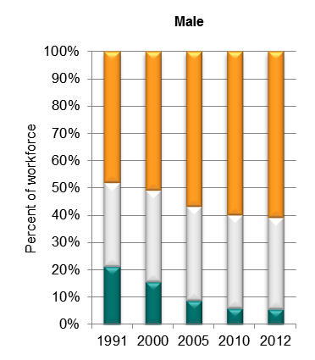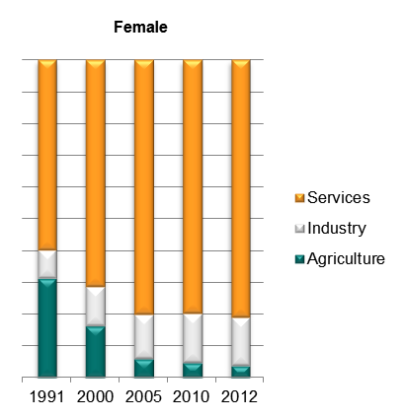

Source: ILO Global Employment Trends 2014 (<http://www.ilo.org/global/research/global-reports/global-employment-trends/2014/WCMS_234879/lang--en/index.htm>).

1. Sectoral employment by sex, South Africa (GGDC Africa sector database data)

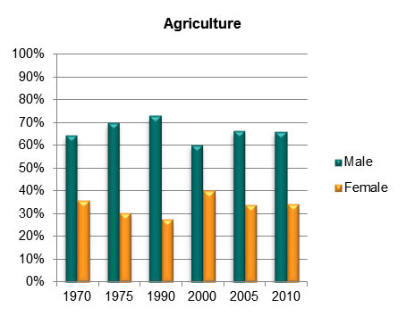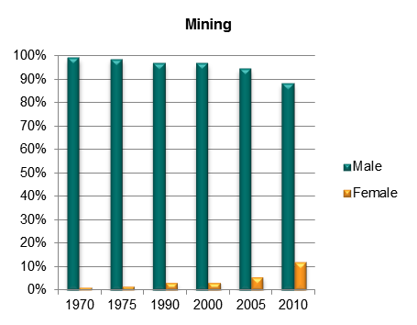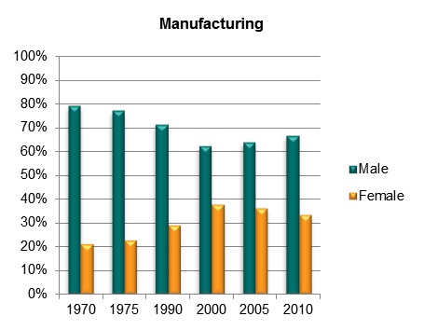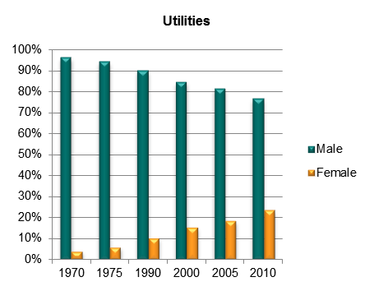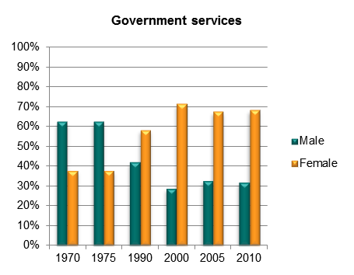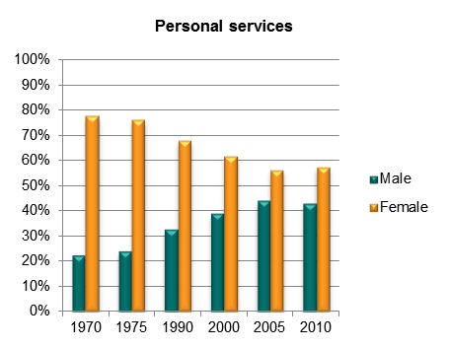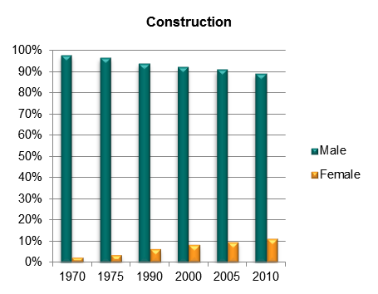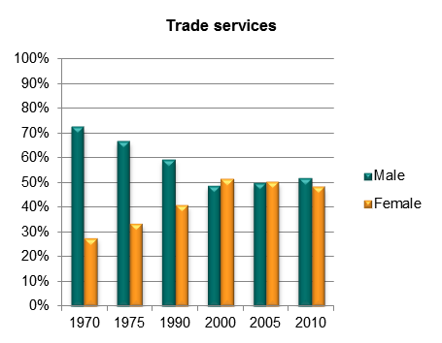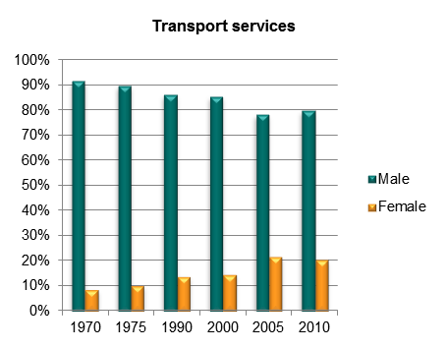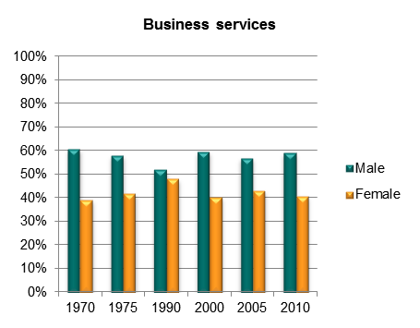

Source: Africa Sector Database (<http://www.rug.nl/research/ggdc/data/africa-sector-database>); de Vries et al. (2013).

1. Sectoral employment by sex, South Africa (ILO WESO data) NEW

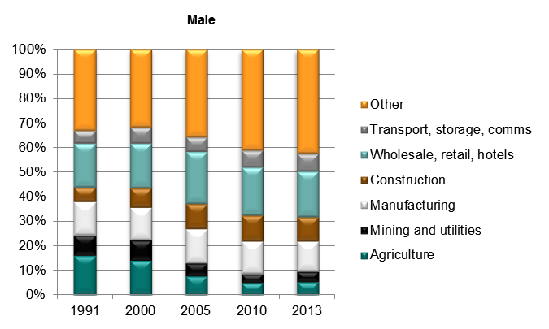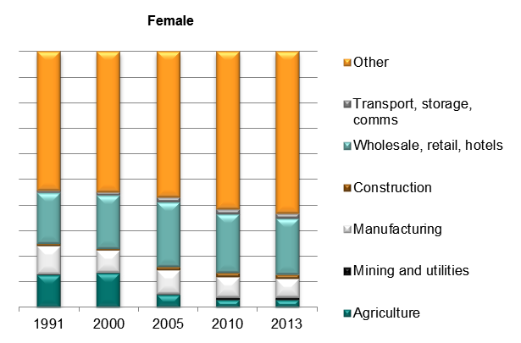

*Source: ILO World Employment and Social Outlook (WESO) – Trends 2015 supporting dataset ‘employment by sector and sex’ (*[*http://www.ilo.org/global/research/global-reports/weso/2015/lang--en/index.htm*](http://www.ilo.org/global/research/global-reports/weso/2015/lang--en/index.htm)*).*

# Trade

## Basic data

1. Total value of trade, South Africa, 2005–13

Source: UN COMTRADE database.

1. Exports by broad HS Section, South Africa, 2005–8 and 2009–13

|  |  |
| --- | --- |
| Key: |  |
| HS Sect. | Description |
| 1 | Live animals; animal products |
| 2 | Vegetable products |
| 3 | Animal or vegetable fats and oils and their cleavage products; prepared edible fats; animal or vegetable waxes |
| 4 | Prepared foodstuffs; beverages, spirits and vinegar; tobacco and manufactured tobacco substitutes |
| 5 | Mineral products |
| 6 | Products of the chemical or allied industries |
| 7 | Plastics and articles thereof; rubber and articles thereof |
| 8 | Raw hides and skins, leather, furskins and articles thereof; saddlery and harness; travel goods, handbags and similar containers; articles of animal gut (other than silk-worm gut) |
| 9 | Wood and articles of wood; wood charcoal; cork and articles of cork; manufactures of straw, of esparto or of other plaiting materials; basketware and wickerwork |
| 10 | Pulp of wood or of other fibrous cellulosic material; recovered (waste and scrap) paper or paperboard; paper and paperboard and articles thereof |
| 11 | Textiles and textile articles |
| 12 | Footwear, headgear, umbrellas, sun umbrellas, walking-sticks, seat-sticks, whips, riding-crops and parts thereof; prepared feathers and articles made therewith; artificial flowers; articles of human hair |
| 13 | Articles of stone, plaster, cement, asbestos, mica or similar materials; ceramic products; glass and glassware |
| 14 | Natural or cultured pearls, precious or semi-precious stones, precious metals, metals clad with precious metal and articles thereof; imitation jewellery; coin thereof; imitation jewellery; coin |
| 15 | Base metals and articles of base metal |
| 16 | Machinery and mechanical appliances; electrical equipment; parts thereof; sound recorders and reproducers, television image and sound recorders and reproducers, and parts and accessories of such articles |
| 17 | Vehicles, aircraft, vessels and associated transport equipment |
| 18 | Optical, photographic, cinematographic, measuring, checking, precision, medical or surgical instruments and apparatus; clocks and watches; musical instruments; parts and accessories thereof |
| 19 | Arms and ammunition; parts and accessories thereof |
| 20 | Miscellaneous manufactured articles |
| 21 | Works of art, collectors’ pieces and antiques |

Note: Bubble sizes and labels relate to the number of HS 6-digit subheads within the Section which were exported  
Source: Authors’ calculation using data from the UN’s COMTRADE database.

1. Change in export share by HS Section, South Africa, 2005–8 and 2009–13

|  |  |
| --- | --- |
| Key: |  |
| HS Sect. | Description |
| 1 | Live animals; animal products |
| 2 | Vegetable products |
| 3 | Animal or vegetable fats and oils and their cleavage products; prepared edible fats; animal or vegetable waxes |
| 4 | Prepared foodstuffs; beverages, spirits and vinegar; tobacco and manufactured tobacco substitutes |
| 5 | Mineral products |
| 6 | Products of the chemical or allied industries |
| 7 | Plastics and articles thereof; rubber and articles thereof |
| 8 | Raw hides and skins, leather, furskins and articles thereof; saddlery and harness; travel goods, handbags and similar containers; articles of animal gut (other than silk-worm gut) |
| 9 | Wood and articles of wood; wood charcoal; cork and articles of cork; manufactures of straw, of esparto or of other plaiting materials; basketware and wickerwork |
| 10 | Pulp of wood or of other fibrous cellulosic material; recovered (waste and scrap) paper or paperboard; paper and paperboard and articles thereof |
| 11 | Textiles and textile articles |
| 12 | Footwear, headgear, umbrellas, sun umbrellas, walking-sticks, seat-sticks, whips, riding-crops and parts thereof; prepared feathers and articles made therewith; artificial flowers; articles of human hair |
| 13 | Articles of stone, plaster, cement, asbestos, mica or similar materials; ceramic products; glass and glassware |
| 14 | Natural or cultured pearls, precious or semi-precious stones, precious metals, metals clad with precious metal and articles thereof; imitation jewellery; coin thereof; imitation jewellery; coin |
| 15 | Base metals and articles of base metal |
| 16 | Machinery and mechanical appliances; electrical equipment; parts thereof; sound recorders and reproducers, television image and sound recorders and reproducers, and parts and accessories of such articles |
| 17 | Vehicles, aircraft, vessels and associated transport equipment |
| 18 | Optical, photographic, cinematographic, measuring, checking, precision, medical or surgical instruments and apparatus; clocks and watches; musical instruments; parts and accessories thereof |
| 19 | Arms and ammunition; parts and accessories thereof |
| 20 | Miscellaneous manufactured articles |
| 21 | Works of art, collectors’ pieces and antiques |

Source: Authors’ calculation using data from the UN’s COMTRADE database.

1. Export visualisation, South Africa, 2005 and 2012

|  |
| --- |
| **2005** |
|  |
| **2012** |
|  |

Source: ‘The Atlas of Economic Complexity’, Center for International Development at Harvard University (<http://www.atlas.cid.harvard.edu>).

1. Top export products, South Africa (average 2011–13)

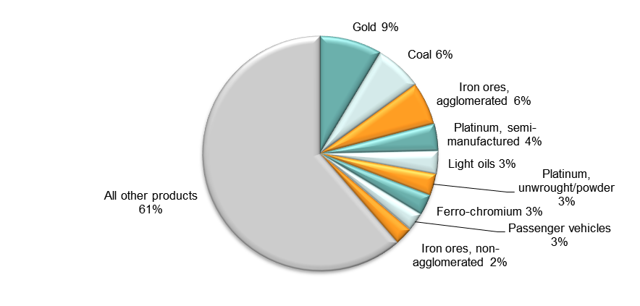

Note: At Harmonised System 6-digit level.  
Source: Authors’ calculations using data from UN COMTRADE database.

1. Top export markets, South Africa (average 2011–13)

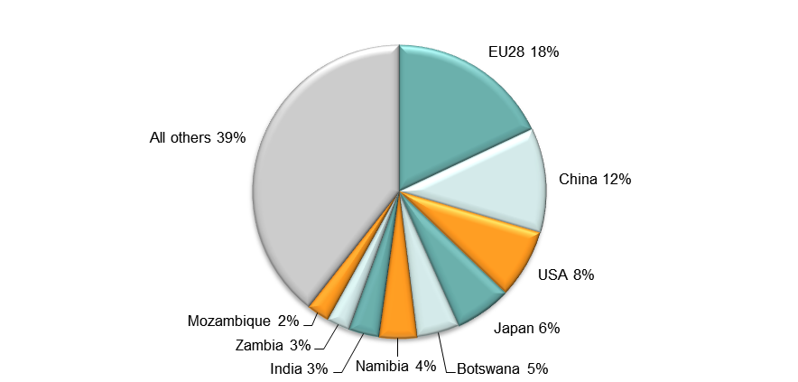

Source: Authors’ calculations using data from UN COMTRADE database.

1. Imports by broad HS Section, South Africa, 2005–8 and 2009–13

|  |  |
| --- | --- |
| Key: |  |
| HS Sect. | Description |
| 1 | Live animals; animal products |
| 2 | Vegetable products |
| 3 | Animal or vegetable fats and oils and their cleavage products; prepared edible fats; animal or vegetable waxes |
| 4 | Prepared foodstuffs; beverages, spirits and vinegar; tobacco and manufactured tobacco substitutes |
| 5 | Mineral products |
| 6 | Products of the chemical or allied industries |
| 7 | Plastics and articles thereof; rubber and articles thereof |
| 8 | Raw hides and skins, leather, furskins and articles thereof; saddlery and harness; travel goods, handbags and similar containers; articles of animal gut (other than silk-worm gut) |
| 9 | Wood and articles of wood; wood charcoal; cork and articles of cork; manufactures of straw, of esparto or of other plaiting materials; basketware and wickerwork |
| 10 | Pulp of wood or of other fibrous cellulosic material; recovered (waste and scrap) paper or paperboard; paper and paperboard and articles thereof |
| 11 | Textiles and textile articles |
| 12 | Footwear, headgear, umbrellas, sun umbrellas, walking-sticks, seat-sticks, whips, riding-crops and parts thereof; prepared feathers and articles made therewith; artificial flowers; articles of human hair |
| 13 | Articles of stone, plaster, cement, asbestos, mica or similar materials; ceramic products; glass and glassware |
| 14 | Natural or cultured pearls, precious or semi-precious stones, precious metals, metals clad with precious metal and articles thereof; imitation jewellery; coin thereof; imitation jewellery; coin |
| 15 | Base metals and articles of base metal |
| 16 | Machinery and mechanical appliances; electrical equipment; parts thereof; sound recorders and reproducers, television image and sound recorders and reproducers, and parts and accessories of such articles |
| 17 | Vehicles, aircraft, vessels and associated transport equipment |
| 18 | Optical, photographic, cinematographic, measuring, checking, precision, medical or surgical instruments and apparatus; clocks and watches; musical instruments; parts and accessories thereof |
| 19 | Arms and ammunition; parts and accessories thereof |
| 20 | Miscellaneous manufactured articles |
| 21 | Works of art, collectors’ pieces and antiques |

Note: Bubble sizes and labels relate to the number of HS 6-digit subheads within the Section which were imported  
Source: Authors’ calculation using data from the UN’s COMTRADE database.

1. Change in import share by HS Section, South Africa, 2005–8 and 2009–13

|  |  |
| --- | --- |
| Key: |  |
| HS Sect. | Description |
| 1 | Live animals; animal products |
| 2 | Vegetable products |
| 3 | Animal or vegetable fats and oils and their cleavage products; prepared edible fats; animal or vegetable waxes |
| 4 | Prepared foodstuffs; beverages, spirits and vinegar; tobacco and manufactured tobacco substitutes |
| 5 | Mineral products |
| 6 | Products of the chemical or allied industries |
| 7 | Plastics and articles thereof; rubber and articles thereof |
| 8 | Raw hides and skins, leather, furskins and articles thereof; saddlery and harness; travel goods, handbags and similar containers; articles of animal gut (other than silk-worm gut) |
| 9 | Wood and articles of wood; wood charcoal; cork and articles of cork; manufactures of straw, of esparto or of other plaiting materials; basketware and wickerwork |
| 10 | Pulp of wood or of other fibrous cellulosic material; recovered (waste and scrap) paper or paperboard; paper and paperboard and articles thereof |
| 11 | Textiles and textile articles |
| 12 | Footwear, headgear, umbrellas, sun umbrellas, walking-sticks, seat-sticks, whips, riding-crops and parts thereof; prepared feathers and articles made therewith; artificial flowers; articles of human hair |
| 13 | Articles of stone, plaster, cement, asbestos, mica or similar materials; ceramic products; glass and glassware |
| 14 | Natural or cultured pearls, precious or semi-precious stones, precious metals, metals clad with precious metal and articles thereof; imitation jewellery; coin thereof; imitation jewellery; coin |
| 15 | Base metals and articles of base metal |
| 16 | Machinery and mechanical appliances; electrical equipment; parts thereof; sound recorders and reproducers, television image and sound recorders and reproducers, and parts and accessories of such articles |
| 17 | Vehicles, aircraft, vessels and associated transport equipment |
| 18 | Optical, photographic, cinematographic, measuring, checking, precision, medical or surgical instruments and apparatus; clocks and watches; musical instruments; parts and accessories thereof |
| 19 | Arms and ammunition; parts and accessories thereof |
| 20 | Miscellaneous manufactured articles |
| 21 | Works of art, collectors’ pieces and antiques |

Source: Authors’ calculation using data from the UN’s COMTRADE database.

1. Import visualisation, South Africa, 2005 and 2012

|  |
| --- |
| **2005** |
|  |
| **2012** |
|  |

Source: ‘The Atlas of Economic Complexity’, Center for International Development at Harvard University (<http://www.atlas.cid.harvard.edu>).

1. Top import products, South Africa (average 2011–13)

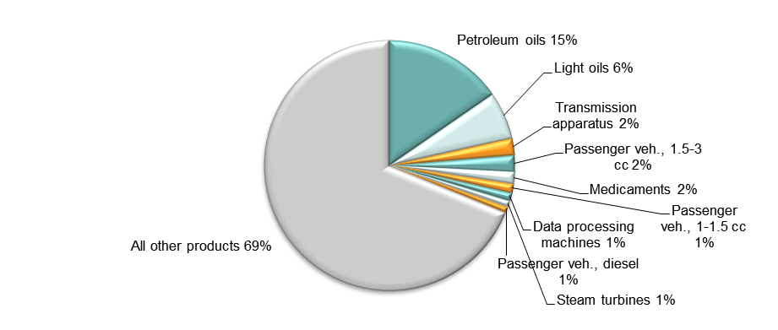

Note: At Harmonised System 6-digit level.  
Source: Authors’ calculations using data from UN COMTRADE database.

1. Top import sources, South Africa (average 2011–13)

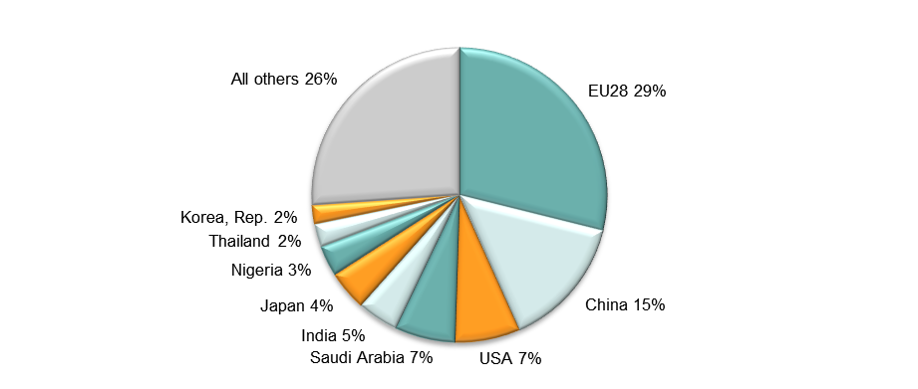

Source: Authors’ calculations using data from UN COMTRADE database.

## Diversification

1. Export diversification index, South Africa, 1965–2010

Notes:  
Higher values reflect lower diversification.  
**Extensive export diversification** reflects an increase in the number of export products or trading partners.  
**Intensive export diversification** considers the shares of export volumes across active products or trading partners. Thus, a country is less diversified when export revenues are driven by only a few sectors or trading partners, even though the country might be exporting many different goods or to many different trading partners. Countries with a more evenly balanced mix of exports or trading partners have a higher level of intensive diversification.  
Source: DFID–IMF Diversification Toolkit (<http://www.imf.org/external/np/res/dfidimf/diversification.htm>): Export Diversification Database.

1. Export quality index, South Africa, 1966–2010

Source: DFID–IMF Diversification Toolkit (<http://www.imf.org/external/np/res/dfidimf/diversification.htm>): Export Quality Database.

1. Number of export items and markets, South Africa, 2005–13

Note: EU countries counted individually.  
Source: Authors’ calculation using data from the UN’s COMTRADE database.

1. Number of import items and suppliers, South Africa, 2005–13

Note: EU countries counted individually.  
Source: Authors’ calculation using data from the UN’s COMTRADE database.

## Revealed comparative advantage

1. Revealed comparative advantage by HS Section, South Africa

|  |  |  |  |  |  |  |  |  |  |  |
| --- | --- | --- | --- | --- | --- | --- | --- | --- | --- | --- |
| **HS Sect.** | **Product label** | **2005** | **2006** | **2007** | **2008** | **2009** | **2010** | **2011** | **2012** | **2013** |
|  | **Total in HS 1-97** | **1.00** | **1.00** | **1.00** | **1.00** | **1.00** | **1.00** | **1.00** | **1.00** | **1.00** |
| 1 | Live animals; animal products | 0.55 | 0.53 | 0.54 | 0.51 | 0.55 | 0.66 | 0.49 | 0.50 | 0.49 |
| 2 | Vegetable products | 1.89 | 1.48 | 1.27 | 1.59 | 1.69 | 1.65 | 1.45 | 1.45 | 1.62 |
| 3 | Animal or vegetable fats and oils and their cleavage products; prepared edible fats; animal or vegetable waxes | 0.20 | 0.17 | 0.12 | 0.25 | 0.32 | 0.51 | 0.45 | 0.54 | 0.48 |
| 4 | Prepared foodstuffs; beverages, spirits and vinegar; tobacco and manufactured tobacco substitutes | 1.36 | 1.29 | 1.09 | 1.02 | 1.27 | 1.43 | 1.12 | 1.18 | 1.26 |
| 5 | Mineral products | 1.12 | 1.03 | 1.22 | 1.07 | 1.47 | 1.35 | 1.28 | 1.32 | 1.34 |
| 6 | Products of the chemical or allied industries | 0.79 | 0.74 | 0.67 | 0.75 | 0.64 | 0.66 | 0.62 | 0.68 | 0.67 |
| 7 | Plastics and articles thereof; rubber and articles thereof | 0.44 | 0.40 | 0.34 | 0.41 | 0.44 | 0.47 | 0.42 | 0.50 | 0.48 |
| 8 | Raw hides and skins, leather, furskins and articles thereof; saddlery and harness; travel goods, handbags and similar containers; articles of animal gut (other than silk-worm gut) | 0.71 | 0.71 | 0.69 | 0.56 | 0.54 | 0.52 | 0.52 | 0.53 | 0.75 |
| 9 | Wood and articles of wood; wood charcoal; cork and articles of cork; manufactures of straw, of esparto or of other plaiting materials; basketware and wickerwork | 1.09 | 0.84 | 0.63 | 0.74 | 0.70 | 0.82 | 0.69 | 0.66 | 0.61 |
| 10 | Pulp of wood or of other fibrous cellulosic material; recovered (waste and scrap) paper or paperboard; paper and paperboard and articles thereof | 1.09 | 1.07 | 1.12 | 1.08 | 1.11 | 1.21 | 1.10 | 1.04 | 1.04 |
| 11 | Textiles and textile articles | 0.29 | 0.26 | 0.24 | 0.22 | 0.23 | 0.31 | 0.28 | 0.31 | 0.31 |
| 12 | Footwear, headgear, umbrellas, sun umbrellas, walking-sticks, seat-sticks, whips, riding-crops and parts thereof; prepared feathers and articles made therewith; artificial flowers; articles of human hair | 0.10 | 0.10 | 0.09 | 0.09 | 0.09 | 0.34 | 0.29 | 0.31 | 0.30 |
| 13 | Articles of stone, plaster, cement, asbestos, mica or similar materials; ceramic products; glass and glassware | 0.62 | 0.59 | 0.51 | 0.37 | 0.42 | 0.59 | 0.49 | 0.51 | 0.50 |
| 14 | Natural or cultured pearls, precious or semi-precious stones, precious metals, metals clad with precious metal and articles thereof; imitation jewellery; coin thereof; imitation jewellery; coin | 10.13 | 10.82 | 10.18 | 8.33 | 6.26 | 5.39 | 7.18 | 6.04 | 6.68 |
| 15 | Base metals and articles of base metal | 2.46 | 2.20 | 2.14 | 2.12 | 2.20 | 2.08 | 1.63 | 1.64 | 1.72 |
| 16 | Machinery and mechanical appliances; electrical equipment; parts thereof; sound recorders and reproducers, television image and sound recorders and reproducers, and parts and accessories of such articles | 0.36 | 0.41 | 0.44 | 0.44 | 0.39 | 0.39 | 0.39 | 0.42 | 0.40 |
| 17 | Vehicles, aircraft, vessels and associated transport equipment | 0.90 | 0.91 | 0.79 | 1.03 | 1.01 | 1.02 | 0.89 | 0.98 | 0.96 |
| 18 | Optical, photographic, cinematographic, measuring, checking, precision, medical or surgical instruments and apparatus; clocks and watches; musical instruments; parts and accessories thereof | 0.17 | 0.16 | 0.17 | 0.19 | 0.22 | 0.19 | 0.18 | 0.16 | 0.18 |
| 19 | Arms and ammunition; parts and accessories thereof | - | - | - | - | - | - | - | - | - |
| 20 | Miscellaneous manufactured articles | 0.68 | 0.59 | 0.52 | 0.46 | 0.47 | 0.62 | 0.47 | 0.41 | 0.37 |
| 21 | Works of art, collectors’ pieces and antiques | 0.52 | 0.38 | 0.36 | 0.95 | 0.44 | 0.45 | 0.37 | 0.65 | 1.02 |

Note: Share of country’s exports in each HS Section in country’s total exports as a ratio of share of world exports in each HS Section in world total exports. ‘World’ = UN COMTRADE’s ‘all countries’ aggregate, i.e. total of however many countries have reported their data in any given year.   
Source: Authors’ calculations using data from the UN’s COMTRADE database.

## Trade in value added

1. Compound annual growth rate of domestic value added, foreign value added and exports, 1996-2011 and 2006-11, South Africa

Source: Own computations using Eora26 database

1. Domestic and foreign value added content of gross exports as share of gross exports, 1996, 2000, 2006 and 2011, South Africa

Source: Own computations using Eora26 database

1. Overall value of domestic and foreign value added, 1996, 2000, 2006 and 2011 (in USD 1,000) , South Africa

Source: Own computations using Eora26 database

1. Compound annual growth rate of DVA embodied in gross exports by sector, 1996-2011 and 2006-2011, South Africa

Source: Own computations using Eora26 database

1. Sectoral DVA embodied in exports as a share of sectoral gross exports, 2000 and 2011, South Africa

Source: Own computations using Eora26 database

1. Sectoral DVA as a share of total DVA, 2000 and 2011, South Africa

Source: Own computations using Eora26 database

1. Compound annual growth rate of FVA embodied in gross exports by sector, 1996-2011 and 2006-2011, South Africa

Source: Own computations using Eora26 database

1. Sectoral FVA embodied in exports as a share of sectoral gross exports, 2000 and 2011, South Africa

Source: Own computations using Eora26 database

1. Sectoral FVA as a share of total FVA, 2000 and 2011, South Africa

Source: Own computations using Eora26 database

## Trade in services

1. Exports of goods and services, South Africa

Source: Authors’ calculation using data from the World Bank’s World Development Indicators.

1. Sectoral shares of services exports, South Africa

Source: Authors’ calculation using data from the World Bank’s World Development Indicators.

# Estimates of total factor productivity at firm level

1. Dispersion in productivity across firms by sector – South Africa



Source: Authors’ calculations using data from World Bank Enterprise Surveys (<http://www.enterprisesurveys.org/>).

1. Distribution in productivity in South Africa – comparing kernel and normal distributions



Source: Authors’ calculations using data from World Bank Enterprise Surveys (<http://www.enterprisesurveys.org/>).