Sudan:
Data on economic transformation

Economic structures 2
Table 1. Value added (% of GDP), Sudan 2
Table 2. GDP, employment and relative productivity levels, Sudan, 1991–2013 NEW 3
Table 3. Labour productivity levels and changes, Sudan, 1991–2013 NEW 3
Figure 1. Relative productivity and changes in employment shares by sector, Sudan NEW 4
Figure 2. Decomposition of labour productivity change, Sudan, 1991–2013 NEW 4
Figure 3. Productivity gaps in Sudan, 2013 NEW 4
Figure 4. Total employment by sex and broad sector, Sudan (ILO GET data) 4
Figure 5. Broad sectoral employment by sex, Sudan (ILO GET data) 4
Figure 6. Sectoral employment by sex, Sudan (ILO WESO data) NEW 4
Trade 6
Basic data 6
Figure 7. Total value of trade, Sudan, 2005–13 6
Figure 8. Exports by broad HS Section, Sudan, 2005–8 and 2009–12 7
Figure 9. Change in export share by HS Section, Sudan, 2005–8 (excl. 2007) and 2009–12 8
Figure 10. Export visualisation, Sudan, 2005 and 2011 9
Figure 11. Top export products, Sudan (average 2010–12) 10
Figure 12. Top export markets, Sudan (average 2010–12) 10
Figure 13. Imports by broad HS Section, Sudan, 2005–8 and 2009–12 11
Figure 14. Change in import share by HS Section, Sudan, 2005–8 and 2009–12 12
Figure 15. Import visualisation, Sudan, 2005 and 2011 13
Figure 16. Top import products, Sudan (average 2010–12) 14
Figure 17. Top import sources, Sudan (average 2010–12) 14
Diversification 15
Figure 18. Export diversification index, Sudan, 1965–2010 15
Figure 19. Export quality index, Sudan, 1970–2010 15
Figure 20. Number of export items and markets, Sudan, 2005–12 16
Figure 21. Number of import items and suppliers, Sudan, 2005–12 16

Revealed comparative advantage 18
Table 4. Revealed comparative advantage by HS Section, Sudan 18
Trade in services 19
Figure 22. Exports of goods and services, Sudan 19
Figure 23. Sectoral shares of services exports, Sudan 19

Economic structures
- Value added (% of GDP), Sudan
 | 1991 | 2000 | 2005 | 2010 | 2012
Agriculture ª | 41.8 | 42.2 | 31.5 | 24.9 | 27.7
Industry ^{b} | 12.6 | 20.8 | 27.7 | 28.3 | 31.2
Of which: Manufacturing | 6.5 | 8.6 | 6.9 | 6.0 | 6.1
Services ^{c} | 45.6 | 37.0 | 40.8 | 46.8 | 41.1
Total | 100.0 | 100.0 | 100.0 | 100.0 | 100.0
Notes:
(a) Agriculture corresponds to ISIC divisions 1-5 and includes forestry, hunting, and fishing, as well as cultivation of crops and livestock production.
(b) Industry corresponds to ISIC divisions 10-45 and includes manufacturing (ISIC divisions 15-37). It comprises value added in mining, manufacturing (also reported as a separate subgroup), construction, electricity, water, and gas.
(c) Services correspond to ISIC divisions 50-99 and they include value added in wholesale and retail trade (including hotels and restaurants), transport, and government, financial, professional, and personal services such as education, health care, and real estate services. Also included are imputed bank service charges, import duties, and any statistical discrepancies noted by national compilers as well as discrepancies arising from rescaling.
Source: World Bank, World Development Indicators (http://databank.worldbank.org/data/views/variableSelection/selectvariables.aspx?source=world-development-indicators).

- GDP, employment and relative productivity levels, Sudan, 1991–2013 (UNSD/ILO WESO data) NEW
Economic activity | Gross value added (current US$, %) |  |  |  |  |  | Employment by sector (%) |  |  |  |  |  | Relative productivity levels ª
 | 1975 | 1991 | 2000 | 2005 | 2010 | 2013 | 1975 | 1991 | 2000 | 2005 | 2010 | 2013 | 1975 | 1991 | 2000 | 2005 | 2010 | 2013
Agriculture | 36.1 | 38.6 | 37.1 | 34.5 | 42.9 | 42.6 | n/a | 57.3 | 55.7 | 52.6 | 50.2 | 52.7 | n/a | 0.6 | 0.7 | 0.7 | 0.7 | 0.8
Mining & utilities | 1.7 | 1.5 | 8.1 | 9.4 | -0.4 | 1.6 | n/a | 2.1 | 2.2 | 2.4 | 2.4 | 2.4 | n/a | -0.3 | 2.9 | 3.9 | 4.2 | 0.9
Manufacturing | 8.6 | 5.3 | 5.7 | 7.8 | 9.9 | 9.8 | n/a | 9.4 | 10.3 | 10.0 | 9.2 | 9.6 | n/a | 0.8 | 0.7 | 0.8 | 0.9 | 1.0
Construction | 4.8 | 4.7 | 3.6 | 4.6 | 4.2 | 4.1 | n/a | 3.3 | 4.0 | 4.7 | 5.8 | 5.2 | n/a | 0.6 | 0.7 | 1.0 | 0.8 | 0.7
Wholesale, retail, hotels | 18.9 | 24.1 | 17.3 | 15.3 | 16.9 | 16.8 | n/a | 9.8 | 10.0 | 10.5 | 11.0 | 10.5 | n/a | 2.5 | 1.8 | 1.5 | 1.3 | 1.6
Transport, storage, comms | 10.4 | 14.8 | 11.9 | 13.4 | 11.1 | 10.7 | n/a | 2.0 | 2.1 | 2.3 | 2.7 | 2.4 | n/a | 7.9 | 4.9 | 5.7 | 5.0 | 5.8
Other | 19.4 | 10.9 | 16.3 | 15.1 | 15.4 | 14.3 | n/a | 16.1 | 15.6 | 17.4 | 18.8 | 17.2 | n/a | 0.9 | 0.9 | 0.9 | 0.8 | 0.7
Total | 100 | 100 | 100 | 100 | 100 | 100 | n/a | 100 | 100 | 100 | 100 | 100 | n/a | 1.0 | 1.0 | 1.0 | 1.0 | 1.0
Notes:
(a) Derived by calculating labour productivity levels (gross value added at constant prices divided by number of persons employed per sector) and expressing the result as a ratio of total economy labour productivity.
Numbers may not sum due to rounding.
Source: Authors’ calculations using UNSD National Accounts Main Aggregates data on ‘gross value added by kind of economic activity’ (https://data.un.org/search.aspx?q=gross+value+added+datamart%5bsnaama%5d, data for ‘Sudan (former)’ 1975–2010 and ‘Sudan’ 2013) and ILO World Employment and Social Outlook (WESO) – Trends 2015 supporting dataset ‘employment by sector and sex’ (http://www.ilo.org/global/research/global-reports/weso/2015/lang--en/index.htm).
- Labour productivity levels and changes, Sudan, 1991–2013 (UNSD/ILO WESO data) NEW
Economic activity | Labour productivity (index, 1991=100) |  |  |  |  | Annualised growth in labour productivity
 | 1991 | 2000 | 2005 | 2010 | 2013 | 1991-2013 | 1991-2000 | 2000-05 | 2005-10 | 2010-13
Agriculture | 100 | 156.7 | 164.8 | 206.8 | 172.6 | 2.5% | 5.1% | 1.0% | 4.6% | -5.8%
Mining & utilities | 100 | -1200.6 | -1915.1 | -2495.2 | -387.5 |  |  | 9.8% | 5.4% | -46.2%
Manufacturing | 100 | 110.6 | 147.4 | 197.4 | 160.8 | 2.2% | 1.1% | 5.9% | 6.0% | -6.6%
Construction | 100 | 149.3 | 243.4 | 231.6 | 158.9 | 2.1% | 4.6% | 10.3% | -1.0% | -11.8%
Wholesale, retail, hotels | 100 | 92.0 | 88.2 | 95.6 | 81.6 | -0.9% | -0.9% | -0.8% | 1.6% | -5.2%
Transport, storage, comms | 100 | 80.8 | 112.3 | 116.3 | 97.4 | -0.1% | -2.3% | 6.8% | 0.7% | -5.7%
Other | 100 | 126.3 | 142.9 | 157.4 | 92.5 | -0.4% | 2.6% | 2.5% | 2.0% | -16.2%
Total | 100 | 130.2 | 154.1 | 184.0 | 131.7 | 1.3% | 3.0% | 3.4% | 3.6% | -10.6%
Note: Derived by calculating labour productivity levels (gross value added at constant 2005 prices divided by number of persons engaged) and expressing the results as an index related to 1991 levels.
Source: Authors’ calculations using UNSD National Accounts Main Aggregates data on ‘gross value added by kind of economic activity’ (https://data.un.org/search.aspx?q=gross+value+added+datamart%5bsnaama%5d, data for ‘Sudan (former)’ 1975–2010 and ‘Sudan’ 2013) and ILO World Employment and Social Outlook (WESO) – Trends 2015 supporting dataset ‘employment by sector and sex’ (http://www.ilo.org/global/research/global-reports/weso/2015/lang--en/index.htm).

- Relative productivity and changes in employment shares by sector, Sudan NEW

Note: Size of bubbles represents number of persons employed in each sector in the later year of each period.
Source: Authors’ calculations using UNSD National Accounts Main Aggregates data on ‘gross value added by kind of economic activity’ (https://data.un.org/search.aspx?q=gross+value+added+datamart%5bsnaama%5d, data for ‘Sudan (former)’ 1975–2010 and ‘Sudan’ 2013) and ILO World Employment and Social Outlook (WESO) – Trends 2015 supporting dataset ‘employment by sector and sex’ (http://www.ilo.org/global/research/global-reports/weso/2015/lang--en/index.htm).

- Decomposition of labour productivity change, Sudan, 1991–2013 NEW

Source: Authors’ calculations using UNSD National Accounts Main Aggregates data on ‘gross value added by kind of economic activity’ (https://data.un.org/search.aspx?q=gross+value+added+datamart%5bsnaama%5d, data for ‘Sudan (former)’ 1975–2010 and ‘Sudan’ 2013) and ILO World Employment and Social Outlook (WESO) – Trends 2015 supporting dataset ‘employment by sector and sex’ (http://www.ilo.org/global/research/global-reports/weso/2015/lang--en/index.htm).

- Productivity gaps in Sudan, 2013 NEW

Source: Authors’ calculations using UNSD National Accounts Main Aggregates data on ‘gross value added by kind of economic activity’ (https://data.un.org/search.aspx?q=gross+value+added+datamart%5bsnaama%5d, data for ‘Sudan (former)’ 1975–2010 and ‘Sudan’ 2013) and ILO World Employment and Social Outlook (WESO) – Trends 2015 supporting dataset ‘employment by sector and sex’ (http://www.ilo.org/global/research/global-reports/weso/2015/lang--en/index.htm).

- Total employment by sex and broad sector, Sudan (ILO GET data)

Source: ILO Global Employment Trends 2014 (http://www.ilo.org/global/research/global-reports/global-employment-trends/2014/WCMS_234879/lang--en/index.htm).

- Broad sectoral employment by sex, Sudan (ILO GET data)

Source: Authors’ calculations using data from the ILO’s Global Employment Trends 2014 (http://www.ilo.org/global/research/global-reports/global-employment-trends/2014/WCMS_234879/lang--en/index.htm).

- Sectoral employment by sex, Sudan (ILO WESO data) NEW

Source: ILO World Employment and Social Outlook (WESO) – Trends 2015 supporting dataset ‘employment by sector and sex’ (http://www.ilo.org/global/research/global-reports/weso/2015/lang--en/index.htm).

Trade

Basic data
- Total value of trade, Sudan, 2005–13

Source: UN COMTRADE database.

- Exports by broad HS Section, Sudan, 2005–8 and 2009–12

Key:
HS Sect. | Description
1 | Live animals; animal products
2 | Vegetable products
3 | Animal or vegetable fats and oils and their cleavage products; prepared edible fats; animal or vegetable waxes
4 | Prepared foodstuffs; beverages, spirits and vinegar; tobacco and manufactured tobacco substitutes
5 | Mineral products
6 | Products of the chemical or allied industries
7 | Plastics and articles thereof; rubber and articles thereof
8 | Raw hides and skins, leather, furskins and articles thereof; saddlery and harness; travel goods, handbags and similar containers; articles of animal gut (other than silk-worm gut)
9 | Wood and articles of wood; wood charcoal; cork and articles of cork; manufactures of straw, of esparto or of other plaiting materials; basketware and wickerwork
10 | Pulp of wood or of other fibrous cellulosic material; recovered (waste and scrap) paper or paperboard; paper and paperboard and articles thereof
11 | Textiles and textile articles
12 | Footwear, headgear, umbrellas, sun umbrellas, walking-sticks, seat-sticks, whips, riding-crops and parts thereof; prepared feathers and articles made therewith; artificial flowers; articles of human hair
13 | Articles of stone, plaster, cement, asbestos, mica or similar materials; ceramic products; glass and glassware
14 | Natural or cultured pearls, precious or semi-precious stones, precious metals, metals clad with precious metal and articles thereof; imitation jewellery; coin thereof; imitation jewellery; coin
15 | Base metals and articles of base metal
16 | Machinery and mechanical appliances; electrical equipment; parts thereof; sound recorders and reproducers, television image and sound recorders and reproducers, and parts and accessories of such articles
17 | Vehicles, aircraft, vessels and associated transport equipment
18 | Optical, photographic, cinematographic, measuring, checking, precision, medical or surgical instruments and apparatus; clocks and watches; musical instruments; parts and accessories thereof
19 | Arms and ammunition; parts and accessories thereof
20 | Miscellaneous manufactured articles
21 | Works of art, collectors’ pieces and antiques
Note: Bubble sizes and labels relate to the number of HS 6-digit subheads within the Section which were exported
Source: Authors’ calculation using data from the UN’s COMTRADE database for ‘Former Sudan’ 2005–11 and ‘Sudan’ 2012. There are no data for 2007.
- Change in export share by HS Section, Sudan, 2005–8 (excl. 2007) and 2009–12

Key:
HS Sect. | Description
1 | Live animals; animal products
2 | Vegetable products
3 | Animal or vegetable fats and oils and their cleavage products; prepared edible fats; animal or vegetable waxes
4 | Prepared foodstuffs; beverages, spirits and vinegar; tobacco and manufactured tobacco substitutes
5 | Mineral products
6 | Products of the chemical or allied industries
7 | Plastics and articles thereof; rubber and articles thereof
8 | Raw hides and skins, leather, furskins and articles thereof; saddlery and harness; travel goods, handbags and similar containers; articles of animal gut (other than silk-worm gut)
9 | Wood and articles of wood; wood charcoal; cork and articles of cork; manufactures of straw, of esparto or of other plaiting materials; basketware and wickerwork
10 | Pulp of wood or of other fibrous cellulosic material; recovered (waste and scrap) paper or paperboard; paper and paperboard and articles thereof
11 | Textiles and textile articles
12 | Footwear, headgear, umbrellas, sun umbrellas, walking-sticks, seat-sticks, whips, riding-crops and parts thereof; prepared feathers and articles made therewith; artificial flowers; articles of human hair
13 | Articles of stone, plaster, cement, asbestos, mica or similar materials; ceramic products; glass and glassware
14 | Natural or cultured pearls, precious or semi-precious stones, precious metals, metals clad with precious metal and articles thereof; imitation jewellery; coin thereof; imitation jewellery; coin
15 | Base metals and articles of base metal
16 | Machinery and mechanical appliances; electrical equipment; parts thereof; sound recorders and reproducers, television image and sound recorders and reproducers, and parts and accessories of such articles
17 | Vehicles, aircraft, vessels and associated transport equipment
18 | Optical, photographic, cinematographic, measuring, checking, precision, medical or surgical instruments and apparatus; clocks and watches; musical instruments; parts and accessories thereof
19 | Arms and ammunition; parts and accessories thereof
20 | Miscellaneous manufactured articles
21 | Works of art, collectors’ pieces and antiques
Source: Authors’ calculation using data from the UN’s COMTRADE database for ‘Former Sudan’ 2005–11 and ‘Sudan’ 2012. There are no data for 2007.

- Export visualisation, Sudan, 2005 and 2011
2005
2011
Source: ‘The Atlas of Economic Complexity’, Center for International Development at Harvard University (http://www.atlas.cid.harvard.edu).

- Top export products, Sudan (average 2010–12)
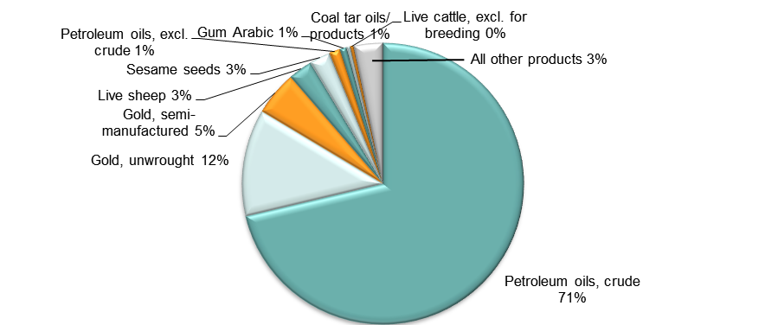
Note: At Harmonised System 6-digit level.
Source: Authors’ calculations using data from UN COMTRADE database for ‘Former Sudan’ 2010–11 and ‘Sudan’ 2012.

- Top export markets, Sudan (average 2010–12)
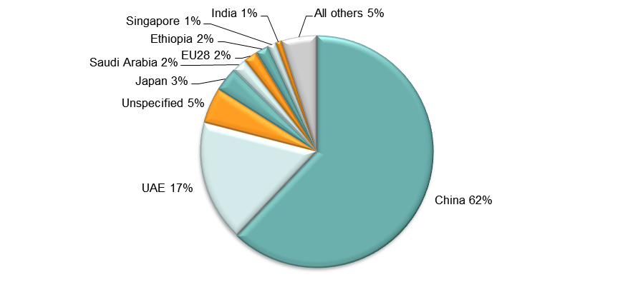
Source: Authors’ calculations using data from UN COMTRADE database for ‘Former Sudan’ 2010–11 and ‘Sudan’ 2012.
- Imports by broad HS Section, Sudan, 2005–8 and 2009–12

Key:
HS Sect. | Description
1 | Live animals; animal products
2 | Vegetable products
3 | Animal or vegetable fats and oils and their cleavage products; prepared edible fats; animal or vegetable waxes
4 | Prepared foodstuffs; beverages, spirits and vinegar; tobacco and manufactured tobacco substitutes
5 | Mineral products
6 | Products of the chemical or allied industries
7 | Plastics and articles thereof; rubber and articles thereof
8 | Raw hides and skins, leather, furskins and articles thereof; saddlery and harness; travel goods, handbags and similar containers; articles of animal gut (other than silk-worm gut)
9 | Wood and articles of wood; wood charcoal; cork and articles of cork; manufactures of straw, of esparto or of other plaiting materials; basketware and wickerwork
10 | Pulp of wood or of other fibrous cellulosic material; recovered (waste and scrap) paper or paperboard; paper and paperboard and articles thereof
11 | Textiles and textile articles
12 | Footwear, headgear, umbrellas, sun umbrellas, walking-sticks, seat-sticks, whips, riding-crops and parts thereof; prepared feathers and articles made therewith; artificial flowers; articles of human hair
13 | Articles of stone, plaster, cement, asbestos, mica or similar materials; ceramic products; glass and glassware
14 | Natural or cultured pearls, precious or semi-precious stones, precious metals, metals clad with precious metal and articles thereof; imitation jewellery; coin thereof; imitation jewellery; coin
15 | Base metals and articles of base metal
16 | Machinery and mechanical appliances; electrical equipment; parts thereof; sound recorders and reproducers, television image and sound recorders and reproducers, and parts and accessories of such articles
17 | Vehicles, aircraft, vessels and associated transport equipment
18 | Optical, photographic, cinematographic, measuring, checking, precision, medical or surgical instruments and apparatus; clocks and watches; musical instruments; parts and accessories thereof
19 | Arms and ammunition; parts and accessories thereof
20 | Miscellaneous manufactured articles
21 | Works of art, collectors’ pieces and antiques
Note: Bubble sizes and labels relate to the number of HS 6-digit subheads within the Section which were imported
Source: Authors’ calculation using data from the UN’s COMTRADE database for ‘Former Sudan’ 2005–11 and ‘Sudan’ 2012.
- Change in import share by HS Section, Sudan, 2005–8 and 2009–12

Key:
HS Sect. | Description
1 | Live animals; animal products
2 | Vegetable products
3 | Animal or vegetable fats and oils and their cleavage products; prepared edible fats; animal or vegetable waxes
4 | Prepared foodstuffs; beverages, spirits and vinegar; tobacco and manufactured tobacco substitutes
5 | Mineral products
6 | Products of the chemical or allied industries
7 | Plastics and articles thereof; rubber and articles thereof
8 | Raw hides and skins, leather, furskins and articles thereof; saddlery and harness; travel goods, handbags and similar containers; articles of animal gut (other than silk-worm gut)
9 | Wood and articles of wood; wood charcoal; cork and articles of cork; manufactures of straw, of esparto or of other plaiting materials; basketware and wickerwork
10 | Pulp of wood or of other fibrous cellulosic material; recovered (waste and scrap) paper or paperboard; paper and paperboard and articles thereof
11 | Textiles and textile articles
12 | Footwear, headgear, umbrellas, sun umbrellas, walking-sticks, seat-sticks, whips, riding-crops and parts thereof; prepared feathers and articles made therewith; artificial flowers; articles of human hair
13 | Articles of stone, plaster, cement, asbestos, mica or similar materials; ceramic products; glass and glassware
14 | Natural or cultured pearls, precious or semi-precious stones, precious metals, metals clad with precious metal and articles thereof; imitation jewellery; coin thereof; imitation jewellery; coin
15 | Base metals and articles of base metal
16 | Machinery and mechanical appliances; electrical equipment; parts thereof; sound recorders and reproducers, television image and sound recorders and reproducers, and parts and accessories of such articles
17 | Vehicles, aircraft, vessels and associated transport equipment
18 | Optical, photographic, cinematographic, measuring, checking, precision, medical or surgical instruments and apparatus; clocks and watches; musical instruments; parts and accessories thereof
19 | Arms and ammunition; parts and accessories thereof
20 | Miscellaneous manufactured articles
21 | Works of art, collectors’ pieces and antiques
Source: Authors’ calculation using data from the UN’s COMTRADE database for ‘Former Sudan’ 2005–11 and ‘Sudan’ 2012.

- Import visualisation, Sudan, 2005 and 2011
2005
2011
Source: ‘The Atlas of Economic Complexity’, Center for International Development at Harvard University (http://www.atlas.cid.harvard.edu).

- Top import products, Sudan (average 2010–12)
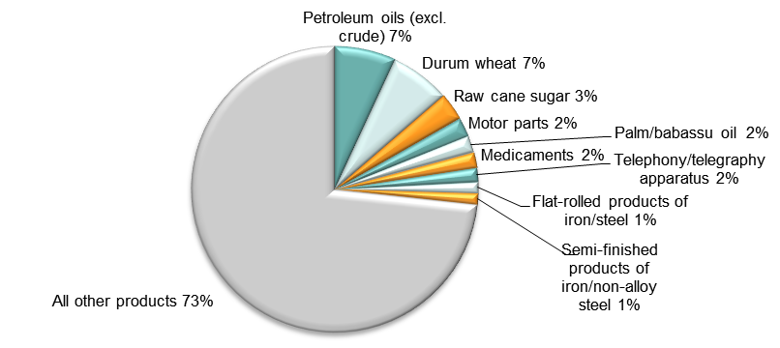
Note: At Harmonised System 6-digit level.
Source: Authors’ calculations using data from UN COMTRADE database for ‘Former Sudan’ 2010–11 and ‘Sudan’ 2012.

- Top import sources, Sudan (average 2010–12)
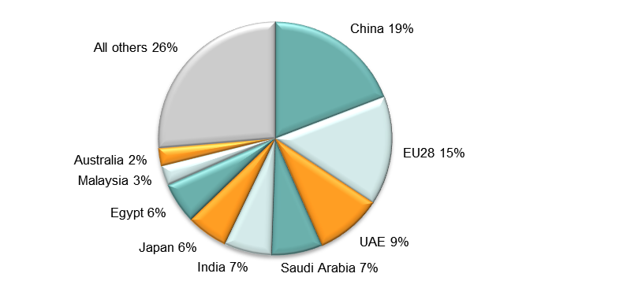
Source: Authors’ calculations using data from UN COMTRADE database for ‘Former Sudan’ 2010–11 and ‘Sudan’ 2012.

Diversification
- Export diversification index, Sudan, 1965–2010

Notes:
Higher values reflect lower diversification.
Extensive export diversification reflects an increase in the number of export products or trading partners.
Intensive export diversification considers the shares of export volumes across active products or trading partners. Thus, a country is less diversified when export revenues are driven by only a few sectors or trading partners, even though the country might be exporting many different goods or to many different trading partners. Countries with a more evenly balanced mix of exports or trading partners have a higher level of intensive diversification.
Source: DFID–IMF Diversification Toolkit (http://www.imf.org/external/np/res/dfidimf/diversification.htm): Export Diversification Database.

- Export quality index, Sudan, 1970–2010

Source: DFID–IMF Diversification Toolkit (http://www.imf.org/external/np/res/dfidimf/diversification.htm): Export Quality Database.

- Number of export items and markets, Sudan, 2005–12

Note: EU countries counted individually.
Source: Authors’ calculation using data from the UN’s COMTRADE database for ‘Former Sudan’ 2005–11 and ‘Sudan’ 2012. There are no data for 2007.

- Number of import items and suppliers, Sudan, 2005–12

Note: EU countries counted individually.
Source: Authors’ calculation using data from the UN’s COMTRADE database for ‘Former Sudan’ 2005–11 and ‘Sudan’ 2012.

Revealed comparative advantage
- Revealed comparative advantage by HS Section, Sudan
HS Sect. | Product label | 2005 | 2006 | 2007 | 2008 | 2009 | 2010 | 2011 | 2012
 | Total in HS 1-97 | 1.00 | 1.00 | n/a | 1.00 | 1.00 | 1.00 | 1.00 | 1.00
1 | Live animals; animal products | 1.51 | 1.27 |  | 0.42 | 1.35 | 0.79 | 1.71 | 6.20
2 | Vegetable products | 2.67 | 2.05 |  | 1.27 | 0.95 | 0.97 | 1.37 | 3.49
3 | Animal or vegetable fats and oils and their cleavage products; prepared edible fats; animal or vegetable waxes | 0.01 | 0.01 |  | 0.01 | 0.00 | 0.00 | 0.01 | 0.03
4 | Prepared foodstuffs; beverages, spirits and vinegar; tobacco and manufactured tobacco substitutes | 0.27 | 0.10 |  | 0.03 | 0.06 | 0.03 | 0.03 | 0.44
5 | Mineral products | 6.12 | 5.72 |  | 5.05 | 5.14 | 4.92 | 4.33 | 0.40
6 | Products of the chemical or allied industries | 0.00 | 0.00 |  | 0.00 | 0.00 | 0.00 | 0.01 | 0.25
7 | Plastics and articles thereof; rubber and articles thereof | 0.01 | 0.00 |  | 0.00 | 0.00 | 0.00 | 0.00 | 0.01
8 | Raw hides and skins, leather, furskins and articles thereof; saddlery and harness; travel goods, handbags and similar containers; articles of animal gut (other than silk-worm gut) | 0.01 | 0.03 |  | 0.60 | 0.40 | 0.42 | 0.59 | 1.80
9 | Wood and articles of wood; wood charcoal; cork and articles of cork; manufactures of straw, of esparto or of other plaiting materials; basketware and wickerwork | 0.01 | 0.00 |  | 0.00 | 0.00 | 0.00 | 0.00 | 0.11
10 | Pulp of wood or of other fibrous cellulosic material; recovered (waste and scrap) paper or paperboard; paper and paperboard and articles thereof | 0.00 | 0.00 |  | 0.00 | 0.00 | 0.00 | 0.00 | 0.00
11 | Textiles and textile articles | 0.48 | 0.29 |  | 0.15 | 0.10 | 0.08 | 0.07 | 0.15
12 | Footwear, headgear, umbrellas, sun umbrellas, walking-sticks, seat-sticks, whips, riding-crops and parts thereof; prepared feathers and articles made therewith; artificial flowers; articles of human hair | - | - |  | - | - | - | 0.00 | 0.00
13 | Articles of stone, plaster, cement, asbestos, mica or similar materials; ceramic products; glass and glassware | 0.00 | - |  | 0.00 | 0.00 | 0.00 | 0.00 | 0.01
14 | Natural or cultured pearls, precious or semi-precious stones, precious metals, metals clad with precious metal and articles thereof; imitation jewellery; coin thereof; imitation jewellery; coin | 0.84 | 0.75 |  | 0.01 | 5.64 | 3.79 | 2.95 | 20.13
15 | Base metals and articles of base metal | 0.04 | 0.04 |  | 0.06 | 0.03 | 0.03 | 0.03 | 0.08
16 | Machinery and mechanical appliances; electrical equipment; parts thereof; sound recorders and reproducers, television image and sound recorders and reproducers, and parts and accessories of such articles | 0.00 | 0.00 |  | 0.00 | 0.00 | 0.00 | 0.00 | 0.00
17 | Vehicles, aircraft, vessels and associated transport equipment | - | - |  | 0.00 | 0.01 | 0.00 | 0.00 | 0.01
18 | Optical, photographic, cinematographic, measuring, checking, precision, medical or surgical instruments and apparatus; clocks and watches; musical instruments; parts and accessories thereof | - | - |  | 0.00 | 0.00 | 0.00 | 0.00 | 0.00
19 | Arms and ammunition; parts and accessories thereof | - | - |  | - | 0.00 | - | - | -
20 | Miscellaneous manufactured articles | 0.00 | 0.00 |  | 0.00 | 0.00 | 0.00 | 0.00 | 0.00
21 | Works of art, collectors’ pieces and antiques | 0.00 | - |  | 0.00 | 0.00 | - | - | 0.00
Note: Share of country’s exports in each HS Section in country’s total exports as a ratio of share of world exports in each HS Section in world total exports. ‘World’ = UN COMTRADE’s ‘all countries’ aggregate, i.e. total of however many countries have reported their data in any given year.
Source: Authors’ calculations using data from the UN’s COMTRADE database.

Trade in services
- Exports of goods and services, Sudan

Source: Authors’ calculation using data from the World Bank’s World Development Indicators.
- Sectoral shares of services exports, Sudan

Source: Authors’ calculation using data from the World Bank’s World Development Indicators.

