Malawi:
Data on economic transformation

Economic structures 1
Table 1. GDP, employment and relative productivity levels, Malawi, 1960–2010
(GGDC Africa database data) 1
Table 2. GDP, employment and relative productivity levels, Malawi, 1991–2013
(UNSD/ILO WESO data) NEW 2
Table 3. Labour productivity levels and changes, Malawi, 1966–2010
(GGDC Africa database data) 3
Table 4. Labour productivity levels and changes, Malawi, 1991–2013
(UNSD/ILO WESO data) NEW 4
Figure 1. Relative productivity and changes in employment shares by sector, Malawi
(GGDC Africa database data) 5
Figure 2. Relative productivity and changes in employment shares by sector, Malawi
(UNSD/ILO WESO data) NEW 6
Figure 3. Decomposition of labour productivity change, Malawi, 1990–2010
(GGDC Africa database data) 8
Figure 4. Decomposition of labour productivity change, Malawi, 1991–2013
(UNSD/ILO WESO data) NEW 8
Figure 5. Productivity gaps in Malawi, 2010 (GGDC Africa database data) 9
Figure 6. Productivity gaps in Malawi, 2013 (UNSD/ILO WESO data) NEW 10
Figure 7. Total employment by sex and broad sector, Malawi (ILO GET data) 11
Figure 8. Sectoral employment by sex, Malawi (GGDC Africa database data) 11
Figure 9. Sectoral employment by sex, Malawi (ILO WESO data) NEW 13
Figure 10. Percentage of workers (age 25+) in agriculture, Malawi 13
Trade 14
Basic data 14
Figure 11. Total value of trade, Malawi, 2005–13 14
Figure 12. Exports by broad HS Section, Malawi, 2005–8 and 2009–13 15
Figure 13. Change in export share by HS Section, Malawi, 2005–8 and 2009–13 16
Figure 14. Export visualisation, Malawi, 2005 and 2012 17
Figure 15. Top export products, Malawi (average 2011–13) 18
Figure 16. Top export markets, Malawi (average 2011–13) 18
Figure 17. Imports by broad HS Section, Malawi, 2005–8 and 2009–13 19
Figure 18. Change in import share by HS Section, Malawi, 2005–8 and 2009–13 20
Figure 19. Import visualisation, Malawi, 2005 and 2012 21
Figure 20. Top import products, Malawi (average 2011–13) 22
Figure 21. Top import sources, Malawi (average 2011–13) 22
Diversification 23
Figure 22. Export diversification index, Malawi, 1965–2010 23
Figure 23. Export quality index, Malawi, 1966–2010 23
Figure 24. Number of export items and markets, Malawi, 2005–13 24
Figure 25. Number of import items and suppliers, Malawi, 2005–13 24
Revealed comparative advantage 25
Table 5. Revealed comparative advantage by HS Section, Malawi 25
Trade in value added 26
Figure 26. Compound annual growth rate of domestic value added, foreign value added and exports, 1996-2011 and 2006-11, Malawi 26
Figure 27. Domestic and foreign value added content of gross exports as share of gross exports, 1996, 2000, 2006 and 2011, Malawi 26
Figure 28. Overall value of domestic and foreign value added, 1996, 2000, 2006 and 2011 (in USD 1,000) , Malawi 26
Figure 29. Compound annual growth rate of DVA embodied in gross exports by sector, 1996-2011 and 2006-2011, Malawi 27
Figure 30. Sectoral DVA embodied in exports as a share of sectoral gross exports, 2000 and 2011, Malawi 27
Figure 31. Sectoral DVA as a share of total DVA, 2000 and 2011, Malawi 28
Figure 32. Compound annual growth rate of FVA embodied in gross exports by sector, 1996-2011 and 2006-2011, Malawi 29
Figure 33. Sectoral FVA embodied in exports as a share of sectoral gross exports, 2000 and 2011, Malawi 29
Figure 34. Sectoral FVA as a share of total FVA, 2000 and 2011, Malawi 30
Trade in services 31
Figure 35. Exports of goods and services, Malawi 31
Figure 36. Sectoral shares of services exports, Malawi 31
Wages by occupation 32
Figure 37. Relative wages in Malawi 32

Economic structures

- GDP, employment and relative productivity levels, Malawi, 1960–2010 (GGDC Africa database data)
 | Gross value added (%) ª |  |  |  |  |  | Number of persons engaged (%) ^{b} |  |  |  |  |  | Relative productivity levels ^{c}
 | 1960 | 1975 | 1990 | 2000 | 2005 | 2010 | 1966 | 1975 | 1990 | 2000 | 2005 | 2010 | 1966 | 1975 | 1990 | 2000 | 2005 | 2010
Agriculture | 52.4 | 29.0 | 24.1 | 37.6 | 32.7 | 31.5 | 84.4 | 85.0 | 86.1 | 82.3 | 75.4 | 65.2 | 0.5 | 0.3 | 0.3 | 0.5 | 0.4 | 0.5
Industry | 12.0 | 22.3 | 23.6 | 19.3 | 17.1 | 17.5 | 5.9 | 6.5 | 4.9 | 4.8 | 6.0 | 9.4 | 2.8 | 3.0 | 3.8 | 3.4 | 2.8 | 2.2
Mining | 0.4 | 1.0 | 1.3 | 1.0 | 1.4 | 1.2 | 0.2 | 0.1 | 0.2 | 0.0 | 0.1 | 0.1 | 3.5 | 7.3 | 6.1 | 16.4 | 21.5 | 25.0
Manufacturing | 5.6 | 11.8 | 16.0 | 12.2 | 9.2 | 11.2 | 2.8 | 3.9 | 3.0 | 2.7 | 3.0 | 4.4 | 3.2 | 2.9 | 4.0 | 3.6 | 3.1 | 2.4
Other industry ^{d} | 6.0 | 9.5 | 6.2 | 6.0 | 6.5 | 5.2 | 3.0 | 2.4 | 1.8 | 2.1 | 3.0 | 4.9 | 2.4 | 2.9 | 3.4 | 2.8 | 2.2 | 1.5
Services ^{e} | 35.6 | 48.7 | 52.3 | 43.1 | 50.3 | 51.0 | 9.7 | 8.5 | 9.0 | 12.8 | 18.6 | 25.4 | 4.5 | 6.3 | 6.3 | 3.5 | 2.7 | 1.9
Market services | 22.7 | 31.7 | 33.9 | 29.8 | 33.3 | 37.7 | 3.3 | 4.6 | 4.6 | 7.5 | 10.5 | 16.0 | 6.8 | 8.0 | 7.4 | 4.0 | 3.2 | 2.3
Distribution services | 22.2 | 28.4 | 28.2 | 21.9 | 25.0 | 29.1 | 3.1 | 4.4 | 4.1 | 6.8 | 9.8 | 15.2 | 6.7 | 7.3 | 6.5 | 3.3 | 2.6 | 1.9
Finance and business services | 0.5 | 3.3 | 5.7 | 7.9 | 8.3 | 8.6 | 0.2 | 0.3 | 0.5 | 0.7 | 0.7 | 0.7 | 9.2 | 20.1 | 14.6 | 10.7 | 12.3 | 11.5
Non-market services | 12.9 | 17.1 | 18.4 | 13.3 | 16.9 | 13.3 | 6.4 | 3.8 | 4.4 | 5.4 | 8.1 | 9.4 | 3.4 | 4.3 | 5.2 | 2.9 | 2.1 | 1.3
Government services | 11.0 | 11.8 | 13.9 | 8.5 | 11.6 | 9.0 | 4.2 | 2.5 | 3.3 | 4.5 | 6.4 | 7.2 | 3.9 | 4.8 | 5.3 | 2.6 | 1.8 | 1.1
Other services | 1.9 | 5.3 | 4.5 | 4.8 | 5.3 | 4.3 | 2.2 | 1.4 | 1.1 | 0.9 | 1.6 | 2.3 | 2.4 | 3.4 | 4.7 | 4.6 | 3.3 | 2.1
Total economy | 100 | 100 | 100 | 100 | 100 | 100 | 100 | 100 | 100 | 100 | 100 | 100 | 1 | 1 | 1 | 1 | 1 | 1
Notes:
(a) Based on current prices in local currency.
(b) Includes paid employees, the self-employed and family workers.
(c) Derived by calculating labour productivity levels (gross value added at constant prices divided by number of persons engaged) and expressing the result as a ratio of total economy labour productivity.
(d) ‘Other industry’ includes construction and public services.
(e) ‘Distribution’ includes transport services and distributive trade as well as hotels and restaurants; ‘Finance and business services’ excludes real estate activities; ‘Other services’ include other community, personal and household services.
Numbers may not sum due to rounding.
Source: Authors’ calculations using the Africa Sector Database (http://www.rug.nl/research/ggdc/data/africa-sector-database); de Vries et al. (2013).

- GDP, employment and relative productivity levels, Malawi, 1991–2013 (UNSD/ILO WESO data) NEW
Economic activity | Gross value added (current US$, %) |  |  |  |  |  | Employment by sector (%) |  |  |  |  |  | Relative productivity levels ª
 | 1975 | 1991 | 2000 | 2005 | 2010 | 2013 | 1975 | 1991 | 2000 | 2005 | 2010 | 2013 | 1975 | 1991 | 2000 | 2005 | 2010 | 2013
Agriculture | 52.5 | 45.0 | 41.5 | 37.1 | 31.9 | 32.2 | n/a | 79.2 | 79.5 | 79.8 | 78.9 | 78.7 | n/a | 0.4 | 0.5 | 0.5 | 0.4 | 0.4
Mining & utilities | 1.7 | 3.4 | 1.9 | 2.0 | 2.5 | 2.4 | n/a | 0.9 | 0.8 | 0.9 | 1.0 | 0.9 | n/a | 1.0 | 1.8 | 2.2 | 1.3 | 1.8
Manufacturing | 15.9 | 20.3 | 14.9 | 11.6 | 10.7 | 11.1 | n/a | 5.1 | 4.0 | 3.6 | 3.7 | 3.5 | n/a | 2.8 | 2.8 | 3.3 | 4.5 | 4.5
Construction | 9.7 | 5.0 | 2.8 | 3.2 | 3.2 | 3.1 | n/a | 1.7 | 1.5 | 1.6 | 1.7 | 1.6 | n/a | 1.5 | 1.8 | 2.0 | 1.9 | 1.9
Wholesale, retail, hotels | 4.3 | 6.2 | 9.3 | 11.5 | 16.7 | 17.3 | n/a | 1.6 | 1.6 | 1.7 | 1.8 | 1.8 | n/a | 6.1 | 5.3 | 6.7 | 6.9 | 6.6
Transport, storage, comms | 4.3 | 3.5 | 5.6 | 6.3 | 8.7 | 8.4 | n/a | 0.3 | 0.3 | 0.3 | 0.4 | 0.4 | n/a | 22.4 | 16.8 | 18.7 | 17.8 | 17.8
Other | 11.6 | 16.6 | 24.0 | 28.3 | 26.3 | 25.6 | n/a | 11.3 | 12.2 | 12.1 | 12.6 | 13.0 | n/a | 2.8 | 2.4 | 2.3 | 2.0 | 2.0
Total | 100 | 100 | 100 | 100 | 100 | 100 | n/a | 100 | 100 | 100 | 100 | 100 | n/a | 1.0 | 1.0 | 1.0 | 1.0 | 1.0
Notes:
(a) Derived by calculating labour productivity levels (gross value added at constant prices divided by number of persons employed per sector) and expressing the result as a ratio of total economy labour productivity.
Numbers may not sum due to rounding.
Source: Authors’ calculations using UNSD National Accounts Main Aggregates data on ‘gross value added by kind of economic activity’ (https://data.un.org/search.aspx?q=gross+value+added+datamart%5bsnaama%5d) and ILO World Employment and Social Outlook (WESO) – Trends 2015 supporting dataset ‘employment by sector and sex’ (http://www.ilo.org/global/research/global-reports/weso/2015/lang--en/index.htm). NB: in the ‘gross value added’ data, ‘Agriculture’ excludes irrigation canals and landscaping care, ‘Mining, Manufacturing, Utilities’ (which are disaggregated here) excludes publishing activities and includes irrigation canals, ‘Manufacturing’ excludes recycling and publishing activities, ‘Wholesale, retail trade, restaurants and hotels’ excludes repair of personal and household goods, ‘Transport, storage and communication’ excludes travel agencies, includes publishing activities, computer and related activities and radio/TV activities, ‘Other’ excludes computer and related activities and radio/TV activities and includes travel agencies and landscaping care; it was not possible to make corresponding adjustments when aggregating the employment data.

- Labour productivity levels and changes, Malawi, 1966–2010 (GGDC Africa database data)
 | Labour productivity levels (index, 1966=100) |  |  |  |  |  | Annualised growth
 | 1966 | 1975 | 1990 | 2000 | 2005 | 2010 | 1966–2010 | 1990–2000 | 2000–05 | 2005–10
Agriculture | 100 | 77.1 | 58.5 | 109.2 | 103.7 | 134.9 | 0.7% | 6.4% | -1.0% | 5.4%
Industry | 100 | 122.3 | 131.7 | 131.5 | 113.5 | 108.8 | 0.2% | 0.0% | -2.9% | -0.8%
Mining | 100 | 236.1 | 165.5 | 507.1 | 682.4 | 971.2 | 5.3% | 11.8% | 6.1% | 7.3%
Manufacturing | 100 | 105.8 | 121.5 | 124.0 | 109.8 | 102.8 | 0.1% | 0.2% | -2.4% | -1.3%
Other | 100 | 136.5 | 134.1 | 126.0 | 100.9 | 85.1 | -0.4% | -0.6% | -4.3% | -3.4%
Services | 100 | 159.7 | 134.1 | 85.3 | 67.2 | 59.2 | -1.2% | -4.4% | -4.7% | -2.5%
Market services | 100 | 134.2 | 104.2 | 63.5 | 52.3 | 46.5 | -1.7% | -4.8% | -3.8% | -2.3%
Distribution services | 100 | 124.1 | 94.1 | 53.3 | 42.9 | 38.4 | -2.2% | -5.5% | -4.3% | -2.2%
Finance and business services | 100 | 248.9 | 152.9 | 127.5 | 149.2 | 171.7 | 1.2% | -1.8% | 3.2% | 2.9%
Non-market services | 100 | 145.9 | 148.4 | 95.6 | 70.1 | 54.9 | -1.4% | -4.3% | -6.0% | -4.8%
Government services | 100 | 141.0 | 132.7 | 72.9 | 52.1 | 39.3 | -2.1% | -5.8% | -6.5% | -5.5%
Other services | 100 | 163.3 | 189.3 | 212.6 | 155.5 | 120.3 | 0.4% | 1.2% | -6.1% | -5.0%
Total economy | 100 | 114.3 | 96.4 | 109.5 | 112.3 | 138.1 | 0.7% | 1.3% | 0.5% | 4.2%
Note: Derived by calculating labour productivity levels (gross value added at constant 2005 prices divided by number of persons engaged) and expressing the results as an index related to 1966 levels.
Source: Authors’ calculations using the Africa Sector Database (http://www.rug.nl/research/ggdc/data/africa-sector-database); de Vries et al. (2013).

- Labour productivity levels and changes, Malawi, 1991–2013 (UNSD/ILO WESO data) NEW
Economic activity | Labour productivity (index, 1991=100) |  |  |  |  | Annualised growth in labour productivity
 | 1991 | 2000 | 2005 | 2010 | 2013 | 1991-2013 | 1991-2000 | 2000-05 | 2005-10 | 2010-13
Agriculture | 100 | 122.7 | 98.3 | 108.3 | 109.1 | 0.4% | 2.3% | -4.3% | 1.9% | 0.3%
Mining & utilities | 100 | 183.5 | 201.4 | 139.3 | 197.0 | 3.1% | 7.0% | 1.9% | -7.1% | 12.3%
Manufacturing | 100 | 105.0 | 107.6 | 175.1 | 178.6 | 2.7% | 0.5% | 0.5% | 10.2% | 0.7%
Construction | 100 | 123.2 | 120.1 | 139.0 | 140.1 | 1.5% | 2.3% | -0.5% | 3.0% | 0.3%
Wholesale, retail, hotels | 100 | 89.7 | 100.6 | 121.0 | 117.9 | 0.8% | -1.2% | 2.3% | 3.8% | -0.9%
Transport, storage, comms | 100 | 77.6 | 76.6 | 85.7 | 86.7 | -0.6% | -2.8% | -0.3% | 2.3% | 0.4%
Other | 100 | 87.8 | 75.6 | 77.5 | 77.3 | -1.2% | -1.4% | -2.9% | 0.5% | -0.1%
Total | 100 | 103.6 | 91.8 | 107.9 | 109.0 | 0.4% | 0.4% | -2.4% | 3.3% | 0.3%
Note: Derived by calculating labour productivity levels (gross value added at constant 2005 prices divided by number of persons engaged) and expressing the results as an index related to 1991 levels.
Source: Authors’ calculations using UNSD National Accounts Main Aggregates data on ‘gross value added by kind of economic activity’ (https://data.un.org/search.aspx?q=gross+value+added+datamart%5bsnaama%5d) and ILO World Employment and Social Outlook (WESO) – Trends 2015 supporting dataset ‘employment by sector and sex’ (http://www.ilo.org/global/research/global-reports/weso/2015/lang--en/index.htm). NB: in the ‘gross value added’ data, ‘Agriculture’ excludes irrigation canals and landscaping care, ‘Mining, Manufacturing, Utilities’ (which are disaggregated here) excludes publishing activities and includes irrigation canals, ‘Manufacturing’ excludes recycling and publishing activities, ‘Wholesale, retail trade, restaurants and hotels’ excludes repair of personal and household goods, ‘Transport, storage and communication’ excludes travel agencies, includes publishing activities, computer and related activities and radio/TV activities, ‘Other’ excludes computer and related activities and radio/TV activities and includes travel agencies and landscaping care; it was not possible to make corresponding adjustments when aggregating the employment data.

- Relative productivity and changes in employment shares by sector, Malawi (GGDC Africa database data)

Note: Size of bubbles represents number of persons engaged in each sector in the later year of each of the three periods.
Source: Authors’ calculations using the Africa Sector Database (http://www.rug.nl/research/ggdc/data/africa-sector-database); de Vries et al. (2013).
- Relative productivity and changes in employment shares by sector, Malawi (UNSD/ILO WESO data) NEW

Note: Size of bubbles represents number of persons employed in each sector in the later year of each period.
Source: Authors’ calculations using UNSD National Accounts Main Aggregates data on ‘gross value added by kind of economic activity’ (https://data.un.org/search.aspx?q=gross+value+added+datamart%5bsnaama%5d) and ILO World Employment and Social Outlook (WESO) – Trends 2015 supporting dataset ‘employment by sector and sex’ (http://www.ilo.org/global/research/global-reports/weso/2015/lang--en/index.htm). NB: in the ‘gross value added’ data, ‘Agriculture’ excludes irrigation canals and landscaping care, ‘Mining, Manufacturing, Utilities’ (which are disaggregated here) excludes publishing activities and includes irrigation canals, ‘Manufacturing’ excludes recycling and publishing activities, ‘Wholesale, retail trade, restaurants and hotels’ excludes repair of personal and household goods, ‘Transport, storage and communication’ excludes travel agencies, includes publishing activities, computer and related activities and radio/TV activities, ‘Other’ excludes computer and related activities and radio/TV activities and includes travel agencies and landscaping care; it was not possible to make corresponding adjustments when aggregating the employment data.

- Decomposition of labour productivity change, Malawi, 1990–2010 (GGDC Africa database data)

Source: Authors’ calculations using the Africa Sector Database (http://www.rug.nl/research/ggdc/data/africa-sector-database); de Vries et al. (2013).

- Decomposition of labour productivity change, Malawi, 1991–2013 (UNSD/ILO WESO data) NEW

Source: Authors’ calculations using UNSD National Accounts Main Aggregates data on ‘gross value added by kind of economic activity’ (https://data.un.org/search.aspx?q=gross+value+added+datamart%5bsnaama%5d) and ILO World Employment and Social Outlook (WESO) – Trends 2015 supporting dataset ‘employment by sector and sex’ (http://www.ilo.org/global/research/global-reports/weso/2015/lang--en/index.htm). NB: in the ‘gross value added’ data, ‘Agriculture’ excludes irrigation canals and landscaping care, ‘Mining, Manufacturing, Utilities’ (which are disaggregated here) excludes publishing activities and includes irrigation canals, ‘Manufacturing’ excludes recycling and publishing activities, ‘Wholesale, retail trade, restaurants and hotels’ excludes repair of personal and household goods, ‘Transport, storage and communication’ excludes travel agencies, includes publishing activities, computer and related activities and radio/TV activities, ‘Other’ excludes computer and related activities and radio/TV activities and includes travel agencies and landscaping care; it was not possible to make corresponding adjustments when aggregating the employment data.

- Productivity gaps in Malawi, 2010 (GGDC Africa database data)

Note: The shares in employment of mining and finance/business services are too small to be visible in the histogram above, and have been omitted from it. See alternative graph below.

Source: Authors’ calculations using the Africa Sector Database (http://www.rug.nl/research/ggdc/data/africa-sector-database); de Vries et al. (2013).

- Productivity gaps in Malawi, 2013 (UNSD/ILO WESO data) NEW

Source: Authors’ calculations using UNSD National Accounts Main Aggregates data on ‘gross value added by kind of economic activity’ (https://data.un.org/search.aspx?q=gross+value+added+datamart%5bsnaama%5d) and ILO World Employment and Social Outlook (WESO) – Trends 2015 supporting dataset ‘employment by sector and sex’ (http://www.ilo.org/global/research/global-reports/weso/2015/lang--en/index.htm). NB: in the ‘gross value added’ data, ‘Agriculture’ excludes irrigation canals and landscaping care, ‘Mining, Manufacturing, Utilities’ (which are disaggregated here) excludes publishing activities and includes irrigation canals, ‘Manufacturing’ excludes recycling and publishing activities, ‘Wholesale, retail trade, restaurants and hotels’ excludes repair of personal and household goods, ‘Transport, storage and communication’ excludes travel agencies, includes publishing activities, computer and related activities and radio/TV activities, ‘Other’ excludes computer and related activities and radio/TV activities and includes travel agencies and landscaping care; it was not possible to make corresponding adjustments when aggregating the employment data.
- Total employment by sex and broad sector, Malawi (ILO GET data)

Source: ILO Global Employment Trends 2014 (http://www.ilo.org/global/research/global-reports/global-employment-trends/2014/WCMS_234879/lang--en/index.htm).

- Sectoral employment by sex, Malawi (GGDC Africa database data)

Source: Africa Sector Database (http://www.rug.nl/research/ggdc/data/africa-sector-database); de Vries et al. (2013).

- Sectoral employment by sex, Malawi (ILO WESO data) NEW

Source: ILO World Employment and Social Outlook (WESO) – Trends 2015 supporting dataset ‘employment by sector and sex’ (http://www.ilo.org/global/research/global-reports/weso/2015/lang--en/index.htm).

- Percentage of workers (age 25+) in agriculture, Malawi

Note: Using DHS data.
Source: McMillan and Harttgen (2014) (http://www.nber.org/papers/w20077).

Trade

Basic data
- Total value of trade, Malawi, 2005–13

Source: ITC Trade Map.

- Exports by broad HS Section, Malawi, 2005–8 and 2009–13

Key:
HS Sect. | Description
1 | Live animals; animal products
2 | Vegetable products
3 | Animal or vegetable fats and oils and their cleavage products; prepared edible fats; animal or vegetable waxes
4 | Prepared foodstuffs; beverages, spirits and vinegar; tobacco and manufactured tobacco substitutes
5 | Mineral products
6 | Products of the chemical or allied industries
7 | Plastics and articles thereof; rubber and articles thereof
8 | Raw hides and skins, leather, furskins and articles thereof; saddlery and harness; travel goods, handbags and similar containers; articles of animal gut (other than silk-worm gut)
9 | Wood and articles of wood; wood charcoal; cork and articles of cork; manufactures of straw, of esparto or of other plaiting materials; basketware and wickerwork
10 | Pulp of wood or of other fibrous cellulosic material; recovered (waste and scrap) paper or paperboard; paper and paperboard and articles thereof
11 | Textiles and textile articles
12 | Footwear, headgear, umbrellas, sun umbrellas, walking-sticks, seat-sticks, whips, riding-crops and parts thereof; prepared feathers and articles made therewith; artificial flowers; articles of human hair
13 | Articles of stone, plaster, cement, asbestos, mica or similar materials; ceramic products; glass and glassware
14 | Natural or cultured pearls, precious or semi-precious stones, precious metals, metals clad with precious metal and articles thereof; imitation jewellery; coin thereof; imitation jewellery; coin
15 | Base metals and articles of base metal
16 | Machinery and mechanical appliances; electrical equipment; parts thereof; sound recorders and reproducers, television image and sound recorders and reproducers, and parts and accessories of such articles
17 | Vehicles, aircraft, vessels and associated transport equipment
18 | Optical, photographic, cinematographic, measuring, checking, precision, medical or surgical instruments and apparatus; clocks and watches; musical instruments; parts and accessories thereof
19 | Arms and ammunition; parts and accessories thereof
20 | Miscellaneous manufactured articles
21 | Works of art, collectors’ pieces and antiques
Note: Bubble sizes and labels relate to the number of HS 6-digit subheads within the Section which were exported
Source: Authors’ calculation using data from the ITC’s Trade Map.

- Change in export share by HS Section, Malawi, 2005–8 and 2009–13

Key:
HS Sect. | Description
1 | Live animals; animal products
2 | Vegetable products
3 | Animal or vegetable fats and oils and their cleavage products; prepared edible fats; animal or vegetable waxes
4 | Prepared foodstuffs; beverages, spirits and vinegar; tobacco and manufactured tobacco substitutes
5 | Mineral products
6 | Products of the chemical or allied industries
7 | Plastics and articles thereof; rubber and articles thereof
8 | Raw hides and skins, leather, furskins and articles thereof; saddlery and harness; travel goods, handbags and similar containers; articles of animal gut (other than silk-worm gut)
9 | Wood and articles of wood; wood charcoal; cork and articles of cork; manufactures of straw, of esparto or of other plaiting materials; basketware and wickerwork
10 | Pulp of wood or of other fibrous cellulosic material; recovered (waste and scrap) paper or paperboard; paper and paperboard and articles thereof
11 | Textiles and textile articles
12 | Footwear, headgear, umbrellas, sun umbrellas, walking-sticks, seat-sticks, whips, riding-crops and parts thereof; prepared feathers and articles made therewith; artificial flowers; articles of human hair
13 | Articles of stone, plaster, cement, asbestos, mica or similar materials; ceramic products; glass and glassware
14 | Natural or cultured pearls, precious or semi-precious stones, precious metals, metals clad with precious metal and articles thereof; imitation jewellery; coin thereof; imitation jewellery; coin
15 | Base metals and articles of base metal
16 | Machinery and mechanical appliances; electrical equipment; parts thereof; sound recorders and reproducers, television image and sound recorders and reproducers, and parts and accessories of such articles
17 | Vehicles, aircraft, vessels and associated transport equipment
18 | Optical, photographic, cinematographic, measuring, checking, precision, medical or surgical instruments and apparatus; clocks and watches; musical instruments; parts and accessories thereof
19 | Arms and ammunition; parts and accessories thereof
20 | Miscellaneous manufactured articles
21 | Works of art, collectors’ pieces and antiques
Source: Authors’ calculation using data from the ITC’s Trade Map.

- Export visualisation, Malawi, 2005 and 2012
2005
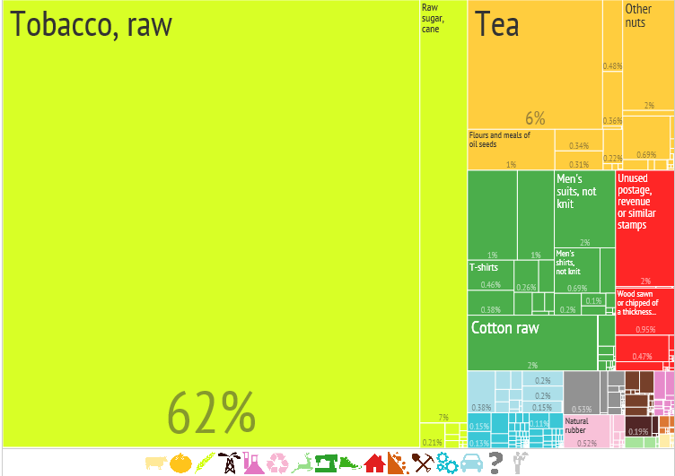
2012
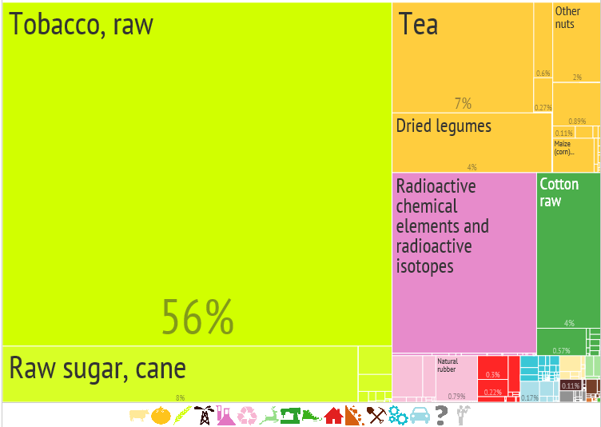
Source: ‘The Atlas of Economic Complexity’, Center for International Development at Harvard University (http://www.atlas.cid.harvard.edu).

- Top export products, Malawi (average 2011–13)
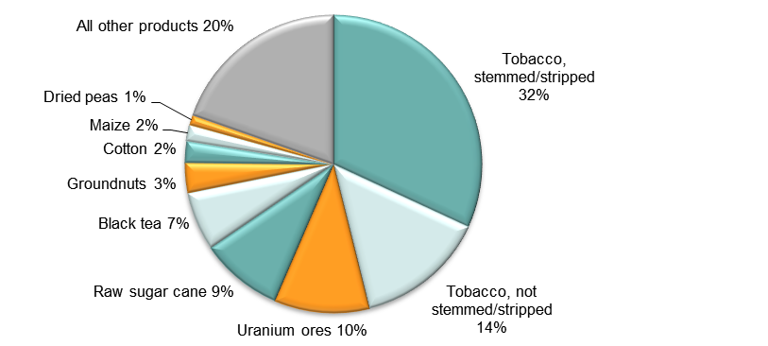
Note: At Harmonised System 6-digit level.
Source: Authors’ calculations using data from the ITC’s Trade Map.

- Top export markets, Malawi (average 2011–13)
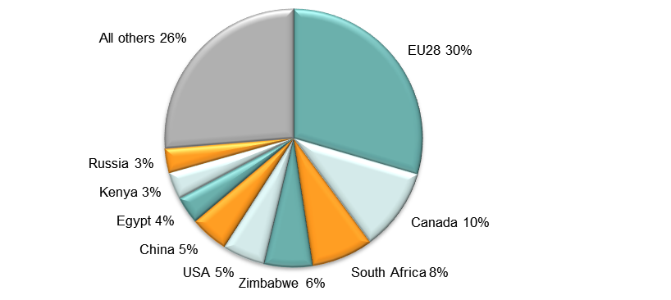
Source: Authors’ calculations using data from the ITC’s Trade Map.
- Imports by broad HS Section, Malawi, 2005–8 and 2009–13

Key:
HS Sect. | Description
1 | Live animals; animal products
2 | Vegetable products
3 | Animal or vegetable fats and oils and their cleavage products; prepared edible fats; animal or vegetable waxes
4 | Prepared foodstuffs; beverages, spirits and vinegar; tobacco and manufactured tobacco substitutes
5 | Mineral products
6 | Products of the chemical or allied industries
7 | Plastics and articles thereof; rubber and articles thereof
8 | Raw hides and skins, leather, furskins and articles thereof; saddlery and harness; travel goods, handbags and similar containers; articles of animal gut (other than silk-worm gut)
9 | Wood and articles of wood; wood charcoal; cork and articles of cork; manufactures of straw, of esparto or of other plaiting materials; basketware and wickerwork
10 | Pulp of wood or of other fibrous cellulosic material; recovered (waste and scrap) paper or paperboard; paper and paperboard and articles thereof
11 | Textiles and textile articles
12 | Footwear, headgear, umbrellas, sun umbrellas, walking-sticks, seat-sticks, whips, riding-crops and parts thereof; prepared feathers and articles made therewith; artificial flowers; articles of human hair
13 | Articles of stone, plaster, cement, asbestos, mica or similar materials; ceramic products; glass and glassware
14 | Natural or cultured pearls, precious or semi-precious stones, precious metals, metals clad with precious metal and articles thereof; imitation jewellery; coin thereof; imitation jewellery; coin
15 | Base metals and articles of base metal
16 | Machinery and mechanical appliances; electrical equipment; parts thereof; sound recorders and reproducers, television image and sound recorders and reproducers, and parts and accessories of such articles
17 | Vehicles, aircraft, vessels and associated transport equipment
18 | Optical, photographic, cinematographic, measuring, checking, precision, medical or surgical instruments and apparatus; clocks and watches; musical instruments; parts and accessories thereof
19 | Arms and ammunition; parts and accessories thereof
20 | Miscellaneous manufactured articles
21 | Works of art, collectors’ pieces and antiques
Note: Bubble sizes and labels relate to the number of HS 6-digit subheads within the Section which were imported
Source: Authors’ calculation using data from the ITC’s Trade Map.
- Change in import share by HS Section, Malawi, 2005–8 and 2009–13

Key:
HS Sect. | Description
1 | Live animals; animal products
2 | Vegetable products
3 | Animal or vegetable fats and oils and their cleavage products; prepared edible fats; animal or vegetable waxes
4 | Prepared foodstuffs; beverages, spirits and vinegar; tobacco and manufactured tobacco substitutes
5 | Mineral products
6 | Products of the chemical or allied industries
7 | Plastics and articles thereof; rubber and articles thereof
8 | Raw hides and skins, leather, furskins and articles thereof; saddlery and harness; travel goods, handbags and similar containers; articles of animal gut (other than silk-worm gut)
9 | Wood and articles of wood; wood charcoal; cork and articles of cork; manufactures of straw, of esparto or of other plaiting materials; basketware and wickerwork
10 | Pulp of wood or of other fibrous cellulosic material; recovered (waste and scrap) paper or paperboard; paper and paperboard and articles thereof
11 | Textiles and textile articles
12 | Footwear, headgear, umbrellas, sun umbrellas, walking-sticks, seat-sticks, whips, riding-crops and parts thereof; prepared feathers and articles made therewith; artificial flowers; articles of human hair
13 | Articles of stone, plaster, cement, asbestos, mica or similar materials; ceramic products; glass and glassware
14 | Natural or cultured pearls, precious or semi-precious stones, precious metals, metals clad with precious metal and articles thereof; imitation jewellery; coin thereof; imitation jewellery; coin
15 | Base metals and articles of base metal
16 | Machinery and mechanical appliances; electrical equipment; parts thereof; sound recorders and reproducers, television image and sound recorders and reproducers, and parts and accessories of such articles
17 | Vehicles, aircraft, vessels and associated transport equipment
18 | Optical, photographic, cinematographic, measuring, checking, precision, medical or surgical instruments and apparatus; clocks and watches; musical instruments; parts and accessories thereof
19 | Arms and ammunition; parts and accessories thereof
20 | Miscellaneous manufactured articles
21 | Works of art, collectors’ pieces and antiques
Source: Authors’ calculation using data from the ITC’s Trade Map.

- Import visualisation, Malawi, 2005 and 2012
2005
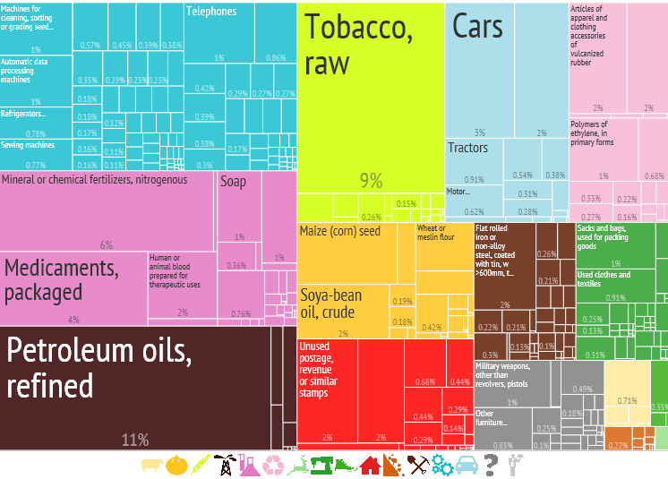
2012
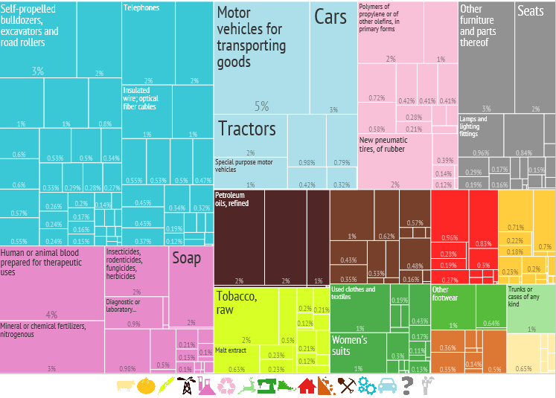
Source: ‘The Atlas of Economic Complexity’, Center for International Development at Harvard University (http://www.atlas.cid.harvard.edu).

- Top import products, Malawi (average 2011–13)
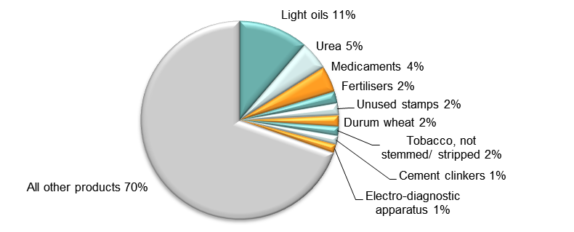
Note: At Harmonised System 6-digit level.
Source: Authors’ calculations using data from the ITC’s Trade Map.

- Top import sources, Malawi (average 2011–13)
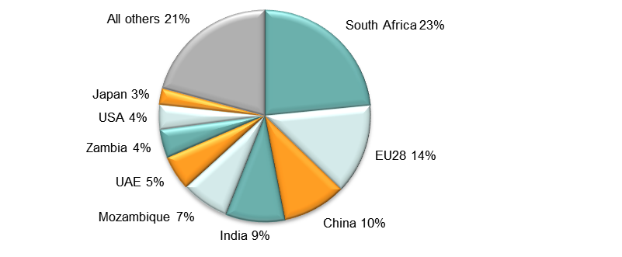
Source: Authors’ calculations using data from the ITC’s Trade Map.

Diversification
- Export diversification index, Malawi, 1965–2010

Notes:
Higher values reflect lower diversification.
Extensive export diversification reflects an increase in the number of export products or trading partners.
Intensive export diversification considers the shares of export volumes across active products or trading partners. Thus, a country is less diversified when export revenues are driven by only a few sectors or trading partners, even though the country might be exporting many different goods or to many different trading partners. Countries with a more evenly balanced mix of exports or trading partners have a higher level of intensive diversification.
Source: DFID–IMF Diversification Toolkit (http://www.imf.org/external/np/res/dfidimf/diversification.htm): Export Diversification Database.

- Export quality index, Malawi, 1966–2010

Source: DFID–IMF Diversification Toolkit (http://www.imf.org/external/np/res/dfidimf/diversification.htm): Export Quality Database.

- Number of export items and markets, Malawi, 2005–13

Note: EU countries counted individually.
Source: Authors’ calculation using data from the ITC’s Trade Map.

- Number of import items and suppliers, Malawi, 2005–13

Note: EU countries counted individually.
Source: Authors’ calculation using data from the ITC’s Trade Map.

Revealed comparative advantage
- Revealed comparative advantage by HS Section, Malawi
HS Sect. | Product label | 2005 | 2006 | 2007 | 2008 | 2009 | 2010 | 2011 | 2012 | 2013
 | Total in HS 1-97 | 1.00 | 1.00 | 1.00 | 1.00 | 1.00 | 1.00 | 1.00 | 1.00 | 1.00
1 | Live animals; animal products | 0.04 | 0.15 | 0.04 | 0.06 | 0.03 | 0.13 | 0.12 | 0.93 | 0.15
2 | Vegetable products | 7.97 | 6.80 | 13.00 | 4.78 | 5.84 | 5.50 | 7.21 | 5.45 | 6.74
3 | Animal or vegetable fats and oils and their cleavage products; prepared edible fats; animal or vegetable waxes | 0.02 | 0.01 | 0.05 | 0.12 | 0.14 | 0.04 | 0.02 | 0.00 | 0.02
4 | Prepared foodstuffs; beverages, spirits and vinegar; tobacco and manufactured tobacco substitutes | 21.77 | 24.84 | 20.02 | 25.89 | 19.99 | 19.80 | 18.27 | 18.45 | 17.35
5 | Mineral products | 0.00 | 0.02 | 0.00 | 0.01 | 0.06 | 0.65 | 0.47 | 0.61 | 0.59
6 | Products of the chemical or allied industries | 0.03 | 0.02 | 0.07 | 0.05 | 0.02 | 0.06 | 0.07 | 0.02 | 0.07
7 | Plastics and articles thereof; rubber and articles thereof | 0.15 | 0.28 | 0.63 | 0.30 | 0.40 | 0.64 | 0.63 | 0.51 | 0.52
8 | Raw hides and skins, leather, furskins and articles thereof; saddlery and harness; travel goods, handbags and similar containers; articles of animal gut (other than silk-worm gut) | 0.18 | 0.22 | 0.22 | 0.17 | 0.15 | 0.11 | 0.12 | 0.27 | 0.23
9 | Wood and articles of wood; wood charcoal; cork and articles of cork; manufactures of straw, of esparto or of other plaiting materials; basketware and wickerwork | 0.67 | 1.07 | 0.97 | 1.46 | 1.34 | 1.53 | 1.07 | 2.23 | 2.33
10 | Pulp of wood or of other fibrous cellulosic material; recovered (waste and scrap) paper or paperboard; paper and paperboard and articles thereof | 0.45 | 0.32 | 0.49 | 0.14 | 0.10 | 0.09 | 0.12 | 0.33 | 0.15
11 | Textiles and textile articles | 2.47 | 1.88 | 1.48 | 1.95 | 1.13 | 0.85 | 1.13 | 1.16 | 0.69
12 | Footwear, headgear, umbrellas, sun umbrellas, walking-sticks, seat-sticks, whips, riding-crops and parts thereof; prepared feathers and articles made therewith; artificial flowers; articles of human hair | 0.01 | 0.04 | 0.05 | 0.02 | 0.02 | 0.03 | 0.02 | 0.03 | 0.04
13 | Articles of stone, plaster, cement, asbestos, mica or similar materials; ceramic products; glass and glassware | 0.05 | 0.03 | 0.04 | 0.06 | 0.04 | 0.03 | 0.03 | 0.02 | 0.01
14 | Natural or cultured pearls, precious or semi-precious stones, precious metals, metals clad with precious metal and articles thereof; imitation jewellery; coin thereof; imitation jewellery; coin | 0.04 | 0.00 | 0.00 | 0.01 | 0.00 | 0.01 | 0.00 | 0.00 | 0.01
15 | Base metals and articles of base metal | 0.05 | 0.08 | 0.01 | 0.02 | 0.05 | 0.06 | 0.08 | 0.03 | 0.03
16 | Machinery and mechanical appliances; electrical equipment; parts thereof; sound recorders and reproducers, television image and sound recorders and reproducers, and parts and accessories of such articles | 0.06 | 0.06 | 0.04 | 0.04 | 0.06 | 0.08 | 0.04 | 0.04 | 0.07
17 | Vehicles, aircraft, vessels and associated transport equipment | 0.13 | 0.08 | 0.03 | 0.08 | 0.09 | 0.06 | 0.19 | 0.10 | 0.11
18 | Optical, photographic, cinematographic, measuring, checking, precision, medical or surgical instruments and apparatus; clocks and watches; musical instruments; parts and accessories thereof | 0.03 | 0.03 | 0.04 | 0.03 | 0.03 | 0.03 | 0.02 | 0.02 | 0.10
19 | Arms and ammunition; parts and accessories thereof | 16.73 | 19.89 | 1.60 | 0.00 | - | 0.16 | 24.23 | - | -
20 | Miscellaneous manufactured articles | 0.27 | 0.28 | 0.11 | 0.20 | 0.27 | 0.12 | 0.20 | 0.14 | 0.07
21 | Works of art, collectors’ pieces and antiques | 0.43 | 0.05 | 0.02 | 0.17 | 0.03 | 0.01 | 0.01 | 0.02 | 0.01
Note: Share of country’s exports in each HS Section in country’s total exports as a ratio of share of world exports in each HS Section in world total exports. ‘World’ = UN COMTRADE’s ‘all countries’ aggregate, i.e. total of however many countries have reported their data in any given year.
Source: Authors’ calculations using data from the UN’s COMTRADE database.

Trade in value added
- Compound annual growth rate of domestic value added, foreign value added and exports, 1996-2011 and 2006-11, Malawi

Source: Own computations using Eora26 database

- Domestic and foreign value added content of gross exports as share of gross exports, 1996, 2000, 2006 and 2011, Malawi

Source: Own computations using Eora26 database

- Overall value of domestic and foreign value added, 1996, 2000, 2006 and 2011 (in USD 1,000) , Malawi

Source: Own computations using Eora26 database

- Compound annual growth rate of DVA embodied in gross exports by sector, 1996-2011 and 2006-2011, Malawi

Source: Own computations using Eora26 database

- Sectoral DVA embodied in exports as a share of sectoral gross exports, 2000 and 2011, Malawi

Source: Own computations using Eora26 database

- Sectoral DVA as a share of total DVA, 2000 and 2011, Malawi

Source: Own computations using Eora26 database

- Compound annual growth rate of FVA embodied in gross exports by sector, 1996-2011 and 2006-2011, Malawi

Source: Own computations using Eora26 database

- Sectoral FVA embodied in exports as a share of sectoral gross exports, 2000 and 2011, Malawi

Source: Own computations using Eora26 database

- Sectoral FVA as a share of total FVA, 2000 and 2011, Malawi

Source: Own computations using Eora26 database

Trade in services
- Exports of goods and services, Malawi

Source: Authors’ calculation using data from the World Bank’s World Development Indicators.
- Sectoral shares of services exports, Malawi

Source: Authors’ calculation using data from the World Bank’s World Development Indicators.

Wages by occupation
- Relative wages in Malawi

Source: Monthly wages in US$ (adjusted: Oostendorp 2012) (stata variable mw3wuus), see http://www.nber.org/oww/ – occupational wages compared to country average for that year.

