Somalia:
Data on economic transformation

Economic structures 3
Table 1. Sectoral shares in gross value added, Somalia, 1991–2013 NEW 3
Figure 1. Total employment by sex and broad sector, Somalia 3
Figure 2. Broad sectoral employment by sex, Somalia 4
Trade 5
Basic data 5
Figure 3. Total value of trade, Somalia, 2005–13 (mirror data) 5
Figure 4. Exports by broad HS Section, Somalia, 2005–8 and 2009–13 (mirror data) 6
Figure 5. Change in export share by HS Section, Somalia, 2005–8 and 2009–13 (mirror data) 7
Figure 6. Export visualisation, Somalia, 2005 and 2012 8
Figure 7. Top export products, Somalia (average 2011–13, mirror data) 9
Figure 8. Top export markets, Somalia (average 2011–13, mirror data) 9
Figure 9. Imports by broad HS Section, Somalia, 2005–8 and 2009–13 (mirror data) 10
Figure 10. Change in import share by HS Section, Somalia, 2005–8 and 2009–13 (mirror data) 11
Figure 11. Import visualisation, Somalia, 2005 and 2012 12
Figure 12. Top import products, Somalia (average 2011–13, mirror data) 13
Figure 13. Top import sources, Somalia (average 2011–13, mirror data) 13
Diversification 14
Figure 14. Export diversification index, Somalia, 1965–2010 14
Figure 15. Export quality index, Somalia, 1970–2010 14
Figure 16. Number of export items and markets, Somalia, 2005–13 (mirror data) 15
Figure 17. Number of import items and suppliers, Somalia, 2005–13 (mirror data) 15
Revealed comparative advantage 17
Table 2. Revealed comparative advantage by HS Section, Somalia (mirror data) 17
Trade in value added 18
Figure 18. Compound annual growth rate of domestic value added, foreign value added and exports, 1996-2011 and 2006-11, Somalia 18
Figure 19. Domestic and foreign value added content of gross exports as share of gross exports, 1996, 2000, 2006 and 2011, Somalia 18
Figure 20. Overall value of domestic and foreign value added, 1996, 2000, 2006 and 2011 (in USD 1,000) , Somalia 18
Figure 21. Compound annual growth rate of DVA embodied in gross exports by sector, 1996-2011 and 2006-2011, Somalia 19
Figure 22. Sectoral DVA embodied in exports as a share of sectoral gross exports, 2000 and 2011, Somalia 19
Figure 23. Sectoral DVA as a share of total DVA, 2000 and 2011, Somalia 20
Figure 24. Compound annual growth rate of FVA embodied in gross exports by sector, 1996-2011 and 2006-2011, Somalia 21
Figure 25. Sectoral FVA embodied in exports as a share of sectoral gross exports, 2000 and 2011, Somalia 21
Figure 26. Sectoral FVA as a share of total FVA, 2000 and 2011, Somalia 22

Economic structures
- Sectoral shares in gross value added, Somalia, 1991–2013 NEW
Economic activity | Gross value added (current US$, %)
 | 1975 | 1991 | 2000 | 2005 | 2010 | 2013
Agriculture | 56.4 | 64.3 | 60.2 | 60.1 | 60.2 | 60.2
Mining & utilities | 1.3 | 0.5 | 0.7 | 0.7 | 0.7 | 0.7
Manufacturing | 3.7 | 2.3 | 2.5 | 2.5 | 2.5 | 2.5
Construction | 5.5 | 4.1 | 4.2 | 4.2 | 4.2 | 4.2
Wholesale, retail, hotels | 11.0 | 10.5 | 10.6 | 10.6 | 10.6 | 10.6
Transport, storage, comms | 8.5 | 7.6 | 9.3 | 9.7 | 9.4 | 9.4
Other | 13.5 | 10.7 | 12.6 | 12.3 | 12.5 | 12.5
Total | 100 | 100 | 100 | 100 | 100 | 100
Source: Authors’ calculations using UNSD National Accounts Main Aggregates data on ‘gross value added by kind of economic activity’ (https://data.un.org/search.aspx?q=gross+value+added+datamart%5bsnaama%5d).

- Total employment by sex and broad sector, Somalia

Source: ILO Global Employment Trends 2014 (http://www.ilo.org/global/research/global-reports/global-employment-trends/2014/WCMS_234879/lang--en/index.htm).

- Broad sectoral employment by sex, Somalia

Source: Authors’ calculations using data from the ILO’s Global Employment Trends 2014 (http://www.ilo.org/global/research/global-reports/global-employment-trends/2014/WCMS_234879/lang--en/index.htm).

Trade

Basic data
- Total value of trade, Somalia, 2005–13 (mirror data)

Source: ITC Trade Map. Note the use of mirror data, which is indicative only and should be treated with caution. In particular, the total number of reporters may vary from year to year.

- Exports by broad HS Section, Somalia, 2005–8 and 2009–13 (mirror data)

Key:
HS Sect. | Description
1 | Live animals; animal products
2 | Vegetable products
3 | Animal or vegetable fats and oils and their cleavage products; prepared edible fats; animal or vegetable waxes
4 | Prepared foodstuffs; beverages, spirits and vinegar; tobacco and manufactured tobacco substitutes
5 | Mineral products
6 | Products of the chemical or allied industries
7 | Plastics and articles thereof; rubber and articles thereof
8 | Raw hides and skins, leather, furskins and articles thereof; saddlery and harness; travel goods, handbags and similar containers; articles of animal gut (other than silk-worm gut)
9 | Wood and articles of wood; wood charcoal; cork and articles of cork; manufactures of straw, of esparto or of other plaiting materials; basketware and wickerwork
10 | Pulp of wood or of other fibrous cellulosic material; recovered (waste and scrap) paper or paperboard; paper and paperboard and articles thereof
11 | Textiles and textile articles
12 | Footwear, headgear, umbrellas, sun umbrellas, walking-sticks, seat-sticks, whips, riding-crops and parts thereof; prepared feathers and articles made therewith; artificial flowers; articles of human hair
13 | Articles of stone, plaster, cement, asbestos, mica or similar materials; ceramic products; glass and glassware
14 | Natural or cultured pearls, precious or semi-precious stones, precious metals, metals clad with precious metal and articles thereof; imitation jewellery; coin thereof; imitation jewellery; coin
15 | Base metals and articles of base metal
16 | Machinery and mechanical appliances; electrical equipment; parts thereof; sound recorders and reproducers, television image and sound recorders and reproducers, and parts and accessories of such articles
17 | Vehicles, aircraft, vessels and associated transport equipment
18 | Optical, photographic, cinematographic, measuring, checking, precision, medical or surgical instruments and apparatus; clocks and watches; musical instruments; parts and accessories thereof
19 | Arms and ammunition; parts and accessories thereof
20 | Miscellaneous manufactured articles
21 | Works of art, collectors’ pieces and antiques
Note: Bubble sizes and labels relate to the number of HS 6-digit subheads within the Section which were exported
Source: Authors’ calculation using data from ITC’s Trade Map. Note the use of mirror data, which is indicative only and should be treated with caution.
- Change in export share by HS Section, Somalia, 2005–8 and 2009–13 (mirror data)

Key:
HS Sect. | Description
1 | Live animals; animal products
2 | Vegetable products
3 | Animal or vegetable fats and oils and their cleavage products; prepared edible fats; animal or vegetable waxes
4 | Prepared foodstuffs; beverages, spirits and vinegar; tobacco and manufactured tobacco substitutes
5 | Mineral products
6 | Products of the chemical or allied industries
7 | Plastics and articles thereof; rubber and articles thereof
8 | Raw hides and skins, leather, furskins and articles thereof; saddlery and harness; travel goods, handbags and similar containers; articles of animal gut (other than silk-worm gut)
9 | Wood and articles of wood; wood charcoal; cork and articles of cork; manufactures of straw, of esparto or of other plaiting materials; basketware and wickerwork
10 | Pulp of wood or of other fibrous cellulosic material; recovered (waste and scrap) paper or paperboard; paper and paperboard and articles thereof
11 | Textiles and textile articles
12 | Footwear, headgear, umbrellas, sun umbrellas, walking-sticks, seat-sticks, whips, riding-crops and parts thereof; prepared feathers and articles made therewith; artificial flowers; articles of human hair
13 | Articles of stone, plaster, cement, asbestos, mica or similar materials; ceramic products; glass and glassware
14 | Natural or cultured pearls, precious or semi-precious stones, precious metals, metals clad with precious metal and articles thereof; imitation jewellery; coin thereof; imitation jewellery; coin
15 | Base metals and articles of base metal
16 | Machinery and mechanical appliances; electrical equipment; parts thereof; sound recorders and reproducers, television image and sound recorders and reproducers, and parts and accessories of such articles
17 | Vehicles, aircraft, vessels and associated transport equipment
18 | Optical, photographic, cinematographic, measuring, checking, precision, medical or surgical instruments and apparatus; clocks and watches; musical instruments; parts and accessories thereof
19 | Arms and ammunition; parts and accessories thereof
20 | Miscellaneous manufactured articles
21 | Works of art, collectors’ pieces and antiques
Source: Authors’ calculation using data from ITC’s Trade Map. Note the use of mirror data, which is indicative only and should be treated with caution.

- Export visualisation, Somalia, 2005 and 2012
2005
2012
Source: MIT Observatory of Economic Complexity (http://atlas.media.mit.edu/explore/tree_map/hs/export/rwa/all/show/2012/).

- Top export products, Somalia (average 2011–13, mirror data)
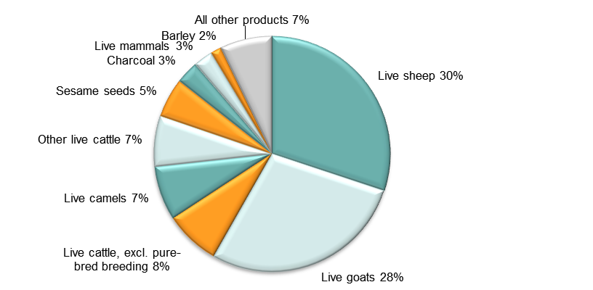
Note: At Harmonised System 6-digit level.
Source: Authors’ calculations using data from ITC’s Trade Map. Note the use of mirror data, which is indicative only and should be treated with caution.

- Top export markets, Somalia (average 2011–13, mirror data)
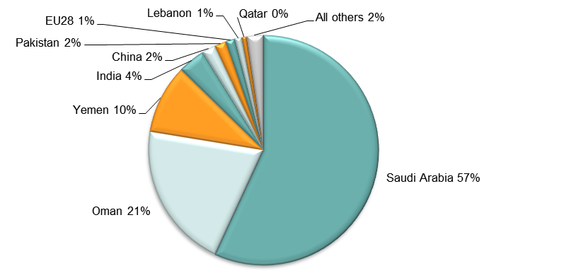
Source: Authors’ calculations using data from ITC’s Trade Map. Note the use of mirror data, which is indicative only and should be treated with caution.
- Imports by broad HS Section, Somalia, 2005–8 and 2009–13 (mirror data)

Key:
HS Sect. | Description
1 | Live animals; animal products
2 | Vegetable products
3 | Animal or vegetable fats and oils and their cleavage products; prepared edible fats; animal or vegetable waxes
4 | Prepared foodstuffs; beverages, spirits and vinegar; tobacco and manufactured tobacco substitutes
5 | Mineral products
6 | Products of the chemical or allied industries
7 | Plastics and articles thereof; rubber and articles thereof
8 | Raw hides and skins, leather, furskins and articles thereof; saddlery and harness; travel goods, handbags and similar containers; articles of animal gut (other than silk-worm gut)
9 | Wood and articles of wood; wood charcoal; cork and articles of cork; manufactures of straw, of esparto or of other plaiting materials; basketware and wickerwork
10 | Pulp of wood or of other fibrous cellulosic material; recovered (waste and scrap) paper or paperboard; paper and paperboard and articles thereof
11 | Textiles and textile articles
12 | Footwear, headgear, umbrellas, sun umbrellas, walking-sticks, seat-sticks, whips, riding-crops and parts thereof; prepared feathers and articles made therewith; artificial flowers; articles of human hair
13 | Articles of stone, plaster, cement, asbestos, mica or similar materials; ceramic products; glass and glassware
14 | Natural or cultured pearls, precious or semi-precious stones, precious metals, metals clad with precious metal and articles thereof; imitation jewellery; coin thereof; imitation jewellery; coin
15 | Base metals and articles of base metal
16 | Machinery and mechanical appliances; electrical equipment; parts thereof; sound recorders and reproducers, television image and sound recorders and reproducers, and parts and accessories of such articles
17 | Vehicles, aircraft, vessels and associated transport equipment
18 | Optical, photographic, cinematographic, measuring, checking, precision, medical or surgical instruments and apparatus; clocks and watches; musical instruments; parts and accessories thereof
19 | Arms and ammunition; parts and accessories thereof
20 | Miscellaneous manufactured articles
21 | Works of art, collectors’ pieces and antiques
Note: Bubble sizes and labels relate to the number of HS 6-digit subheads within the Section which were imported
Source: Authors’ calculation using data from ITC’s Trade Map. Note the use of mirror data, which is indicative only and should be treated with caution.
- Change in import share by HS Section, Somalia, 2005–8 and 2009–13 (mirror data)

Key:
HS Sect. | Description
1 | Live animals; animal products
2 | Vegetable products
3 | Animal or vegetable fats and oils and their cleavage products; prepared edible fats; animal or vegetable waxes
4 | Prepared foodstuffs; beverages, spirits and vinegar; tobacco and manufactured tobacco substitutes
5 | Mineral products
6 | Products of the chemical or allied industries
7 | Plastics and articles thereof; rubber and articles thereof
8 | Raw hides and skins, leather, furskins and articles thereof; saddlery and harness; travel goods, handbags and similar containers; articles of animal gut (other than silk-worm gut)
9 | Wood and articles of wood; wood charcoal; cork and articles of cork; manufactures of straw, of esparto or of other plaiting materials; basketware and wickerwork
10 | Pulp of wood or of other fibrous cellulosic material; recovered (waste and scrap) paper or paperboard; paper and paperboard and articles thereof
11 | Textiles and textile articles
12 | Footwear, headgear, umbrellas, sun umbrellas, walking-sticks, seat-sticks, whips, riding-crops and parts thereof; prepared feathers and articles made therewith; artificial flowers; articles of human hair
13 | Articles of stone, plaster, cement, asbestos, mica or similar materials; ceramic products; glass and glassware
14 | Natural or cultured pearls, precious or semi-precious stones, precious metals, metals clad with precious metal and articles thereof; imitation jewellery; coin thereof; imitation jewellery; coin
15 | Base metals and articles of base metal
16 | Machinery and mechanical appliances; electrical equipment; parts thereof; sound recorders and reproducers, television image and sound recorders and reproducers, and parts and accessories of such articles
17 | Vehicles, aircraft, vessels and associated transport equipment
18 | Optical, photographic, cinematographic, measuring, checking, precision, medical or surgical instruments and apparatus; clocks and watches; musical instruments; parts and accessories thereof
19 | Arms and ammunition; parts and accessories thereof
20 | Miscellaneous manufactured articles
21 | Works of art, collectors’ pieces and antiques
Source: Authors’ calculation using data from ITC’s Trade Map. Note the use of mirror data, which is indicative only and should be treated with caution.

- Import visualisation, Somalia, 2005 and 2012
2005
2012
Source: MIT Observatory of Economic Complexity (http://atlas.media.mit.edu/explore/tree_map/hs/export/rwa/all/show/2012/).

- Top import products, Somalia (average 2011–13, mirror data)
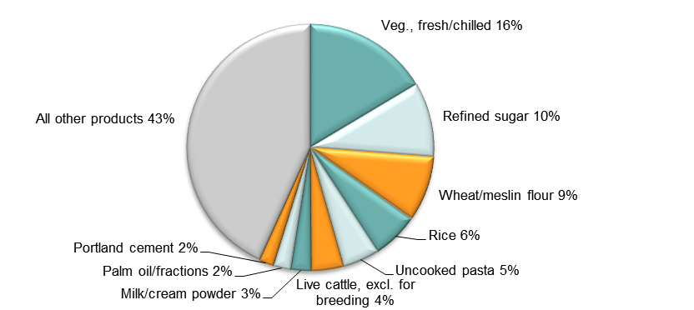
Note: At Harmonised System 6-digit level.
Source: Authors’ calculations using data from ITC’s Trade Map. Note the use of mirror data, which is indicative only and should be treated with caution.

- Top import sources, Somalia (average 2011–13, mirror data)
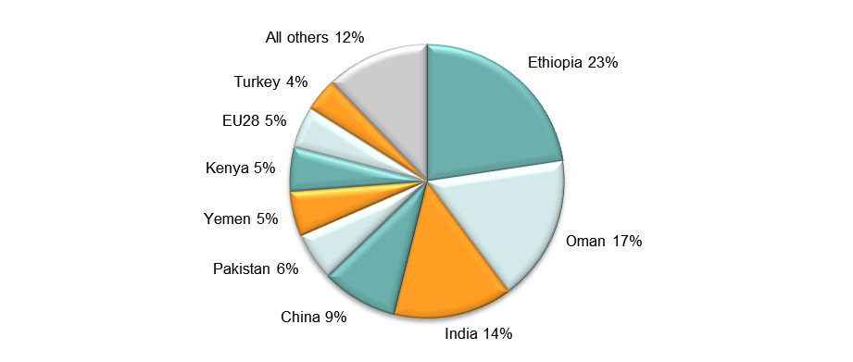
Source: Authors’ calculations using data from ITC’s Trade Map. Note the use of mirror data, which is indicative only and should be treated with caution.

Diversification
- Export diversification index, Somalia, 1965–2010

Notes:
Higher values reflect lower diversification.
Extensive export diversification reflects an increase in the number of export products or trading partners.
Intensive export diversification considers the shares of export volumes across active products or trading partners. Thus, a country is less diversified when export revenues are driven by only a few sectors or trading partners, even though the country might be exporting many different goods or to many different trading partners. Countries with a more evenly balanced mix of exports or trading partners have a higher level of intensive diversification.
Source: DFID–IMF Diversification Toolkit (http://www.imf.org/external/np/res/dfidimf/diversification.htm): Export Diversification Database.

- Export quality index, Somalia, 1970–2010

Source: DFID–IMF Diversification Toolkit (http://www.imf.org/external/np/res/dfidimf/diversification.htm): Export Quality Database.

- Number of export items and markets, Somalia, 2005–13 (mirror data)

Note: EU countries counted individually.
Source: Authors’ calculation using data from ITC’s Trade Map. Note the use of mirror data, which is indicative only and should be treated with caution. In particular, as countries report their data in different versions of the Harmonised System, virtually identical products may have had different codes during the period covered in the graph, and thus be duplicated in the subhead count plotted above.

- Number of import items and suppliers, Somalia, 2005–13 (mirror data)

Note: EU countries counted individually.
Source: Authors’ calculation using data from ITC’s Trade Map. In particular, as countries report their data in different versions of the Harmonised System, virtually identical products may have had different codes during the period covered in the graph, and thus be duplicated in the subhead count plotted above.

Revealed comparative advantage
- Revealed comparative advantage by HS Section, Somalia (mirror data)
HS Sect. | Product label | 2005 | 2006 | 2007 | 2008 | 2009 | 2010 | 2011 | 2012 | 2013
 | Total in HS 1-97 | 1.00 | 1.00 | 1.00 | 1.00 | 1.00 | 1.00 | 1.00 | 1.00 | 1.00
1 | Live animals; animal products | 38.44 | 32.32 | 25.58 | 23.10 | 37.13 | 43.40 | 41.05 | 43.72 | 40.53
2 | Vegetable products | 1.46 | 2.93 | 1.71 | 5.54 | 1.37 | 1.73 | 2.70 | 0.99 | 4.17
3 | Animal or vegetable fats and oils and their cleavage products; prepared edible fats; animal or vegetable waxes | 0.32 | 0.47 | 0.12 | 0.03 | 0.07 | 0.01 | 0.00 | 0.02 | 0.00
4 | Prepared foodstuffs; beverages, spirits and vinegar; tobacco and manufactured tobacco substitutes | 0.57 | 0.46 | 0.21 | 0.09 | 0.09 | 0.02 | 0.00 | 0.01 | 0.00
5 | Mineral products | 0.05 | 0.04 | 0.02 | 0.02 | 0.00 | 0.00 | 0.01 | 0.00 | 0.00
6 | Products of the chemical or allied industries | 0.04 | 0.03 | 0.14 | 0.08 | 0.08 | 0.01 | 0.01 | 0.02 | 0.01
7 | Plastics and articles thereof; rubber and articles thereof | 0.10 | 0.42 | 0.70 | 0.46 | 0.09 | 0.04 | 0.12 | 0.11 | 0.21
8 | Raw hides and skins, leather, furskins and articles thereof; saddlery and harness; travel goods, handbags and similar containers; articles of animal gut (other than silk-worm gut) | 7.51 | 10.71 | 8.85 | 16.25 | 7.11 | 5.74 | 8.09 | 5.93 | 2.60
9 | Wood and articles of wood; wood charcoal; cork and articles of cork; manufactures of straw, of esparto or of other plaiting materials; basketware and wickerwork | 6.93 | 13.79 | 9.30 | 17.97 | 13.12 | 7.95 | 8.66 | 8.19 | 0.20
10 | Pulp of wood or of other fibrous cellulosic material; recovered (waste and scrap) paper or paperboard; paper and paperboard and articles thereof | 0.02 | 0.00 | 0.07 | 0.02 | 0.06 | 0.00 | 0.01 | 0.00 | 0.00
11 | Textiles and textile articles | 0.03 | 0.03 | 0.10 | 0.03 | 0.02 | 0.01 | 0.02 | 0.00 | 0.00
12 | Footwear, headgear, umbrellas, sun umbrellas, walking-sticks, seat-sticks, whips, riding-crops and parts thereof; prepared feathers and articles made therewith; artificial flowers; articles of human hair | 0.00 | 0.02 | 0.07 | 0.08 | 0.18 | 0.01 | 0.01 | - | 0.01
13 | Articles of stone, plaster, cement, asbestos, mica or similar materials; ceramic products; glass and glassware | 0.00 | 0.01 | 0.17 | 0.08 | 0.07 | 0.00 | 0.00 | 0.00 | 0.00
14 | Natural or cultured pearls, precious or semi-precious stones, precious metals, metals clad with precious metal and articles thereof; imitation jewellery; coin thereof; imitation jewellery; coin | 1.05 | 3.37 | 5.89 | 8.19 | 0.00 | 0.00 | 0.00 | 0.00 | 0.01
15 | Base metals and articles of base metal | 0.50 | 0.40 | 0.28 | 0.03 | 0.03 | 0.00 | 0.01 | 0.01 | 0.01
16 | Machinery and mechanical appliances; electrical equipment; parts thereof; sound recorders and reproducers, television image and sound recorders and reproducers, and parts and accessories of such articles | 0.04 | 0.03 | 0.56 | 0.03 | 0.01 | 0.01 | 0.01 | 0.05 | 0.01
17 | Vehicles, aircraft, vessels and associated transport equipment | 0.02 | 0.16 | 0.05 | 0.01 | 0.04 | 0.01 | 0.00 | 0.01 | 0.03
18 | Optical, photographic, cinematographic, measuring, checking, precision, medical or surgical instruments and apparatus; clocks and watches; musical instruments; parts and accessories thereof | 0.01 | 0.04 | 0.03 | 0.15 | 0.00 | 0.02 | 0.00 | 0.00 | 0.00
19 | Arms and ammunition; parts and accessories thereof | - | - | - | - | - | - | - | - | -
20 | Miscellaneous manufactured articles | 0.06 | 0.01 | 0.07 | 0.02 | 0.05 | 0.03 | 0.03 | 0.00 | 0.02
21 | Works of art, collectors’ pieces and antiques | - | - | 0.02 | 0.01 | 0.31 | 0.00 | 0.04 | 0.14 | 0.53
Note: Share of country’s exports in each HS Section in country’s total exports (based on mirror data) as a ratio of share of world exports in each HS Section in world total exports. ‘World’ = UN COMTRADE’s ‘all countries’ aggregate, i.e. total of however many countries have reported their data in any given year.
Source: Authors’ calculations using data from the UN’s COMTRADE database.

Trade in value added
- Compound annual growth rate of domestic value added, foreign value added and exports, 1996-2011 and 2006-11, Somalia

Source: Own computations using Eora26 database

- Domestic and foreign value added content of gross exports as share of gross exports, 1996, 2000, 2006 and 2011, Somalia

Source: Own computations using Eora26 database

- Overall value of domestic and foreign value added, 1996, 2000, 2006 and 2011 (in USD 1,000) , Somalia

Source: Own computations using Eora26 database

- Compound annual growth rate of DVA embodied in gross exports by sector, 1996-2011 and 2006-2011, Somalia

Source: Own computations using Eora26 database

- Sectoral DVA embodied in exports as a share of sectoral gross exports, 2000 and 2011, Somalia

Source: Own computations using Eora26 database

- Sectoral DVA as a share of total DVA, 2000 and 2011, Somalia

Source: Own computations using Eora26 database

- Compound annual growth rate of FVA embodied in gross exports by sector, 1996-2011 and 2006-2011, Somalia

Source: Own computations using Eora26 database

- Sectoral FVA embodied in exports as a share of sectoral gross exports, 2000 and 2011, Somalia

Source: Own computations using Eora26 database

- Sectoral FVA as a share of total FVA, 2000 and 2011, Somalia

Source: Own computations using Eora26 database

