**West Bank & Gaza:  
Data on economic transformation**

Economic structures 1

Table 1. GDP, employment and relative productivity levels, West Bank & Gaza   
(WDI/ILO GET data) 1

Table 2. GDP, employment and relative productivity levels, West Bank & Gaza, 1991–2013   
(UNSD/ILO WESO data) NEW 2

Table 3. Labour productivity levels and changes, West Bank & Gaza   
(WDI/ILO GET data) 3

Table 4. Labour productivity levels and changes, West Bank & Gaza, 1991–2013   
(UNSD/ILO WESO data) NEW 3

Figure 1. Relative productivity and changes in employment shares by sector, West Bank & Gaza (WDI/ILO GET data) 4

Figure 2. Relative productivity and changes in employment shares by sector, West Bank & Gaza (UNSD/ILO WESO data) NEW 5

Figure 3. Decomposition of labour productivity change, West Bank & Gaza, 1990–2010 (WDI/ILO GET data) 7

Figure 4. Decomposition of labour productivity change, West Bank & Gaza, 1991–2013 (UNSD/ILO WESO data) NEW 7

Figure 5. Productivity gaps in West Bank & Gaza, 2012 (WDI/ILO GET data) 8

Figure 6. Productivity gaps in West Bank & Gaza, 2013 (UNSD/ILO WESO data) NEW 8

Figure 7. Total employment by sex and broad sector, West Bank & Gaza (ILO GET data) 9

Figure 8. Broad sectoral employment by sex, West Bank & Gaza (ILO GET data) 9

Figure 9. Sectoral employment by sex, West Bank & Gaza (ILO WESO data) NEW 10

Trade 11

Basic data 11

Figure 10. Total value of trade, West Bank & Gaza, 2007–12 11

Figure 11. Exports by broad HS Section, West Bank & Gaza, 2007–8 and 2009–12 12

Figure 12. Change in export share by HS Section, West Bank & Gaza, 2007–8 and 2009–12 13

Figure 13. Top export products, West Bank & Gaza (average 2010–12) 14

Figure 14. Top export markets, West Bank & Gaza (average 2010–12) 14

Figure 15. Imports by broad HS Section, West Bank & Gaza, 2007–8 and 2009–12 15

Figure 16. Change in import share by HS Section, West Bank & Gaza, 2007–8 and 2009–12 16

Figure 17. Top import products, West Bank & Gaza (average 2010–12) 17

Figure 18. Top import sources, West Bank & Gaza (average 2010–12) 17

Diversification 18

Figure 19. Number of export items and markets, West Bank & Gaza, 2007–12 18

Figure 20. Number of import items and suppliers, West Bank & Gaza, 2007–12 18

Revealed comparative advantage 19

Table 5. Revealed comparative advantage by HS Section, West Bank & Gaza 19

Trade in value added 20

Figure 21. Compound annual growth rate of domestic value added, foreign value added and exports, 1996-2011 and 2006-11, Gaza Strip 20

Figure 22. Domestic and foreign value added content of gross exports as share of gross exports, 1996, 2000, 2006 and 2011, Gaza Strip 20

Figure 23. Overall value of domestic and foreign value added, 1996, 2000, 2006 and 2011 (in USD 1,000) , Gaza Strip 20

Figure 24. Compound annual growth rate of DVA embodied in gross exports by sector, 1996-2011 and 2006-2011, Gaza Strip 21

Figure 25. Sectoral DVA embodied in exports as a share of sectoral gross exports, 2000 and 2011, Gaza Strip 21

Figure 26. Sectoral DVA as a share of total DVA, 2000 and 2011, Gaza Strip 22

Figure 27. Compound annual growth rate of FVA embodied in gross exports by sector, 1996-2011 and 2006-2011, Gaza Strip 23

Figure 28. Sectoral FVA embodied in exports as a share of sectoral gross exports, 2000 and 2011, Gaza Strip 23

Figure 29. Sectoral FVA as a share of total FVA, 2000 and 2011, Gaza Strip 24

Trade in services 25

Figure 30. Exports of goods and services, West Bank & Gaza 25

Figure 31. Sectoral shares of services exports, West Bank & Gaza 25

Estimates of total factor productivity at firm level 26

Figure 32. Dispersion in productivity across firms by sector – West Bank & Gaza 26

Figure 33. Distribution in productivity in West Bank & Gaza – comparing kernel and normal distributions 27

# Economic structures

1. GDP, employment and relative productivity levels, West Bank & Gaza (WDI/ILO GET data)

|  |  |  |  |  |  |  |  |  |  |  |  |  |
| --- | --- | --- | --- | --- | --- | --- | --- | --- | --- | --- | --- | --- |
|  | Value added (% of GDP) | | | | % of total employment | | | | Relative productivity levels d | | | |
|  | *1996* | *2000* | *2006* | *2012* | *1996* | *2000* | *2006* | *2012* | *1996* | *2000* | *2006* | *2012* |
| Agriculture a | 13.4 | 11.2 | 6.7 | n/a | 14.3 | 13.7 | 16.1 | 11.5 | 1.1 | 0.8 | 0.4 | 0.5 |
| Industry b | 32.8 | 25.4 | 26.9 | n/a | 28.4 | 34.4 | 23.9 | 26.3 | 0.9 | 0.7 | 1.1 | 1.1 |
| *Of which: Manufacturing* | *17.0* | *12.9* | *14.2* | *n/a* | *n/a* | *n/a* | *n/a* | *n/a* |  |  |  |  |
| Services c | 53.8 | 63.4 | 66.4 | n/a | 57.3 | 51.9 | 60.0 | 62.2 | 1.0 | 1.3 | 1.1 | 1.0 |
| **Total** | **100.0** | **100.0** | **100.0** |  | **100.0** | **100.0** | **100.0** | **100.0** | **1** | **1** | **1** | **1** |

Notes:  
(a) Agriculture corresponds to ISIC divisions 1-5 and includes forestry, hunting, and fishing, as well as cultivation of crops and livestock production.   
(b) Industry corresponds to ISIC divisions 10-45 and includes manufacturing (ISIC divisions 15-37). It comprises value added in mining, manufacturing (also reported as a separate subgroup), construction, electricity, water, and gas.  
(c) Services correspond to ISIC divisions 50-99 and they include value added in wholesale and retail trade (including hotels and restaurants), transport, and government, financial, professional, and personal services such as education, health care, and real estate services. Also included are imputed bank service charges, import duties, and any statistical discrepancies noted by national compilers as well as discrepancies arising from rescaling.  
(d) Derived by calculating labour productivity levels (value added at constant prices divided by number of persons employed) and expressing the result as a ratio of total economy labour productivity.  
Numbers may not sum due to rounding.  
Source: Authors’ calculations using sectoral value added and employment share data from the World Bank’s World Development Indicators (<http://databank.worldbank.org/data/views/variableSelection/selectvariables.aspx?source=world-development-indicators>) and total employment data from the ILO’s Global Employment Trends 2014 (<http://www.ilo.org/global/research/global-reports/global-employment-trends/2014/WCMS_234879/lang--en/index.htm>).

1. GDP, employment and relative productivity levels, West Bank & Gaza, 1991–2013 (UNSD/ILO WESO data) NEW

|  |  |  |  |  |  |  |  |  |  |  |  |  |  |  |  |  |  |  |
| --- | --- | --- | --- | --- | --- | --- | --- | --- | --- | --- | --- | --- | --- | --- | --- | --- | --- | --- |
| **Economic activity** | **Gross value added (current US$, %)** | | | | | | **Employment by sector (%)** | | | | | | **Relative productivity levels a** | | | | | |
|  | *1975* | *1991* | *2000* | *2005* | *2010* | *2013* | *1975* | *1991* | *2000* | *2005* | *2010* | *2013* | *1975* | *1991* | *2000* | *2005* | *2010* | *2013* |
| Agriculture | 13.2 | 13.3 | 10.8 | 5.8 | 6.4 | 4.6 | n/a | 15.6 | 13.5 | 14.5 | 11.9 | 10.5 | n/a | 0.8 | 0.7 | 0.4 | 0.6 | 0.5 |
| Mining & utilities | 3.3 | 3.3 | 4.2 | 5.2 | 3.3 | 2.7 | n/a | 1.1 | 0.5 | 0.5 | 0.7 | 1.1 | n/a | 3.2 | 5.5 | 10.2 | 4.6 | 2.7 |
| Manufacturing | 17.2 | 17.2 | 11.7 | 14.0 | 15.3 | 16.6 | n/a | 18.3 | 14.1 | 12.8 | 12.6 | 11.6 | n/a | 1.0 | 0.9 | 1.1 | 1.2 | 1.2 |
| Construction | 10.1 | 10.1 | 8.1 | 6.6 | 4.7 | 6.6 | n/a | 10.2 | 19.7 | 12.8 | 13.3 | 15.5 | n/a | 0.6 | 0.4 | 0.5 | 0.7 | 0.7 |
| Wholesale, retail, hotels | 14.5 | 14.3 | 13.8 | 13.2 | 20.6 | 21.7 | n/a | 19.1 | 17.5 | 19.5 | 20.1 | 19.6 | n/a | 0.9 | 0.9 | 0.7 | 1.0 | 1.1 |
| Transport, storage, comms | 3.7 | 3.6 | 5.3 | 6.2 | 8.8 | 7.9 | n/a | 4.8 | 5.1 | 5.6 | 6.1 | 6.5 | n/a | 1.0 | 1.9 | 1.1 | 1.5 | 1.3 |
| Other | 37.9 | 38.1 | 46.1 | 48.9 | 40.8 | 39.9 | n/a | 30.9 | 29.6 | 34.2 | 35.3 | 35.1 | n/a | 1.2 | 1.4 | 1.4 | 1.0 | 1.0 |
| **Total** | **100** | **100** | **100** | **100** | **100** | **100** | **n/a** | **100** | **100** | **100** | **100** | **100** | **n/a** | **1.0** | **1.0** | **1.0** | **1.0** | **1.0** |

Notes:  
(a) Derived by calculating labour productivity levels (gross value added at constant prices divided by number of persons employed per sector) and expressing the result as a ratio of total economy labour productivity.  
Numbers may not sum due to rounding.  
Source: Authors’ calculations using UNSD National Accounts Main Aggregates data on ‘gross value added by kind of economic activity’ (<https://data.un.org/search.aspx?q=gross+value+added+datamart%5bsnaama%5d>) and ILO World Employment and Social Outlook (WESO) – Trends 2015 supporting dataset ‘employment by sector and sex’ (<http://www.ilo.org/global/research/global-reports/weso/2015/lang--en/index.htm>). NB: The gross value added data are for ‘State of Palestine’ and the employment data for ‘West Bank and Gaza Strip’. In the gross value added data ‘Agriculture’ excludes irrigation canals and landscaping care, ‘Mining, Manufacturing, Utilities’ (which are disaggregated here) excludes publishing activities and includes irrigation canals, ‘Manufacturing’ excludes recycling and publishing activities, ‘Wholesale, retail trade, restaurants and hotels’ excludes repair of personal and household goods, ‘Transport, storage and communication’ excludes travel agencies, includes publishing activities, computer and related activities and radio/TV activities, ‘Other’ excludes computer and related activities and radio/TV activities and includes travel agencies and landscaping care; it was not possible to make corresponding adjustments when aggregating the employment data.

1. Labour productivity levels and changes, West Bank & Gaza (WDI/ILO GET data)

|  |  |  |  |  |  |  |  |  |
| --- | --- | --- | --- | --- | --- | --- | --- | --- |
|  | Labour productivity levels (index, 1996=100) | | | | Annualised growth | | | |
|  | *1996* | *2000* | *2006* | *2012* | *1996-2012* | *1996–2000* | *2000–06* | *2006–12* |
| Agriculture | 100.0 | 70.3 | 38.7 | 51.6 | -4.1% | -8.4% | -9.5% | 4.9% |
| Industry | 100.0 | 75.4 | 114.0 | 130.9 | 1.7% | -6.8% | 7.1% | 2.3% |
| Services | 100.0 | 134.0 | 114.3 | 115.0 | 0.9% | 7.6% | -2.6% | 0.1% |
| **Total** | **100.0** | **104.7** | **101.1** | **110.6** | **0.6%** | **1.1%** | **-0.6%** | **1.5%** |

Source: Authors’ calculations using sectoral value added and employment share data from the World Bank’s World Development Indicators (<http://databank.worldbank.org/data/views/variableSelection/selectvariables.aspx?source=world-development-indicators>) and total employment data from the ILO’s Global Employment Trends 2014 (<http://www.ilo.org/global/research/global-reports/global-employment-trends/2014/WCMS_234879/lang--en/index.htm>).

1. Labour productivity levels and changes, West Bank & Gaza, 1991–2013 (UNSD/ILO WESO data) NEW

|  |  |  |  |  |  |  |  |  |  |  |
| --- | --- | --- | --- | --- | --- | --- | --- | --- | --- | --- |
| **Economic activity** | **Labour productivity (index, 1991=100)** | | | | | **Annualised growth in labour productivity** | | | | |
|  | *1991* | *2000* | *2005* | *2010* | *2013* | *1991-2013* | *1991-2000* | *2000-05* | *2005-10* | *2010-13* |
| Agriculture | 100 | 121.0 | 70.8 | 98.6 | 91.4 | -0.4% | 2.1% | -10.2% | 6.9% | -2.5% |
| Mining & utilities | 100 | 240.3 | 478.1 | 218.9 | 142.6 | 1.6% | 10.2% | 14.7% | -14.5% | -13.3% |
| Manufacturing | 100 | 128.5 | 169.5 | 180.8 | 214.0 | 3.5% | 2.8% | 5.7% | 1.3% | 5.8% |
| Construction | 100 | 81.7 | 121.9 | 170.5 | 193.7 | 3.1% | -2.2% | 8.3% | 6.9% | 4.4% |
| Wholesale, retail, hotels | 100 | 141.8 | 115.3 | 173.7 | 210.8 | 3.4% | 4.0% | -4.0% | 8.5% | 6.7% |
| Transport, storage, comms | 100 | 256.3 | 161.7 | 224.0 | 206.2 | 3.3% | 11.0% | -8.8% | 6.7% | -2.7% |
| Other | 100 | 166.6 | 176.2 | 128.6 | 144.4 | 1.7% | 5.8% | 1.1% | -6.1% | 3.9% |
| **Total** | **100** | **140.6** | **149.6** | **150.8** | **167.7** | **2.4%** | **3.9%** | **1.2%** | **0.2%** | **3.6%** |

Note: Derived by calculating labour productivity levels (gross value added at constant 2005 prices divided by number of persons engaged) and expressing the results as an index related to 1991 levels.  
Source: Authors’ calculations using UNSD National Accounts Main Aggregates data on ‘gross value added by kind of economic activity’ (<https://data.un.org/search.aspx?q=gross+value+added+datamart%5bsnaama%5d>) and ILO World Employment and Social Outlook (WESO) – Trends 2015 supporting dataset ‘employment by sector and sex’ (<http://www.ilo.org/global/research/global-reports/weso/2015/lang--en/index.htm>). NB: The gross value added data are for ‘State of Palestine’ and the employment data for ‘West Bank and Gaza Strip’. In the gross value added data ‘Agriculture’ excludes irrigation canals and landscaping care, ‘Mining, Manufacturing, Utilities’ (which are disaggregated here) excludes publishing activities and includes irrigation canals, ‘Manufacturing’ excludes recycling and publishing activities, ‘Wholesale, retail trade, restaurants and hotels’ excludes repair of personal and household goods, ‘Transport, storage and communication’ excludes travel agencies, includes publishing activities, computer and related activities and radio/TV activities, ‘Other’ excludes computer and related activities and radio/TV activities and includes travel agencies and landscaping care; it was not possible to make corresponding adjustments when aggregating the employment data.

1. Relative productivity and changes in employment shares by sector, West Bank & Gaza (WDI/ILO GET data)

Note: Size of bubbles represents number of persons engaged in each sector in the later year of each of the three periods.  
Source: Authors’ calculations using sectoral value added and employment share data from the World Bank’s World Development Indicators (<http://databank.worldbank.org/data/views/variableSelection/selectvariables.aspx?source=world-development-indicators>) and total employment data from the ILO’s Global Employment Trends 2014 (<http://www.ilo.org/global/research/global-reports/global-employment-trends/2014/WCMS_234879/lang--en/index.htm>).

1. Relative productivity and changes in employment shares by sector, West Bank & Gaza (UNSD/ILO WESO data) NEW

Note: Size of bubbles represents number of persons employed in each sector in the later year of each period.  
Source: Authors’ calculations using UNSD National Accounts Main Aggregates data on ‘gross value added by kind of economic activity’ (<https://data.un.org/search.aspx?q=gross+value+added+datamart%5bsnaama%5d>) and ILO World Employment and Social Outlook (WESO) – Trends 2015 supporting dataset ‘employment by sector and sex’ (<http://www.ilo.org/global/research/global-reports/weso/2015/lang--en/index.htm>). NB: The gross value added data are for ‘State of Palestine’ and the employment data for ‘West Bank and Gaza Strip’. In the gross value added data ‘Agriculture’ excludes irrigation canals and landscaping care, ‘Mining, Manufacturing, Utilities’ (which are disaggregated here) excludes publishing activities and includes irrigation canals, ‘Manufacturing’ excludes recycling and publishing activities, ‘Wholesale, retail trade, restaurants and hotels’ excludes repair of personal and household goods, ‘Transport, storage and communication’ excludes travel agencies, includes publishing activities, computer and related activities and radio/TV activities, ‘Other’ excludes computer and related activities and radio/TV activities and includes travel agencies and landscaping care; it was not possible to make corresponding adjustments when aggregating the employment data.

1. Decomposition of labour productivity change, West Bank & Gaza, 1990–2010 (WDI/ILO GET data)

Source: Authors’ calculations using sectoral value added and employment share data from the World Bank’s World Development Indicators (<http://databank.worldbank.org/data/views/variableSelection/selectvariables.aspx?source=world-development-indicators>) and total employment data from the ILO’s Global Employment Trends 2014 (<http://www.ilo.org/global/research/global-reports/global-employment-trends/2014/WCMS_234879/lang--en/index.htm>).

1. Decomposition of labour productivity change, West Bank & Gaza, 1991–2013 (UNSD/ILO WESO data) NEW

Source: Authors’ calculations using UNSD National Accounts Main Aggregates data on ‘gross value added by kind of economic activity’ (<https://data.un.org/search.aspx?q=gross+value+added+datamart%5bsnaama%5d>) and ILO World Employment and Social Outlook (WESO) – Trends 2015 supporting dataset ‘employment by sector and sex’ (<http://www.ilo.org/global/research/global-reports/weso/2015/lang--en/index.htm>). NB: The gross value added data are for ‘State of Palestine’ and the employment data for ‘West Bank and Gaza Strip’. In the gross value added data ‘Agriculture’ excludes irrigation canals and landscaping care, ‘Mining, Manufacturing, Utilities’ (which are disaggregated here) excludes publishing activities and includes irrigation canals, ‘Manufacturing’ excludes recycling and publishing activities, ‘Wholesale, retail trade, restaurants and hotels’ excludes repair of personal and household goods, ‘Transport, storage and communication’ excludes travel agencies, includes publishing activities, computer and related activities and radio/TV activities, ‘Other’ excludes computer and related activities and radio/TV activities and includes travel agencies and landscaping care; it was not possible to make corresponding adjustments when aggregating the employment data.

1. Productivity gaps in West Bank & Gaza, 2012 (WDI/ILO GET data)

Source: Authors’ calculations using sectoral value added and employment share data from the World Bank’s World Development Indicators (<http://databank.worldbank.org/data/views/variableSelection/selectvariables.aspx?source=world-development-indicators>) and total employment data from the ILO’s Global Employment Trends 2014 (<http://www.ilo.org/global/research/global-reports/global-employment-trends/2014/WCMS_234879/lang--en/index.htm>).

1. Productivity gaps in West Bank & Gaza, 2013 (UNSD/ILO WESO data) NEW

Source: Authors’ calculations using UNSD National Accounts Main Aggregates data on ‘gross value added by kind of economic activity’ (<https://data.un.org/search.aspx?q=gross+value+added+datamart%5bsnaama%5d>) and ILO World Employment and Social Outlook (WESO) – Trends 2015 supporting dataset ‘employment by sector and sex’ (<http://www.ilo.org/global/research/global-reports/weso/2015/lang--en/index.htm>). NB: The gross value added data are for ‘State of Palestine’ and the employment data for ‘West Bank and Gaza Strip’. In the gross value added data ‘Agriculture’ excludes irrigation canals and landscaping care, ‘Mining, Manufacturing, Utilities’ (which are disaggregated here) excludes publishing activities and includes irrigation canals, ‘Manufacturing’ excludes recycling and publishing activities, ‘Wholesale, retail trade, restaurants and hotels’ excludes repair of personal and household goods, ‘Transport, storage and communication’ excludes travel agencies, includes publishing activities, computer and related activities and radio/TV activities, ‘Other’ excludes computer and related activities and radio/TV activities and includes travel agencies and landscaping care; it was not possible to make corresponding adjustments when aggregating the employment data.

1. Total employment by sex and broad sector, West Bank & Gaza (ILO GET data)

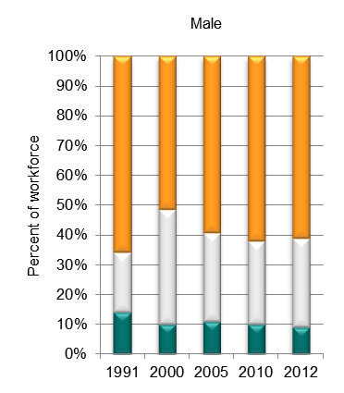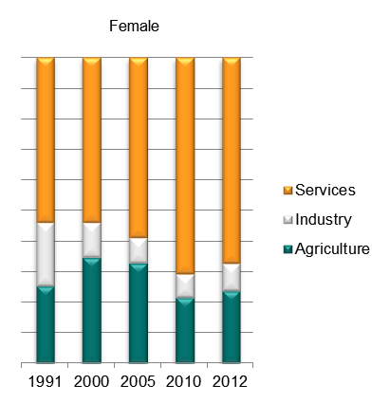

Source: ILO Global Employment Trends 2014 (<http://www.ilo.org/global/research/global-reports/global-employment-trends/2014/WCMS_234879/lang--en/index.htm>).

1. Broad sectoral employment by sex, West Bank & Gaza (ILO GET data)

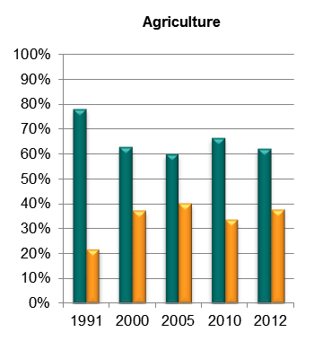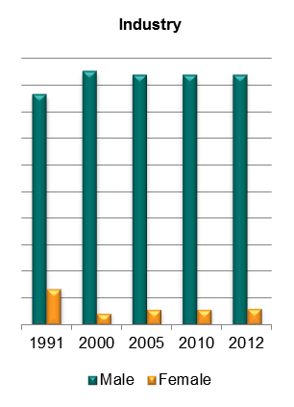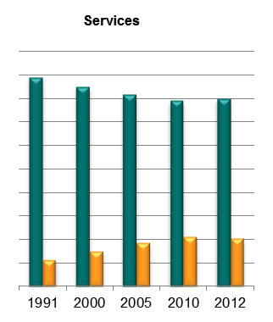

Source: Authors’ calculations using data from the ILO’s Global Employment Trends 2014 (<http://www.ilo.org/global/research/global-reports/global-employment-trends/2014/WCMS_234879/lang--en/index.htm>).

1. Sectoral employment by sex, West Bank & Gaza (ILO WESO data) NEW

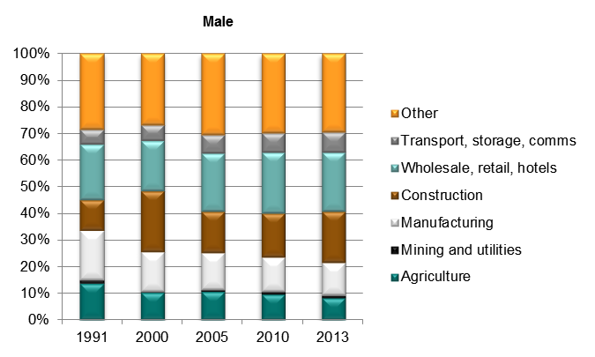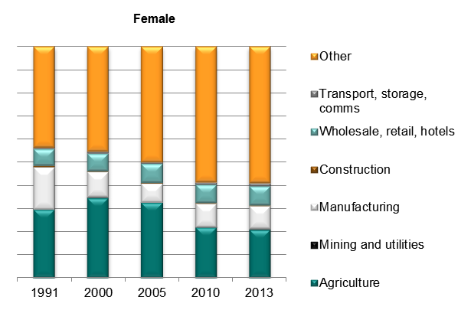

*Source: ILO World Employment and Social Outlook (WESO) – Trends 2015 supporting dataset ‘employment by sector and sex’ (*[*http://www.ilo.org/global/research/global-reports/weso/2015/lang--en/index.htm*](http://www.ilo.org/global/research/global-reports/weso/2015/lang--en/index.htm)*).*

# Trade

## Basic data

1. Total value of trade, West Bank & Gaza, 2007–12

Source: UN COMTRADE database.

1. Exports by broad HS Section, West Bank & Gaza, 2007–8 and 2009–12

|  |  |
| --- | --- |
| Key: |  |
| HS Sect. | Description |
| 1 | Live animals; animal products |
| 2 | Vegetable products |
| 3 | Animal or vegetable fats and oils and their cleavage products; prepared edible fats; animal or vegetable waxes |
| 4 | Prepared foodstuffs; beverages, spirits and vinegar; tobacco and manufactured tobacco substitutes |
| 5 | Mineral products |
| 6 | Products of the chemical or allied industries |
| 7 | Plastics and articles thereof; rubber and articles thereof |
| 8 | Raw hides and skins, leather, furskins and articles thereof; saddlery and harness; travel goods, handbags and similar containers; articles of animal gut (other than silk-worm gut) |
| 9 | Wood and articles of wood; wood charcoal; cork and articles of cork; manufactures of straw, of esparto or of other plaiting materials; basketware and wickerwork |
| 10 | Pulp of wood or of other fibrous cellulosic material; recovered (waste and scrap) paper or paperboard; paper and paperboard and articles thereof |
| 11 | Textiles and textile articles |
| 12 | Footwear, headgear, umbrellas, sun umbrellas, walking-sticks, seat-sticks, whips, riding-crops and parts thereof; prepared feathers and articles made therewith; artificial flowers; articles of human hair |
| 13 | Articles of stone, plaster, cement, asbestos, mica or similar materials; ceramic products; glass and glassware |
| 14 | Natural or cultured pearls, precious or semi-precious stones, precious metals, metals clad with precious metal and articles thereof; imitation jewellery; coin thereof; imitation jewellery; coin |
| 15 | Base metals and articles of base metal |
| 16 | Machinery and mechanical appliances; electrical equipment; parts thereof; sound recorders and reproducers, television image and sound recorders and reproducers, and parts and accessories of such articles |
| 17 | Vehicles, aircraft, vessels and associated transport equipment |
| 18 | Optical, photographic, cinematographic, measuring, checking, precision, medical or surgical instruments and apparatus; clocks and watches; musical instruments; parts and accessories thereof |
| 19 | Arms and ammunition; parts and accessories thereof |
| 20 | Miscellaneous manufactured articles |
| 21 | Works of art, collectors’ pieces and antiques |

Note: Bubble sizes and labels relate to the number of HS 6-digit subheads within the Section which were exported  
Source: Authors’ calculation using data from the UN’s COMTRADE database.

1. Change in export share by HS Section, West Bank & Gaza, 2007–8 and 2009–12

|  |  |
| --- | --- |
| Key: |  |
| HS Sect. | Description |
| 1 | Live animals; animal products |
| 2 | Vegetable products |
| 3 | Animal or vegetable fats and oils and their cleavage products; prepared edible fats; animal or vegetable waxes |
| 4 | Prepared foodstuffs; beverages, spirits and vinegar; tobacco and manufactured tobacco substitutes |
| 5 | Mineral products |
| 6 | Products of the chemical or allied industries |
| 7 | Plastics and articles thereof; rubber and articles thereof |
| 8 | Raw hides and skins, leather, furskins and articles thereof; saddlery and harness; travel goods, handbags and similar containers; articles of animal gut (other than silk-worm gut) |
| 9 | Wood and articles of wood; wood charcoal; cork and articles of cork; manufactures of straw, of esparto or of other plaiting materials; basketware and wickerwork |
| 10 | Pulp of wood or of other fibrous cellulosic material; recovered (waste and scrap) paper or paperboard; paper and paperboard and articles thereof |
| 11 | Textiles and textile articles |
| 12 | Footwear, headgear, umbrellas, sun umbrellas, walking-sticks, seat-sticks, whips, riding-crops and parts thereof; prepared feathers and articles made therewith; artificial flowers; articles of human hair |
| 13 | Articles of stone, plaster, cement, asbestos, mica or similar materials; ceramic products; glass and glassware |
| 14 | Natural or cultured pearls, precious or semi-precious stones, precious metals, metals clad with precious metal and articles thereof; imitation jewellery; coin thereof; imitation jewellery; coin |
| 15 | Base metals and articles of base metal |
| 16 | Machinery and mechanical appliances; electrical equipment; parts thereof; sound recorders and reproducers, television image and sound recorders and reproducers, and parts and accessories of such articles |
| 17 | Vehicles, aircraft, vessels and associated transport equipment |
| 18 | Optical, photographic, cinematographic, measuring, checking, precision, medical or surgical instruments and apparatus; clocks and watches; musical instruments; parts and accessories thereof |
| 19 | Arms and ammunition; parts and accessories thereof |
| 20 | Miscellaneous manufactured articles |
| 21 | Works of art, collectors’ pieces and antiques |

Source: Authors’ calculation using data from the UN’s COMTRADE database.

1. Top export products, West Bank & Gaza (average 2010–12)

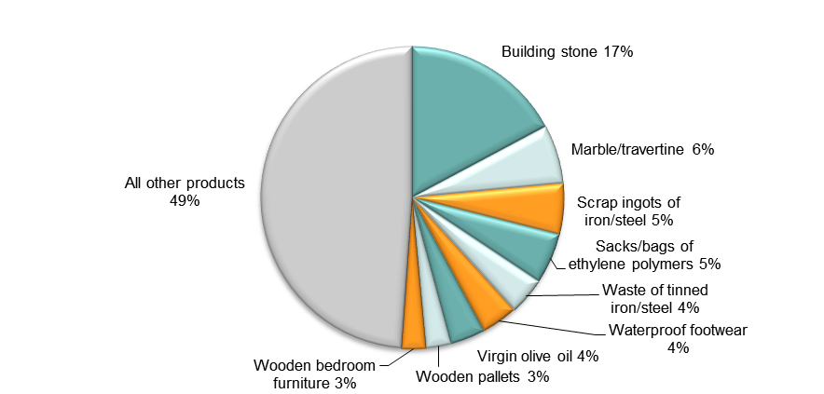

Note: At Harmonised System 6-digit level.  
Source: Authors’ calculations using data from UN COMTRADE database.

1. Top export markets, West Bank & Gaza (average 2010–12)

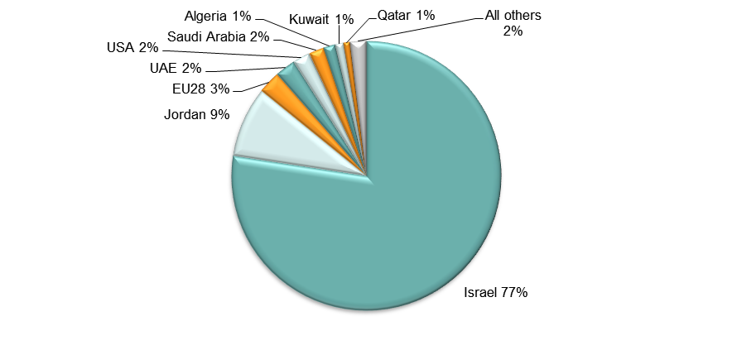

Source: Authors’ calculations using data from UN COMTRADE database.

1. Imports by broad HS Section, West Bank & Gaza, 2007–8 and 2009–12

|  |  |
| --- | --- |
| Key: |  |
| HS Sect. | Description |
| 1 | Live animals; animal products |
| 2 | Vegetable products |
| 3 | Animal or vegetable fats and oils and their cleavage products; prepared edible fats; animal or vegetable waxes |
| 4 | Prepared foodstuffs; beverages, spirits and vinegar; tobacco and manufactured tobacco substitutes |
| 5 | Mineral products |
| 6 | Products of the chemical or allied industries |
| 7 | Plastics and articles thereof; rubber and articles thereof |
| 8 | Raw hides and skins, leather, furskins and articles thereof; saddlery and harness; travel goods, handbags and similar containers; articles of animal gut (other than silk-worm gut) |
| 9 | Wood and articles of wood; wood charcoal; cork and articles of cork; manufactures of straw, of esparto or of other plaiting materials; basketware and wickerwork |
| 10 | Pulp of wood or of other fibrous cellulosic material; recovered (waste and scrap) paper or paperboard; paper and paperboard and articles thereof |
| 11 | Textiles and textile articles |
| 12 | Footwear, headgear, umbrellas, sun umbrellas, walking-sticks, seat-sticks, whips, riding-crops and parts thereof; prepared feathers and articles made therewith; artificial flowers; articles of human hair |
| 13 | Articles of stone, plaster, cement, asbestos, mica or similar materials; ceramic products; glass and glassware |
| 14 | Natural or cultured pearls, precious or semi-precious stones, precious metals, metals clad with precious metal and articles thereof; imitation jewellery; coin thereof; imitation jewellery; coin |
| 15 | Base metals and articles of base metal |
| 16 | Machinery and mechanical appliances; electrical equipment; parts thereof; sound recorders and reproducers, television image and sound recorders and reproducers, and parts and accessories of such articles |
| 17 | Vehicles, aircraft, vessels and associated transport equipment |
| 18 | Optical, photographic, cinematographic, measuring, checking, precision, medical or surgical instruments and apparatus; clocks and watches; musical instruments; parts and accessories thereof |
| 19 | Arms and ammunition; parts and accessories thereof |
| 20 | Miscellaneous manufactured articles |
| 21 | Works of art, collectors’ pieces and antiques |

Note: Bubble sizes and labels relate to the number of HS 6-digit subheads within the Section which were imported  
Source: Authors’ calculation using data from the UN’s COMTRADE database.

1. Change in import share by HS Section, West Bank & Gaza, 2007–8 and 2009–12

|  |  |
| --- | --- |
| Key: |  |
| HS Sect. | Description |
| 1 | Live animals; animal products |
| 2 | Vegetable products |
| 3 | Animal or vegetable fats and oils and their cleavage products; prepared edible fats; animal or vegetable waxes |
| 4 | Prepared foodstuffs; beverages, spirits and vinegar; tobacco and manufactured tobacco substitutes |
| 5 | Mineral products |
| 6 | Products of the chemical or allied industries |
| 7 | Plastics and articles thereof; rubber and articles thereof |
| 8 | Raw hides and skins, leather, furskins and articles thereof; saddlery and harness; travel goods, handbags and similar containers; articles of animal gut (other than silk-worm gut) |
| 9 | Wood and articles of wood; wood charcoal; cork and articles of cork; manufactures of straw, of esparto or of other plaiting materials; basketware and wickerwork |
| 10 | Pulp of wood or of other fibrous cellulosic material; recovered (waste and scrap) paper or paperboard; paper and paperboard and articles thereof |
| 11 | Textiles and textile articles |
| 12 | Footwear, headgear, umbrellas, sun umbrellas, walking-sticks, seat-sticks, whips, riding-crops and parts thereof; prepared feathers and articles made therewith; artificial flowers; articles of human hair |
| 13 | Articles of stone, plaster, cement, asbestos, mica or similar materials; ceramic products; glass and glassware |
| 14 | Natural or cultured pearls, precious or semi-precious stones, precious metals, metals clad with precious metal and articles thereof; imitation jewellery; coin thereof; imitation jewellery; coin |
| 15 | Base metals and articles of base metal |
| 16 | Machinery and mechanical appliances; electrical equipment; parts thereof; sound recorders and reproducers, television image and sound recorders and reproducers, and parts and accessories of such articles |
| 17 | Vehicles, aircraft, vessels and associated transport equipment |
| 18 | Optical, photographic, cinematographic, measuring, checking, precision, medical or surgical instruments and apparatus; clocks and watches; musical instruments; parts and accessories thereof |
| 19 | Arms and ammunition; parts and accessories thereof |
| 20 | Miscellaneous manufactured articles |
| 21 | Works of art, collectors’ pieces and antiques |

Source: Authors’ calculation using data from the UN’s COMTRADE database.

1. Top import products, West Bank & Gaza (average 2010–12)

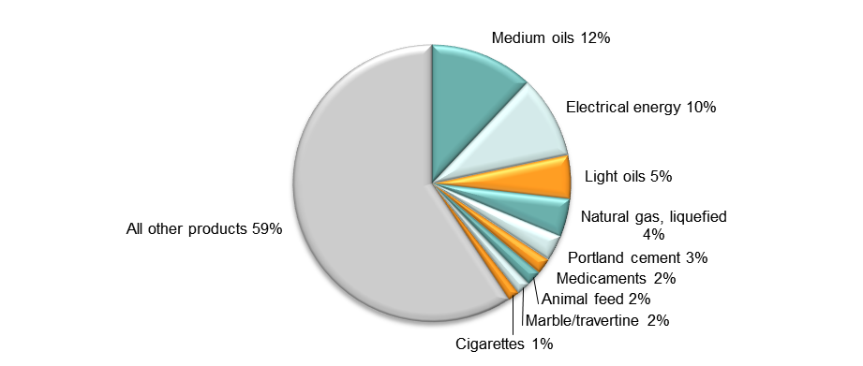

Note: At Harmonised System 6-digit level.  
Source: Authors’ calculations using data from UN COMTRADE database.

1. Top import sources, West Bank & Gaza (average 2010–12)

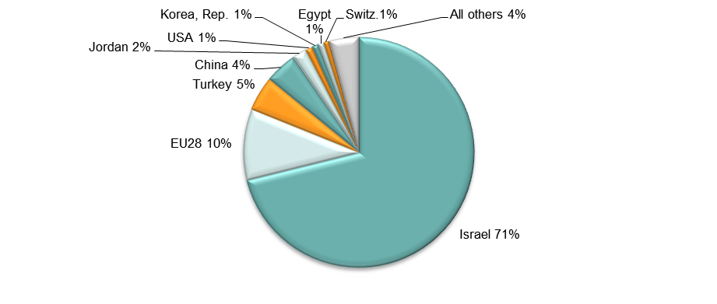

Source: Authors’ calculations using data from UN COMTRADE database.

## Diversification

1. Number of export items and markets, West Bank & Gaza, 2007–12

Note: EU countries counted individually.  
Source: Authors’ calculation using data from the UN’s COMTRADE database.

1. Number of import items and suppliers, West Bank & Gaza, 2007–12

Note: EU countries counted individually.  
Source: Authors’ calculation using data from the UN’s COMTRADE database.

## Revealed comparative advantage

1. Revealed comparative advantage by HS Section, West Bank & Gaza

|  |  |  |  |  |  |  |  |
| --- | --- | --- | --- | --- | --- | --- | --- |
| **HS Sect.** | **Product label** | **2007** | **2008** | **2009** | **2010** | **2011** | **2012** |
|  | **Total in HS 1-97** | **1.00** | **1.00** | **1.00** | **1.00** | **1.00** | **1.00** |
| 1 | Live animals; animal products | 0.39 | 0.41 | 0.42 | 1.43 | 0.47 | 0.40 |
| 2 | Vegetable products | 2.86 | 1.40 | 1.61 | 1.97 | 1.89 | 3.01 |
| 3 | Animal or vegetable fats and oils and their cleavage products; prepared edible fats; animal or vegetable waxes | 9.60 | 7.46 | 6.15 | 5.66 | 5.15 | 6.35 |
| 4 | Prepared foodstuffs; beverages, spirits and vinegar; tobacco and manufactured tobacco substitutes | 1.67 | 1.71 | 1.31 | 1.71 | 1.40 | 1.90 |
| 5 | Mineral products | 0.14 | 0.14 | 0.06 | 0.16 | 0.04 | 0.19 |
| 6 | Products of the chemical or allied industries | 0.14 | 0.23 | 0.37 | 0.31 | 0.30 | 0.26 |
| 7 | Plastics and articles thereof; rubber and articles thereof | 2.05 | 2.27 | 1.73 | 2.10 | 2.11 | 2.14 |
| 8 | Raw hides and skins, leather, furskins and articles thereof; saddlery and harness; travel goods, handbags and similar containers; articles of animal gut (other than silk-worm gut) | 2.02 | 1.71 | 1.04 | 1.27 | 0.67 | 0.78 |
| 9 | Wood and articles of wood; wood charcoal; cork and articles of cork; manufactures of straw, of esparto or of other plaiting materials; basketware and wickerwork | 5.38 | 6.72 | 5.63 | 5.18 | 4.93 | 5.30 |
| 10 | Pulp of wood or of other fibrous cellulosic material; recovered (waste and scrap) paper or paperboard; paper and paperboard and articles thereof | 1.06 | 1.64 | 1.76 | 1.13 | 1.36 | 1.51 |
| 11 | Textiles and textile articles | 0.80 | 0.57 | 0.38 | 0.26 | 0.25 | 0.37 |
| 12 | Footwear, headgear, umbrellas, sun umbrellas, walking-sticks, seat-sticks, whips, riding-crops and parts thereof; prepared feathers and articles made therewith; artificial flowers; articles of human hair | 10.55 | 10.03 | 8.90 | 8.21 | 8.84 | 7.08 |
| 13 | Articles of stone, plaster, cement, asbestos, mica or similar materials; ceramic products; glass and glassware | 27.56 | 23.12 | 27.92 | 26.23 | 27.03 | 24.49 |
| 14 | Natural or cultured pearls, precious or semi-precious stones, precious metals, metals clad with precious metal and articles thereof; imitation jewellery; coin thereof; imitation jewellery; coin | 0.00 | 0.02 | 0.01 | 0.01 | 0.02 | 0.00 |
| 15 | Base metals and articles of base metal | 1.27 | 2.06 | 1.62 | 2.09 | 2.51 | 1.89 |
| 16 | Machinery and mechanical appliances; electrical equipment; parts thereof; sound recorders and reproducers, television image and sound recorders and reproducers, and parts and accessories of such articles | 0.05 | 0.05 | 0.03 | 0.04 | 0.04 | 0.03 |
| 17 | Vehicles, aircraft, vessels and associated transport equipment | 0.01 | 0.01 | 0.01 | 0.05 | 0.03 | 0.04 |
| 18 | Optical, photographic, cinematographic, measuring, checking, precision, medical or surgical instruments and apparatus; clocks and watches; musical instruments; parts and accessories thereof | 0.01 | 0.00 | 0.02 | 0.00 | 0.02 | 0.01 |
| 19 | Arms and ammunition; parts and accessories thereof | - | - | - | - | - | - |
| 20 | Miscellaneous manufactured articles | 4.54 | 5.56 | 6.87 | 5.34 | 6.40 | 6.07 |
| 21 | Works of art, collectors’ pieces and antiques | 0.33 | 0.25 | 0.08 | 0.66 | 2.83 | 0.53 |

Note: Share of country’s exports in each HS Section in country’s total exports as a ratio of share of world exports in each HS Section in world total exports. ‘World’ = UN COMTRADE’s ‘all countries’ aggregate, i.e. total of however many countries have reported their data in any given year.   
Source: Authors’ calculations using data from the UN’s COMTRADE database.

## Trade in value added

1. Compound annual growth rate of domestic value added, foreign value added and exports, 1996-2011 and 2006-11, Gaza Strip

Source: Own computations using Eora26 database

1. Domestic and foreign value added content of gross exports as share of gross exports, 1996, 2000, 2006 and 2011, Gaza Strip

Source: Own computations using Eora26 database

1. Overall value of domestic and foreign value added, 1996, 2000, 2006 and 2011 (in USD 1,000) , Gaza Strip

Source: Own computations using Eora26 database

1. Compound annual growth rate of DVA embodied in gross exports by sector, 1996-2011 and 2006-2011, Gaza Strip

Source: Own computations using Eora26 database

1. Sectoral DVA embodied in exports as a share of sectoral gross exports, 2000 and 2011, Gaza Strip

Source: Own computations using Eora26 database

1. Sectoral DVA as a share of total DVA, 2000 and 2011, Gaza Strip

Source: Own computations using Eora26 database

1. Compound annual growth rate of FVA embodied in gross exports by sector, 1996-2011 and 2006-2011, Gaza Strip

Source: Own computations using Eora26 database

1. Sectoral FVA embodied in exports as a share of sectoral gross exports, 2000 and 2011, Gaza Strip

Source: Own computations using Eora26 database

1. Sectoral FVA as a share of total FVA, 2000 and 2011, Gaza Strip

Source: Own computations using Eora26 database

## Trade in services

1. Exports of goods and services, West Bank & Gaza

Source: Authors’ calculation using data from the World Bank’s World Development Indicators.

1. Sectoral shares of services exports, West Bank & Gaza

Source: Authors’ calculation using data from the World Bank’s World Development Indicators.

# Estimates of total factor productivity at firm level

1. Dispersion in productivity across firms by sector – West Bank & Gaza



Source: Authors’ calculations using data from World Bank Enterprise Surveys (<http://www.enterprisesurveys.org/>).

1. Distribution in productivity in West Bank & Gaza – comparing kernel and normal distributions



Source: Authors’ calculations using data from World Bank Enterprise Surveys (<http://www.enterprisesurveys.org/>).